Olefin-Paraffin Separation with Customized Amorphous Fluoropolymer (CAF) Facilitated Transport Membranes
William Charlton, Hannah Murnen, Sudip Majumdar, Ken Loprete, Ken Pennisi
Compact Membrane Systems, Newport, DE, U.S.A.
Highlights
- The silver containing Facilitated Transport Membranes has shown high flux and olefin/paraffin selectivity in the laboratory over a period of >600 days.
- Facilitated Transport Membrane stability have been evaluated and proved stable in the presence of known poisons.
- Over the past year, CMS has been operating a pilot utilizing these silver based Custom Amorphous Fluoropolymer membranes on a refinery distillation column.
- CMS is partnering with an industry leader to field test commercial scale membranes in a petrochemical facility.
- CMS has expanded research to include C₄ separations, with initial results showing good performance and longevity.

1. Introduction
Ethylene and propylene are major chemical industry raw materials and consume a great deal of energy in their production. The separations of these materials are some of the costliest, most energy intensive, and most technically difficult separations in the industry due to the very similar size and nature of the molecules being separated. The technology currently employed for the separation of ethylene and propylene from paraffins is distillation and is estimated to consume 250 trillion BTU/year of energy.
A membrane based olefin-paraffin separation process would provide substantial economic benefit to petrochemical processes and drastically reduce the energy required. Membrane processes utilizing facilitated transport membranes for separating ethylene/ethane or propylene/propane have been extensively studied and described in the literature. While separations have been demonstrated in the laboratory, problems with membrane stability have prevented development of commercial systems.
Compact Membrane Systems has developed a customized amorphous fluoropolymer (CAF) facilitated transport membrane (FTM) containing silver ions that selectively transport olefin molecules from a mixture of olefin and paraffin that has shown stable performance in both laboratory testing and field pilot trials.

2. Methods
Over the past year, CMS has been operating a pilot utilizing these silver based CAF membranes on a distillation column at the Delaware City Refining Company. The Delaware City pilot is operated on a low concentration olefin stream (i.e., 10-20 wt% propylene in the feed) with the goal of achieving an HD5 quality propane (<.05 wt% propylene) and an enriched propylene stream. In addition, CMS has entered into a project with Dow Chemical through RAPID, a manufacturing institute funded by the U.S. Department of Energy. The goal of the work with Dow is to operate at the other end of the concentration spectrum where the feed is greater than 80% propylene and the target is an upgraded olefin-rich stream from the permeate. A pilot unit is installed in a Dow facility and we will share the latest results from our tests there.
3. Results and discussion
The silver containing FTM has shown high propylene flux and propylene/propane selectivity in the laboratory over a period of >600 days. Similar results were also obtained with ethylene and ethane gas mixtures. We have also evaluated membrane stability in presence of known process poisons such as hydrogen sulfide, acetylene, MAPD and hydrogen and will provide guidance on the appropriate concentration of these species for membrane applications.
CMS will also discuss initial results on laboratory testing of butane streams. This includes mixed gas separation of n-butane and 1-butene. We will share results for a number of operating conditions and will highlight several exciting C₄ separation applications including those with isomer streams. CMS will also provide an overview on the results of our pilot field trials with the Delaware City Refinery Company and the Dow Chemical Company.

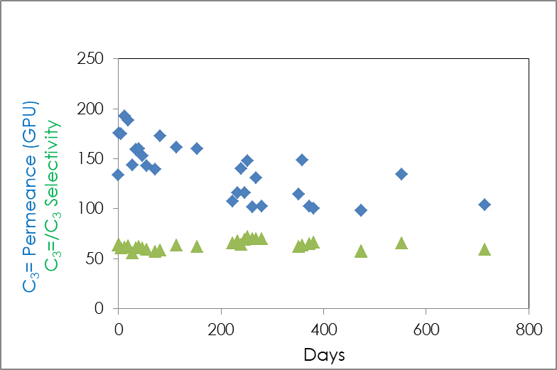
Figure 1. Long term Facilitated Transport Membrane aging study
4. Conclusions
A membrane based olefin-paraffin separation technology has the potential to provide substantial economic benefit to petrochemical industry and drastically reduce the energy required to complete these essential separations. In addition, membrane systems are scalable, allowing their implementation for smaller, stranded streams where distillation columns have not previously been installed due to limited economic value.

