Investigation of reactive mass transfer processes at single rising gas bubbles by means of Time-Resolved Scanning Laser-Induced Fluorescence
Felix Kexel, Sven Kastens, Jens Timmermann, Marko Hoffmann, Alexandra von Kameke, Michael Schlüter
1 Hamburg University of Technology, Institute of Multiphase Flows, Eissendorfer Str. 38, 21073 Hamburg, Germany;
*Corresponding author: michael.schlueter@tuhh.de
Highlights
- O₂ mass transfer
- 3D wake structure
- Time Resolved Scanning Laser Induced Fluorescence (TRSLIF)
1. Introduction
The mass transfer from a gaseous, dispersed phase into the surrounding liquid phase is a major task for chemical industry as well as for bio-, food- or environmental engineering. Nevertheless a reliable and exact design of multiphase reactors is one of the unsolved challenges in process engineering, since local mass transfer process could not be easily investigated within dense bubble swarms.
Therefore the empirical and semi-empirical correlations like for the dimensionless Sherwood number
$Sh=2+C_{1}{Re}^{a}{Sc}^{b}$ (1)
based on integrally measured data, like Sauter bubble diameter, bubble rise velocity (Reynolds number Re) and the material system with liquid viscosity ν and diffusion coefficient of the gaseous species D (Schmidt number Sc) (Brauer, 1979). In contrast to these assumptions, today the dispersed gas phase is more and more considered as individual gas bubbles with local mixing elements and a major contribution to meso mixing in multiphase flows.
To gain a deeper knowledge of local mass transfer phenomena in bubbly flows the planar laser induced fluorescence (p-LIF) technique was widely and successfully used in different experimental arrangements, which was recently reviewed by Rüttinger (Rüttinger et al., 2018). Nevertheless, the applicability of this technique is limited to an accurate and reproducible bubble rise. Due to this limitation, the accurate investigation of 3D mass transfer processes close to deforming fluidic boundary layers at free rising bubbles is a challenging task. The Time Resolved Scanning Laser-Induced Fluorescence (TRS-LIF) enables such deeper insights into local processes in bubbly flows.
2. Methods
The basic setup has already been used in a slightly different configuration by Timmermann (Timmermann et al. 2017, Kastens et al. 2018). As measuring technique, the TRS-LIF is used. A scheme of top view of the setup for TRS-LIF, based on the work of (Soodt et al., 2012), is shown in Fig. 1, left. In contrast to the investigation with p-LIF, the laser sheet is reflected from a rotating polygon (20 or 38 faces) into the volume of interest. With a precise synchronization of rotational speed and laser pulse emission, light sheets with reproducible deflection could be observed and parallelized by a cylindrical lens to obtain equidistant spacing. By variation of the laser pulse rate, polygon rotational speed and the number of pulses per polygon mirror, the generated light stacks are adjustable to the experimental scales, like bubble rise velocity and rise trajectory expansion. It should be noted, that the parameters are interlinked, where a higher sheet number reduces the maximum achievable volume scan rate, limited by the maximum rotational speed of the polygon of 10,000 rpm and the maximum pulse rate of the laser of 20,000 Hz.
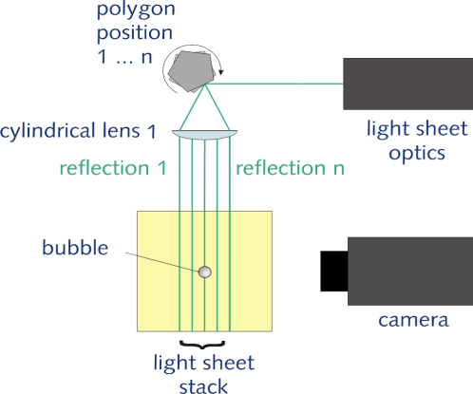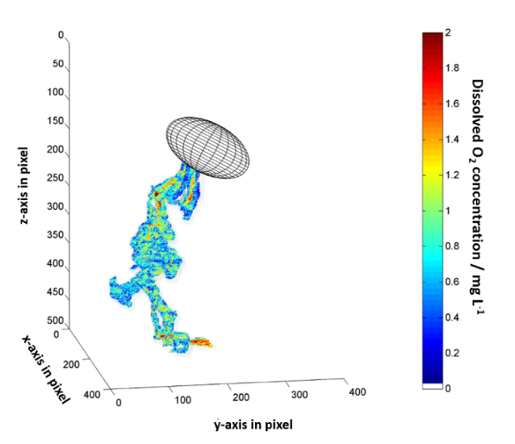
Figure 1. left: Schematic top view of the experimental setup for Time-Resolved Scanning LIF, right: 3D reconstruction of the oxygen concentration field within the wake of a free rising wobbling bubble (Timmermann, 2018).
Upgrading the number of faces on the polygon is a key parameter to optimize the temporal and/or spatial resolution for the realization of nearly instantaneous 3D scans.
3. Results and discussion
Fig. 1, right shows an example of the reconstructed wake structure behind a rising ellipsoidal O₂ bubble. Experiments are obtained at 20°C and atmospheric pressure. The two-dimensional images have been recorded with a frequency of approx. 15,000 fps. This leads to a volume scan rate of 335 Hz for one entire stack. The reconstructed 3D dissolved O₂ concentration within the wake structure shown in Fig. 1, is calculated by using calibration equations for each plane, allowing the determination of the concentration with uncertainties lower than 1 ppm. The mixing within the wake structure is in focus, where vortices with an enriched oxygen concentration are mixed with the bulk phase. The vortex shedding and mixing intensity depends on bubble shape and fluid properties, which are varied in this work. Moreover, a more precise analyzing method using online and parallel oxygen concentration calibration in the reaction vessel. Combined with analyzing each pixel within a plane the uncertainties are decreased below 0.2 ppm.

4. Conclusions
By investigating parallel-consecutive chemical reactions it is expected, that the times-scales of mass transfer and mixing will influence the local yield and selectivity within the bubble wake. With the TRS-LIF method a measurement system has been developed and successfully applied, that allows the analyzation of instantaneous 3D concentration fields within the wake of free rising bubbles. This method enables more detailed information about the influence of local hydrodynamic conditions in gas-liquid flows on yield and selectivity, which will be clarified in near future.
References
- Brauer, H., Particle/fluid transport processes. Fortschritte der Verfahrenstechnik, 17, 61-99 (1979)
- Glaeser, H. Brauer, H. Berechnung des Impuls- und Stofftransports durch die Grenzfläche einer formveränderlichen Blase, VDI-Verlag, (1977).
- Kastens, S. Timmermann, J. Hoffmann, M. Schlüter, M.; Influence of boundary layer deformations on mass transfer and chemical reaction. E-proceeding 19th Lisbon Symposium 2018
- Ohl, C. D. Generator for single bubbles of controllable size, Review of Scientific Instruments, 72(1), 252-254. (2001). DOI: 10.1063/1.1329900.
- Rüttinger, S. Spille, C. Hoffmann, M. Schlüter, M.: Laser-induced Fluorescence in Multiphase Systems. ChemBioEng Reviews, 2018, 5, 253-269. (2018)
- Sone, D., Sakakibara, K. Yamada, M. Sanada, T. Saito, T. Bubble motion and its surrounding liquid motion through the collision of a pair of bubbles, Journal of Power and Energy Systems, 2(1), 306-317, (2008). DOI: 10.1299/jpes.2.306.
- Soodt, T. Schröder, F. Klaas, M. van Overbrüggen, T. Schröder, W. Experimental investigation of the transitional bronchial velocity distribution using stereo scanning PIV. Experiments in Fluids, 52(3), 709-718. (2012). DOI: 10.1007/s00348-011-1103-5.
- Timmermann, J. Hoffmann, M. Schlüter, M. Influence of Bubble Bouncing on Mass Transfer and Chemical Reaction. Chemical Engineering & Technology, 39(10), 1955-1962. (2016). DOI: 10.1002/ceat.201600299.
- Timmermann, J. Experimental analysis of fast reactions in gas-liquid flows. Dissertation. Hamburg, 2018.

