Investigating Ion-Exchange Adsorption of Proteins through Experiments and Molecular Dynamics Simulations
Marine Tournois^{1,*}, Jérémy Esque¹, Isabelle André¹, Stéphane Mathé¹, Maria A. Fernandez¹
1 LISBP, Université de Toulouse, CNRS, INRA, INSA, Toulouse, France
*Corresponding author: marine.tournois@insa-toulouse.fr
Highlights
- The adsorption of α-chymotrypsin on SP Sepharose FF is investigated.
- The steric mass action model is used to describe single adsorption isotherms.
- MD simulations using all-atom models are performed.
- Results from MD simulations are in good agreement with macroscopic experiments.

1. Introduction
Chromatographic processes, especially Ion Exchange Chromatography (IEC), are extensively used in protein purification. However, their industrial scale-up remains under-optimized and is still based on empirical methods. Today, their cost represents up to 80-90% of the global cost for protein production. The protein adsorption on chromatographic media has been thoroughly investigated over the past decades, in terms of surface properties, influence of pH and/or ionic strength as well as protein characterization in single and multicomponent systems. The aim of this work is to better understand the binding mechanisms of proteins on adsorbents using Molecular Dynamics (MD) simulations. Indeed, MD simulations are a powerful tool and allow the study at the atomic level without requiring microscopic experimental techniques. The steric mass action (SMA) model [1], which accounts for the steric hindrance of the protein, is widely used to describe single adsorption isotherms and depends on different parameters such as the characteristic charge of the protein, the steric factor and the equilibrium constant. These parameters were obtained both experimentally and through MD simulations [2][3] for a protein (α-chymotrypsin) and a well-known resin (SP Sepharose FF) chosen as models. It allows validating the relevance of microscopic simulations to predict the protein adsorption behavior in adsorbents and then avoid long and costly experiences. This, in turns, enables simulation-based improvement of protein purification process which may have strong industrial impacts.
2. Methods
Experiments and molecular dynamics simulations were performed to study the ion-exchange mechanism from macroscopic and microscopic scales. Breakthrough curves measurements were performed by loading a protein solution, at controlled pH and ionic strength, into an IEC column, for determination of experimental adsorption isotherms. The SP Sepharose FF ionic capacity was also measured. Then, fitting of the experimental results by the SMA model allowed for the estimation of the characteristic charge, the steric factor and the equilibrium constant.
MD simulations were run using all-atom model [4]: a simulation box, containing the protonated protein (pH=5), the charged ligands (the agarose matrix is not represented), ions (Na⁺ and Cl⁻) and water molecules, was created. The protein is free to move in the box and the ligands are restrained to form a layer at the bottom. Then, long simulations (+100 ns) were performed with GROMACS 2018.3 simulation software and analyzed. Different starting orientations of the protein were also investigated and several simulations were run to obtain a reliable set of data.
3. Results and discussion
The results obtained through macroscopic experiments (presented in Figure 1.a) and microscopic simulations, especially the characteristic charge and the steric factor, were compared. Figure 1.b. shows an example of simulation box at initial conditions.
- (b)
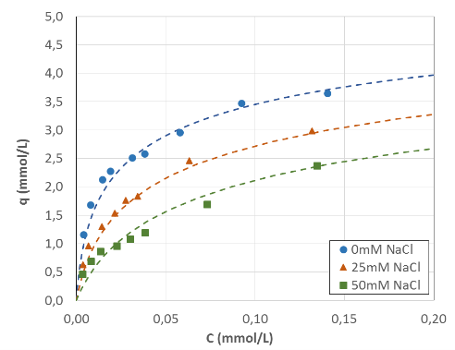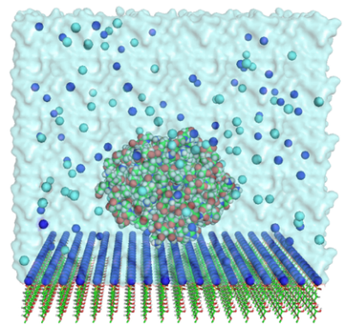
Figure 1. (a) Adsorption isotherms of α-chymotrypsin on SP Sepharose FF (pH=5): experiments vs SMA model (dotted line). (b) MD simulation box at initialization. Charged sites are represented at the bottom of the box (324 ligands); positively and negatively charged ions are colored in blue and cyan respectively.
All MD simulations led to an adsorption of the protein on the chromatographic surface, with exchange of Na⁺ counter-ions, and the binding residues were also identified. Moreover, free binding energies of interaction were calculated and used to highlight the most favorable binding sites of α-chymotrypsin.
4. Conclusions
α-chymotrypsin and SP Sepharose FF were used to investigate the adsorption mechanism at the atomic scale, combining macroscopic experiments and MD simulations. The two parameters from the SMA model (charge and steric factor), obtained through the simulations, are in good agreement with those obtained from experiments. Thus, MD simulations seem to be a reliable tool to predict the protein retention with a chromatographic surface, in a single-component system. The influence of ionic strength, pH or ligand density is still under investigation, as well as the proteins behavior in multi-component system.
Acknowledgements
This work was granted access to the HPC resources on the TGCC-Occigen supercomputer and the Computing mesocenter of Région Midi-Pyrénées (CALMIP, Toulouse, France).
References
- C. A. Brooks, S. M. Cramer, AIChE J. (1992) 1969-1978.
- J. Liang, G. Fieg, F. J. Keil, S. Jakobtorweihen, Ind. Eng. Chem. Res. (2012) 16049-16058
- J. Liang, G. Fieg, S. Jakobtorweihen, Chem. Ing. Tech. (2015) 903-909
- F. Dismer, J. Hubbuch, J. Chromatogr. A (2010) 1343-1353

