Experimental Validation of the Production of PolyVinyl Acetate in a Pilot Reactor – A Case of Optimization

Andrés Augusto Herrera Morales, Bibiana Raba Mora, Iván Darío Gil Chaves, Gerardo Rodriguez Niño & Manuel Florez
ª Chemical and Biochemical Processes Group, Department of Chemical and Environmental Engineering, Universidad Nacional de Colombia, Bogota, Colombia.
idgilc@unal.edu.co*
Highlights
- Validation of an emulsion polymerization.
- Polymer properties continuous determination during reaction time.
- Time reaction reduction up to 30% from a standard procedure.

1. Introduction
Polyvinyl acetate is obtained through an exothermic reaction in a process of free-radical emulsion polymerization. Polyvinyl acetate is widely used in the adhesives industry, and it is also largely implemented in the generation of sub products. For example, it is a film-forming ingredient in water-based (latex) paints; it is used in adhesives, varnishes and lacquer, paper coatings, fabric adhesives, resin bases, among others^{[1]}. The demand for new latex products has rapidly increased, together with research efforts in modeling, optimization and control of the manufacturing process. In the past few years, multiphase models have been developed, reflecting factors like nonlinear behavior and the sensitivity to perturbations^{[2][3]}. A pilot scale emulsion polymerization was developed on a 75L stirred tank reactor based on a model that describes emulsion polymerization phenomena such as initiation, propagation and termination stages. Temperature reactor, viscosity, solids content and particle size distribution were determined in order to validate the model.

2. Methods
At first, a dynamic model was proposed where by a control strategy to assess an optimal condition was defined. The purpose of this model is to minimize the reaction time by varying the heating/cooling flows fed through the reactor jacket. In turn, the model made it possible to estimate the effect of the initiator and the monomer dosage, as well as the influence of temperature on the reaction. Then, a description of the properties was made in order to follow up on the reaction and determine its quality in terms of the solids content, viscosity, distribution of size particle and residual monomer. Solids content and viscosity were determined based on a Colombian Technical Standard, temperature was measured and recorded in Siemens 1200 PLC and Particle size distribution was determined by a dynamic light scattering method with a Zetasizer Nano equipment. ^{[4][5][6][2]}
3. Results and discussion
A total of seven tests were conducted for the validation of the model: two under normal operation conditions and five reproducing the optimal profile. The profiles obtained through the experimentation shows an approximation to the model values, allowing to conclude that the model studied is accurate to real heterogeneous phenomena.
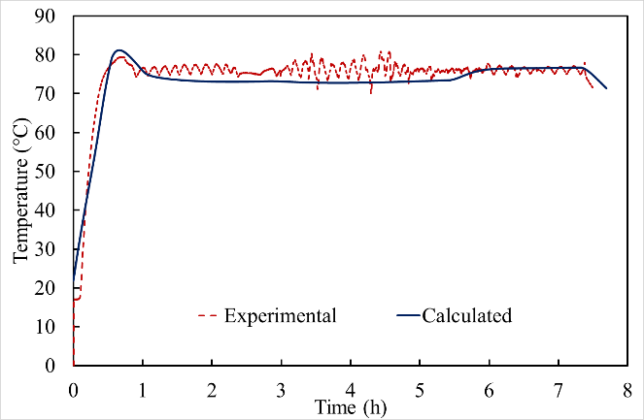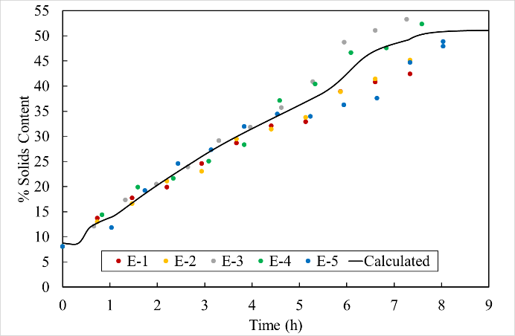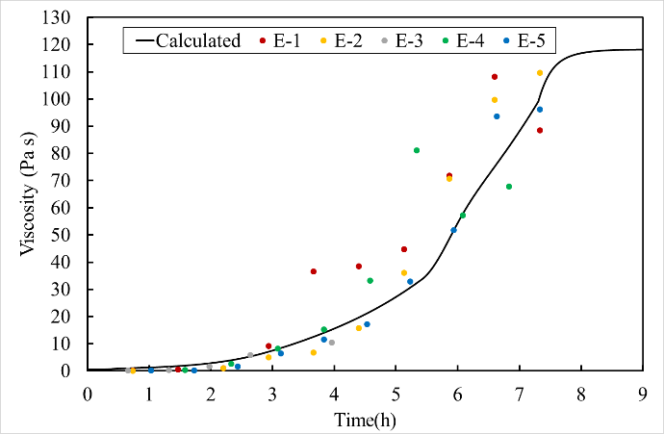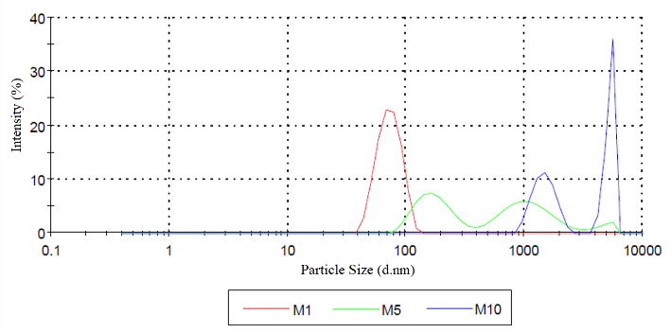

Figure 1. Temperature, solids content, viscosity and particle size distribution from an experimental data of an optimal time emulsion polymerization reaction.
4. Conclusions
From the data obtained from the temperature profile and the product’s final properties it was possible to confirm that through the control strategies proposed for the temperature control optimization model it is possible to reduce the reaction time by 20%, taking as reference the reaction that is currently conducted in the industrial sector.
It was possible to implement strategies like the addition of the monomer and the initiator at different time intervals, as well as the variation of the heating/cooling flows feeding the reactor jacket in a pilot reactor (65 liters), where transport and mass transfer phenomena found in an industrial reactor, at a larger scale, were also present.
The results obtained for each one of the properties make it possible to ensure that the quality of the final polymer obtained through the optimized model is like the one obtained through the conventional process. The model used employed an optimal control, which is designed to track the temperature in the reaction system despite typical perturbations like initiator injections of the monomer.
References
- Market, E. C. (2008). Polyvinyl Acetate and Polyvinyl Alcohol. A review of the CIS Production Eurasian Chemical Market (Vol. 11).
- Penlidis, A., MacGregor, J.F., Hamielec, A.E., 1985. Dynamicmodeling of emulsion polymerization reactors. AIChE J. 31,881–889.
- Dimitratos, J.; Eliçabe, G.; Georgakis, C. Control of emulsion polymerization reactors. AIChE J. 1994, 40, 1993−2021.
- ICONTEC.: Adhesivos. Determinación del contenido de sólidos convencional y delcontenido de sólidos a masa constante. Bogotá: Norma Técnica Colombiana NTC5003, 2010.
- ICONTEC.: Adhesivos. Métodos de ensayo para determinarla viscosidad Bogotá: Norma Técnica Colombiana NTC 2790, 2010.
- Benyahia, B., Latifi, M.A., Fonteix, C., Pla, F., 2011. Multicriteriadynamic optimization of an emulsion copolymerizationreactor. Comput. Chem. Eng. 35, 2886–2895.

