Integrated micro-system for lipase-catalyzed biodiesel production
Martin Gojun*, Anita Šalić, Bruno Zelić
University of Zagreb, Faculty of Chemical Engineering and Technology, Marulićev trg 19,
HR-10000 Zagreb, Croatia
*Corresponding author: mgojun@fkit.hr
Highlights
- Lipase-catalyzed biodiesel synthesis in microreactors was performed
- Different microreactor systems were investigated
- Integrated system composed of lipase-catalyzed biodiesel production and glycerol separation is proposed

1. Introduction
Due to recent widespread issues concerning the over usage of fossil fuels, alternative sources of energy are developed with fast pace. When it comes to transportation, biofuels such as biodiesel, can become a clean and renewable substitute for petroleum diesel. Biodiesel, a mixture of monoalkyl esters of long-chain fatty acids, provides valuable improvement in comparison with petroleum diesel in terms of biodegradability and renewability, better quality of exhaust gas emission and lower environment harmful effect. [1] Between various production processes of biodiesel, transesterification is most commonly used technique, even though the conventional process has some disadvantages. Microreactor technology, as one possible improvement of conventional processes in terms of mixing, mass transfer and reducing the reaction time, has been thoroughly explored in recent decades. [2] However, enzyme-catalyzed process continues to represent area which need to be more briefly investigated. In this work, lipase from Thermomyces lanuginosus was used as catalyst in biodiesel production. Oil, both edible and waste, was used as a substrate. To find out the “ideal system” for biodiesel synthesis, different configurations of microreactors have been used. In addition, some other parameters which affect on biodiesel production have been monitored, such as microchannel size, residence time, reaction temperature and source of catalyst. [3]
2. Methods
Biodiesel production from both edible sunflower oil and waste cook oil using Lipolase 100L was performed in different configurations of microreactors. According to literature data for feeding ratios, microreactor system was set with a goal to find “ideal system”. In addition, each configuration was used for a set of different residence times to examine that impact as well. All experiments were performed at 40°C (optimal temperature for enzyme activity) which was secured with a water bath in which microreactor system was placed. While running the process across few days for each configuration, lipase activity was determined daily, by measuring the change of absorbance at 410 nm with a spectrometer. Feeding inlets in this experiments were edible/waste oil, methanol, enzyme dissolved in buffer and emulsifier. Due to different configurations of microreactors, emulsifier is sometimes needed to prepare stable water:oil or methanol:oil emulsion.
After investigating all different configurations and selecting optimal system, integrated system is introduced. The idea is to connect two microchips in series, so that the first one is used for biodiesel production and the second one is used for simultaneous glycerol separation. [4] The main goal is that glycerol content in biodiesel is below 0.02%, which is limit according to the American standard ASTM D 6571 and the European standard EN 14214.
3. Results and discussion
Different configurations of microreactors with different feeding inlets were used to investigate biodiesel synthesis. Influence of residence time on F.A.M.E. content is shown in Figure 1. for both investigated microreactor systems: a) 2 inlets and 2 outlets, and b) 3 inlets and 2 outlets. Further investigations of different microreactor system configurations and emulsifiers is planned.
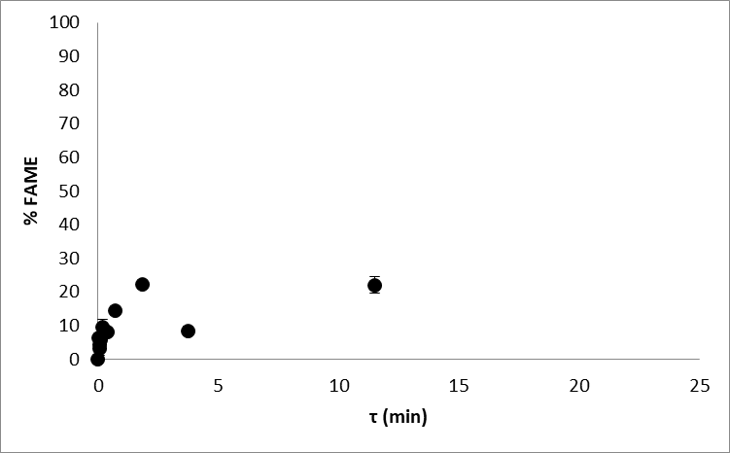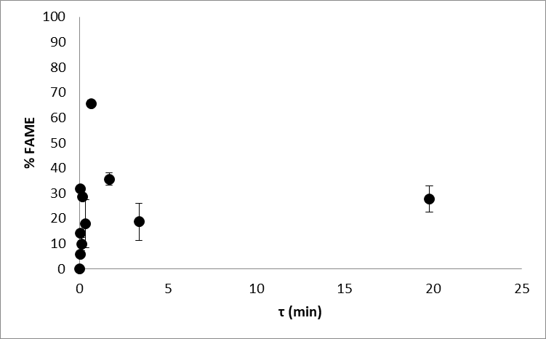
a) b)
Figure 1. Obtained FAME content in a microreactor applzing a) 2/2 microreactor system and b) 3/2 microreactor system.
4. Conclusions
Lipase-catalyzed biodiesel production showed an improvement over conventional transesterification process. Several aspects still need to be investigated. After the biodiesel production, biodiesel purification (removal of glycerol) is required to fulfill American or European standards for biofuels. Thus, integrated system of simultaneous biodiesel production and purification is proposed.
References
[1] A. Mazubert, J. Aubin, S. Elgue, M. Poux, Green Process. Synth. 3 (2014) 419–429.
[2] A. Madhawan, A. Arora, J. Das, A. Kuila, V. Sharma, Biomass Convers. Biorefin. 8 (2018) 485–496.
[3] S. Budžaki, A. Šalić, B. Zelić, M. Tišma, Chem. Biochem. Eng. Q. 29 (2015) 329–333.
[4] A. Šalić, A. Jurinjak Tušek, A. Sander, B. Zelić, New Biotechnol. 47 (2018) 80–88.

