Bubble breakup induced by interaction with vortex-ring.
Maria Zednikova¹, Petr Stanovsky¹, Sandra Orvalho¹, Tereza Travnickova¹
1 Institute of Chemical Process Fundamentals of the CAS, v.v.i., Rozvojova 135, CZ-165 02
Prague, Czech Republic
*Corresponding author: zednikova@icpf.cas.cz
Highlights
- Interactions of single bubble with single vortex-ring are studied experimentally.
- Vortex-ring is characterized combining experiments and numerical simulations.
- Bubble deformation and breakup efficiency is investigated using high-speed camera.
- Results show the present data comparable with data obtained in homogeneous turbulence.

1. Introduction
Breakup of fluid particles (bubbles or drops) in a turbulent flow is a phenomenon encountered in many industrial applications. The understanding of the mechanism is essential to improve the modelling of complex multiphase flows by numerical methods [1]. To provide a controllable experiment where the bubble will break in a defined turbulent flow is quite difficult task because the turbulence has stochastic nature and huge amount of data needs to be treated to achieve a satisfactory level of accuracy. Therefore, more deterministic approach in the bubble breakup studies is needed.
The interaction of a single bubble with a vortex-ring can be assumed as more deterministic system simplifying the collision of bubble with turbulent eddy [2, 3]. Revuelta [2] found that the large vortex rings causes bubble deformations following the shapes identified in turbulent flow and he demonstrated, that the bubble breakup issuing from bubble-vortex-ring interactions can be used as idealized situations of bubble breakup in turbulent flow. However, the conclusion was obtained using numerical simulations and it should to be proved also experimentally. The aim of the contribution is to provide the experiments on bubble breakup induced by interaction with vortex-ring in order to contribute the understanding of the bubble breakup process in turbulent flows and to provide the reliable breakup parameters.
2. Methods
The experiment is based on the production of single bubble and single vortex-ring both moving against each other since they interact (Fig. 1). Vortex-ring is generated by pulse-flow from an immersed nozzle (1.2 in diameter, duration of pulse-flow is typically 25 ms). Bubble of defined size (ranging from 0.8 to 2.5 mm in diameter) is produced by the generator based on movable capillary [4]. The collision process is observed by high-speed camera in order to tract the mother bubble and all the daughter bubbles arising from breakup. Breakup frequency, number and size distribution of daughter bubbles are determined in dependence on mother bubble size and vortex-ring energy. The vortex-ring energy is defined by the circulation strength of the vortex-ring, which is obtained combining the experimental visualizations and numerical simulations of the vortex-ring generation based on the same convective velocity of the vortex-ring (ranging from 0.9 to 1.5 m/s).
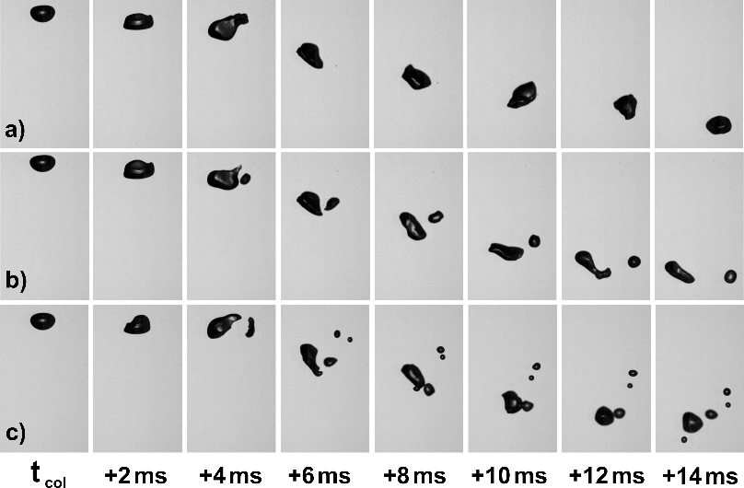
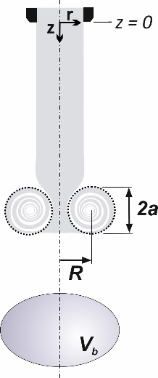

Figure 1. Illustration of coordinate Figure 2. Examples of possible events after the bubble-vortex-ring interactions,
system. a) no bubble breakup, b) binary breakup, c) multiple breakup
3. Results and discussion
The problem of bubble-vortex ring collision can be characterized by Weber number We, which is the ratio of vortex-ring energy and surface energy of the bubble. For low We ≈ 3, the bubble breakup efficiency is about 50%, where no breakup events (Fig. 2a) are of the same probability as the bubble breakup preferably into two daughter bubbles (Fig. 2b). Increasing the Weber number (We > 5), the breakup efficiency is nearly 100% and preferably breakages into multiple daughters occurs (Fig. 2c).
The breakup parameters obtained from the bubble-vortex-ring interactions are compared with breakup parameters obtained in homogeneous turbulent flow [5]. The results show satisfactory agreement in data of breakup frequency and also in number of daughter size distribution.
4. Conclusions
The comparison of present experimental data obtained for interactions of single bubble with single vortex-ring and the data obtained in homogeneous turbulence proved that the bubble-vortex-ring interaction can be assumed as an idealizes situation of collision of bubbles with eddies in turbulent flow.
The financial support by the Czech Science Foundation through project 19-09518S is gratefully acknowledged.
References
[1] J. Solsvik, S. Tangen, H.A. Jakobsen, Rev. Chem. Eng. 29 (2013) 241-356.
[2] A. Revuelta, Eur. J. Mech. B-Fluids 29 (2010) 119-126.
[3] C. Martinez-Bazan, J. Fluid Mech. 780 (2015) 1-4.
[4] J. Vejrazka, M. Fujasova, P. Stanovsky, M.C. Ruzicka, J. Drahos, Fluid Dyn. Res. 40 (2008) 521-533.
[5] J. Vejrazka, M. Zednikova, P. Stanovsky, AIChE J. 64 (2018) 740-757.

