NETmix Technology for the continuous production of Pickering emulsions of hydroxyapatite nanoparticles
Andreia Ribeiro^{1,2}, Yaidelin A. Manrique³, Isabel C.F.R. Ferreira², Maria F. Barreiro^{2,3}, José C.B. Lopes^{1*}, Madalena M. Dias¹
1 Laboratory of Separation and Reaction Engineering – Laboratory of Catalysis and Materials (LSRE-LCM), Faculdade de Engenharia, Universidade do Porto, Portugal; 2 Centro de Investigação de Montanha (CIMO), Instituto Politécnico de Bragança, Portugal; 3 Laboratory of Separation and Reaction Engineering – Laboratory of Catalysis and Materials (LSRE-LCM), Instituto Politécnico de Bragança, Portugal
*Corresponding author: lopes@fe.up.pt
Highlights
- Nanometric hydroxyapatite (n-HAp) was used to stabilize Pickering emulsions.
- Stable Pickering emulsions (PE) were successfully prepared in batch mode.
- NETmix technology allows the production of PE in continuous mode.

1. Introduction
Mixtures of two immiscible liquids – emulsions – are commonly used, and play an important role in several product’s formulations. Examples include food, pharmaceuticals and personal care products [1]. Traditionally, their stabilization is achieved by one, or more, chemical emulsifiers, but it’s can have limited use due thermodynamic instabilities, and due health problems because start to be associated with allergic reactions and carcinogenicity [1,2].
Pickering emulsions (PE) arise as an alternative to traditional emulsions and are receiving significant attention at industrial and academic level. In fact, the solid particles are able to be positioned in the oil-water interface forming a thicker barrier, acting as an emulsion stabilizers [3]. The “surfactant-free” character made PE more suitable for various applications, particularly in food area [1,3].
Hydroxyapatite (HAp) has been described as a suitable Pickering stabilizer, it tends to stabilize O/W emulsions due to its hydrophilicity [4,5]. Nowadays, previous works are focused in the production of PE using bath processes [1,2]. Aiming at achieving a more feasible industrial process, in this work, the NETmix technology is used for the first time to produce PE in continuous mode with high reproducibility. The NETmix was developed at the Associate Laboratory LSRE-LCM, it consists in a network of static mixing chambers interconnected by transport channels (Figure 1 A and B) [6].
2. Materials and Methods
To produce green PE, sunflower oil and water containing dispersed n-HAp were used as oil and aqueous phases, respectively. Two process were performed: i) batch mode (Figure 1 C): the mixing system was comprised by a high-speed homogenizing device Miccra D-9, a thermostatic bath and a peristaltic pump, the sunflower oil was injected into n-HAp aqueous phase; and ii) continuous mode (Figure B): in this process, both phases are feed into NETmix in a pre-mixed mode, with the total flow rate adjusted according to the desired Reynolds number (Re).
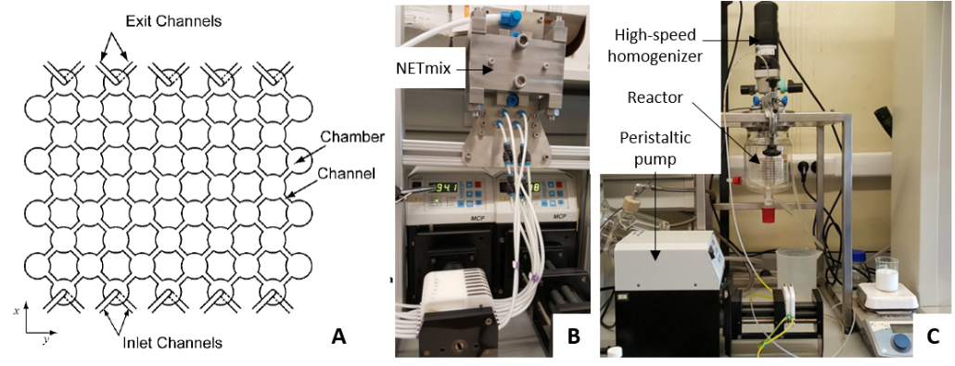
Figure 1. NETmix schematic representation (A). Experimental setup: NETmix (B) and batch (C).
3. Results and discussion
The PE were produced considering the relevant parameters affecting their stability, namely solids content and oil-water ratio. For both, batch and continuous (NETmix), a stable emulsion was achieved with 20-80 as the oil-water ratio and 5 %wt. of n-Hap. In batch mode, the average diameter of the oil droplets ranged between 10-25 µm (Figure 2 A). By cryo-SEM analysis was observed PE droplets with n-HAp layer around oil core (Figure 2 B), the EDS analysis (data not shown) confirmed the presence of these materials. This PE was stable for more than 8 weeks.
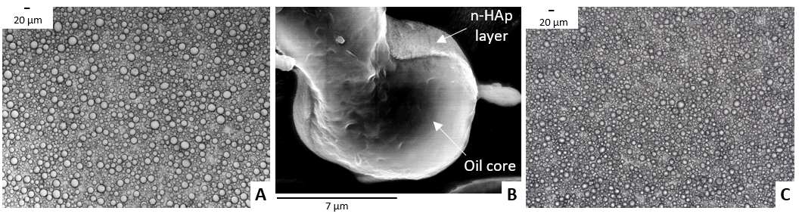
Figure 2. PE images: (A)- optical and (B) – cryo-SEM obtained by batch mode, and (C) – optical obtained using NETmix.
Regarding the production in continuous mode, preliminary results indicate that it is feasible to use the NETmix technology to produce PE. The achieved results are quite promising for Re ~500, the formed PE have average diameters of 5-7 µm (Figure 2 C) being smaller than obtained in batch mode.
4. Conclusions
Stable PE were produced using n-HAp as stabilizers with size distributions ranged between 10 to 25 μm (batch mode) and 5 to 7 μm (continuous mode). Moreover, the NETmix reactor can enable the production of these emulsions at pilot/industrial scale.
References
- X Li, J. Zhu, Y. Pan, R. Meng, B. Zhang, H. Chen, Food Hydrocolloids 90 (2019) 19-27.
- Y. Yang, Z. Fang, X. Chen, W. Zhang, Y. Xie, Y. Chen, W. Yuan, Front Pharmacol 8 (2017) 287.
- C. Berton-Carabin, K. Schroen, Annu Rev Food Sci Technol 6 (2015) 263-297.
- M. Zhang, A. Wang, J. Li, Y. Song, R. He, Mater. Sci. Eng. C, 70 (2017) 396-404.
- S. Fujii, M. Okada, T. Nishimura, H. Maeda, T. Sugimoto, H. Hamasaki, Y. Nakamura, J. Colloid Interface Sci. 374 (2012) 1-8.
- P.E. Laranjeira, A.A. Martins, J.C.B.Lopes, M.M.Dias, AIChem J. 55 (2009) 2226-2243.

