Conservation of the antioxidant activity and nutritional properties of tucumã pulp using vaccum packaging.
Patrícia Albuquerque*, Sthéfanny Azevedo, Sergio Duvoisin Jr.
Amazonas State University, Laboratory of Chemistry Applied to Technology, 1200 Darcy Vargas Ave., Manaus, Amazonas, Brazil, 69050-020.
*Corresponding author: palbuquerque@uea.edu.br
Highlights
- Tucumã pulp has a high content of β-carotene.
- Vacuum packaging and freezing keeps the tucumã nutritional properties for 30 days.
- Antioxidant activity remained preserved for 2 months in frozen samples of tucumã pulp.

1. Introduction
The Amazon region has different fruits often consumed by local population which present high economic potential [1]. The tucumã, also known as tucumã of the Amazonas, tucumã-açu e jabarana [2] is an example of tropical fruit, derived from the palm tree Astrocaryum aculeatum (Arecaceae), which presents significant biotechnological potential. It is characterized as slightly acidic, low sugar, high in β-carotene and high energy fruit [3]. Once the pulp is obtained, it must be consumed within one day at room temperature, or within a week under refrigeration [4]. Since the pulp storage has been performed inappropriately in most of the commercial establishments in Manaus, our objective with this work was to study the conservation of the antioxidant activity and the nutritional properties of tucumã pulp in natura, using vacuum packaging.
2. Methods
The tucumã was collected in a rural property located in Rio Preto da Eva, Amazonas (2°37'31.8"S 59°44'52.6"W). The tucumã pulp was obtained according to Flor et al. [5] and stored into polyethylene bags (200 g of pulp per bag) under vacuum. The packs were stored under freezing (18ºC) and cooling temperature (5ºC). During 150 days, the content of moisture, ash, pH, acidity, ethereal extract, energy, and microbiological growth (coliforms and Salmonella), were verified according to the methodologies describes by the Adolfo Lutz Institute [6]. Antioxidant activity was measured using DPPH• radical scavenging method [7].
3. Results and discussion
It was found that the values of moisture, ash and pH are retained by the use of vacuum packaging, in freezing or cooling temperatures for 5 months; acidity is conserved in vacuum packages only in the freezer for 10 days; the ethereal extract values are maintained for 3 months under freezing temperature and for 1 month when cooled; and the energy value contained in the pulp is kept for 2 months under freezing and for 10 days under cooling. The presence of coliforms and Salmonella were not detected during 5 months of storage for both frozen and cooled samples; and the antioxidant activity remained preserved for 2 months in frozen samples (Figure 1A), but was not maintained in refrigerated samples (Figure 1B).
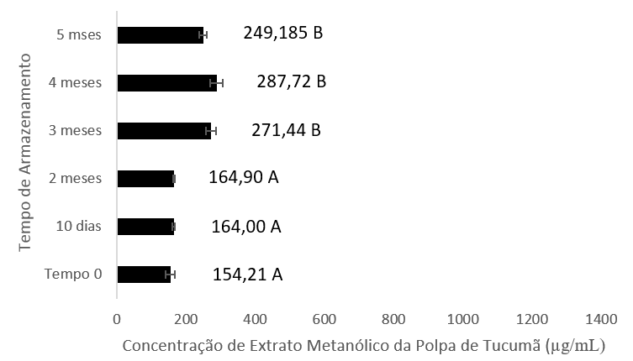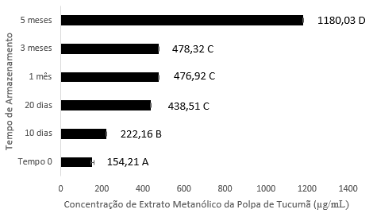
Figure 1. Efficient concentration at 50% (EC₅₀) of tucumã pulp stored in vacuum packaging under cooling (A) and freezing (B) temperature.

The maintenance of antioxidant activity of fruit pulps using freezing temperature was also verified by Freire et al. [8] The authors stored acerola pulp (Malpighia emarginata) at -18ºC and the antioxidant activity was kept for 3 months. Manach et al. [9] affirmed that the concentration of phenolic compounds that are responsible for the antioxidant activity may be affected by factors such as processing, storage, as well as by environmental factors. It has been observed in the tucumã pulp the presence of different flavonoids, such as rutin and quercetin, as well as tanins, like galic acid, caffeic acid and chlorogenic acid [10].
4. Conclusions
Through this study we found that the use of vacuum packaging, associated with freezing, provides the conservation of the main nutritional properties of tucumã pulp in natura, for 30 days of storage, a simple procedure that can be used by local food suppliers.
References
- A. C. Braga, A. E. da Silva, A. C. A. Pelais, C. M. G. Bichara, D. R. Pompeu, Alimentos e Nutrição, 21 (2010) 31-36.
- J. R. da Costa, J. van Leeuwen, J. A. Costa, in: P. Shanley, G. Medina (Eds.), Frutíferas e plantas úteis na vida amazônica. CIFOR, Belém, 2005, pp. 209-222.
- L. K. O. Yuyama, R. N. Maeda, L. Pantoja, J. P. L. Aguiar, H. A. Marinho, Ciência e Tecnologia de Alimentos, 28 (2008) 408-412.
- G. Schroth, M. S. S. Mota, R. Lopes, A. F. de Freitas, Forest Ecology Management, 202 (2004) 161-179.
- N. S. Flor, J. S. Andrade, S. A. N. Ferreira, British J Applied Sci Technol, v. 5, n. 4, p. 371-379, 2015.
- Instituto Adolfo Lutz, Normas Analíticas do Instituto Adolfo Lutz - Métodos Físico-químicos para análise de alimentos. Instituto Adolfo Lutz, São Paulo, 2008.
- J. M. Duarte-Almeida, R. J. dos Santos, M. I. Genovese, F. M. Lajolo, Ciência e Tecnologia de Alimentos, 26 (2006) 446-452.
- J. M. Freire, C. M. P. de Abreu, D. A. Rocha, A. D. Corrêa, N. R. Marques, Ciência Rural, 43 (2013).
- C. Manach, A. Scalbert, C. Morand, C. Rémésy, L. Jimenez, The American Journal of Clinical Nutrition, 79 (2004) 727-747.
- M. R. Sagrillo, J. F. M. Garcia, O. C. de Souza Filho, M. M. M. F. Duarte, E. E. Ribeiro, . C. Cadoná, I. B. M. da Cruz, Food Chemistry 173 (2015) 741-748.

