Optimization of conditions for the purification of chlorogenic acid from a sunflower meal co-product by macroporous resins:
static and dynamic study
Thi Tuong Le¹, Irina Ioannou¹, Armelle Ropars², Arnaud Aymes¹, Jean-Pol Frippiat^{2*}, Romain Kapel^{1*}
¹ Laboratoire Réactions et Génie des Procédés, Université de Lorraine, CNRS, LRGP, F-54000 Nancy, France
² Stress, Immunity, Pathogens, Université de Lorraine, EA 7300, 9 avenue de la foret de Haye, Vandoeuvre-les-nancy, France
*Corresponding author: romain.kapel@univ-lorraine.fr/ jean-Pol.frippiat@univ-lorraine.fr
Highlights
- CGA adsorption on XAD 7 resin was described by pseudo-second-order and Langmuir model.
- Optimal capture conditions were the adsorption flow rate of 15 BV/ h and pH at 2.7 and desorption with ethanol 50% (v/v).
- CGA fraction from sunflower protein purification effluent had similar biological effects than commercial CGA
1. Introduction
The extraction/ purification of plant proteins for food applications yields a large volume of liquid effluent. Recently we developed a process for the production of sunflower proteins isolate. The purification step is made by ultrafiltration with a diafiltration step using NaCl solution. This effluent is composed of various organic micro-solutes (amino acids, organic acids, peptides, carbohydrates etc.). It also contains chlorogenic acid (CGA) which is the main sunflower polyphenol. Many reports show the great biological activities of this polyphenol (like anti-inflammatory properties [1, 2]). The capture of sunflower polyphenol and particularly CGA from ethanol or methanol extracts is well documented [3]. But the capture its capture from an aqueous media charged in hydro-soluble molecule and salts has never been performed to our knowledge.
This study presents the static adsorption/ desorption capacity of CGA in the effluent with macroporous resins. This allowed choosing the most appropriate resin for CGA capture. Then, we implemented a multi-objective optimization strategy to establish the best adsorption /desorption conditions for CGA capture in column. Finally, we studied the biological activity of the obtained fraction compared to commercial CGA.
2. Methods
Batch adsorption/ desorption of CGA was studied with five macroporous resins (XAD4, XAD7, XAD16, XAD1180 and HP20) by monitoring CGA in the liquid phase (SE-HPLC method). CGA in adsorbed on the solid phase was deduced by applying the mass balance. For the dynamic study (column), the effect of pH (2 – 5) and flow rate (5 – 15 BV/h) on dynamic binding capacity (DBC_{10%}), productivity and recovery were modeled by nonlinear regression (Response Surface Methodology, RSM). For the desorption step, the effect of the ethanol concentration (30 - 90% v/v) on CGA purity was also considered. The effects of these fractions on the viability of human THP-1 derived macrophages and wondered if they could moderate their LPS-induced inflammatory response.
3. Results and discussion
XAD 7, XAD 16 and HP 20 showed high CGA adsorption and desorption capacities at equilibrium. Four kinetic models are used to fit experimental CGA adsorption data. The pseudo-second-order model is the most suitable for describing the whole adsorption behavior. Four isotherm models were used to describe the adsorption properties of CGA on resins. The Langmuir model was the most favorable for describing the adsorption at equilibrium (Fig. 1A). For the dynamic study, XAD7 has been selected resin due to showing high specific surface adsorption capacity. The effect of the pH and charge step flow rate on DBC_{10%}, CGA recovery and process productivity by DoE (Fig. 1B). R² obtained for the 3 criteria was higher than 0.9 meaning that the regression models appropriately fitted experimental data well. The multicriteria optimization strategy showed that the best conditions were a flow rate of 15 BV/ h and a pH of pH 2.7 and the most appropriate ethanol concentration was 50% (v/v). Fig. 1C demonstrates that CGA fraction (F1) and CGA standard did not affect cell viability on human THP-1 derived macrophages at dose 50-100 mM. Results revealed that TNF-α was inhibited approximately of 15-20% when we treated samples with LPS before and after 1 hr, similar to that obtained with CGA standard. These results suggested a newly discovered anti-inflammatory feature of CGA from by-products of protein extraction.

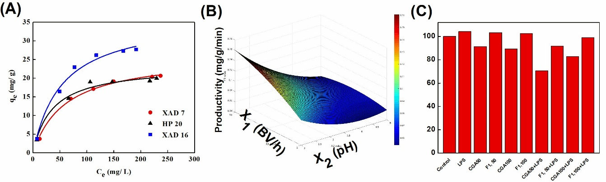
Figure 1. Illustrated results. A. Langmuir model; B. Response surface of productivity; C. Cytotoxicity on THP-1 cells line.

4. Conclusions
In the static study, the adsorption of CGA had a monolayer adsorption behavior. The pH of the starting effluent significantly affected the adsorption and desorption capacities. Based on RSM, the optimal conditions for purification of chlorogenic acid was defined. The obtained fractions and standard did not affect cell viability. This natural product may then be proposed as an alternative product that helps in preventing and treating inflammatory disorders. Studies are currently ongoing to evaluate the capacity of these fractions to reduce THP-1-derived macrophages inflammatory response.
References
- Szydlowska et al. 2010, J Argic. Food Chem, 58 : 7502-7509
- Weisz et al. 2013, IFSET Journal, 17: 169-179
- F.S. Taha et al. 2011, Am. J. Food Technol. 6: 1002-1020.

