Bacterial alginate production under oxygen transfer rate controlled conditions
Belén Ponce, Alvaro Díaz-Barrera*
Escuela de Ingeniería Bioquímica, Pontificia Universidad Católica de Valparaíso, Av. Brasil 2147 Casilla 4059, Valparaíso, Chile.
* Corresponding author: alvaro.diaz@pucv.cl
Highlights
- Control of the oxygen transfer rate based on the oxygen in the feed gas
- Alginate production and their molecular weight were affected by oxygen transfer rate control
- Under OTR controlled, alginate molecular weight produced during the stationary phase of growth was constant
1. Introduction
Alginates are polysaccharides composed of (1-4)-β-D-mannuronic acid and its C-5-epimer, α-L-guluronic acid. These polymers are used in the food and pharmaceutical industries as stabilizing, thickening, gel- or film-forming agents [1]. Alginates are produced by brown algae, but they can also be produced by the bacterium Azotobacter vinelandii. One strategy to produce alginates with defined molecular weight (MW) is through the manipulation of the culture conditions during fermentation. In our group, we have found evidences that the oxygen transfer rate (OTR) affects the molecular weight of alginate [2]. During the stationary phase of growth, both the OTR and the MW alginate decrease. In order to produce alginates with an MW constant during the fermentation time, it is possible to perform cultures at constant OTR. The aim of this work was to implement a control strategy for maintaining value of OTR constant, manipulating the oxygen in the feed gas. Thus, the alginate production was evaluated under OTR constant.
2. Methods
A. vinelandii ATCC 9046 was used. The bacterium was grown under nitrogen fixation conditions, using sucrose as carbon source. Batch cultures were prepared in a 3-L bioreactor (working volume of 1.5-L). The bioreactor was operated at 500 rpm and 30 °C. Mass flow meters/controllers were used to supply gases, keeping a constant value (1.5 L min⁻¹) by the real-time operation computer control system. The OTR was estimated by online measurements of the oxygen in the exit gas using a gas analyzer (Teledyne Instruments, model 7500). The cultures were conducted under controlled OTR or without controlling OTR. The OTR was controlled by gas blending, using a system based on a proportional-integral control, which automatically adapted the proportions of nitrogen and oxygen in the inflowing gas through mass flow controllers (Brooks Instruments, model SLA5800). Samples of cultures (20 ml) were withdrawn from the bioreactor for analytical measurements. All experiments were conducted in triplicate.

3. Results and discussion
Figure 1 shows the cell growth and OTR evolution under controlled OTR and without controlling OTR. In the cultures without controlling OTR, the maximum biomass (6.7 g L⁻¹) was higher as compared to under OTR control (5.0 g L⁻¹). During the cell growth phase, the cultures performed without OTR control shown an OTR constant, which is indicative of oxygen-limited conditions. After 40 h of cultivation (cells stopped the growing), in the cultures conducted under OTR controlled, the OTR was constant, reaching 20 mmol L⁻¹ h⁻¹.
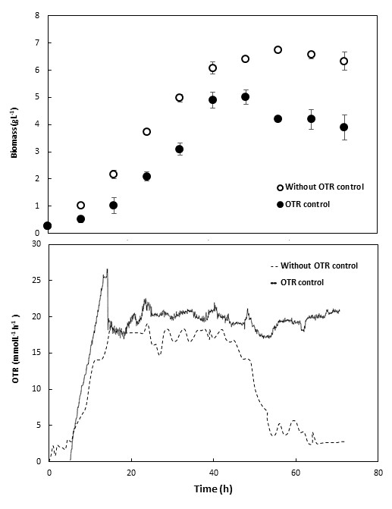  Figure 1. Biomass and OTR evolution in A. vinelandii cultures carried out in 3-L bioreactor. | 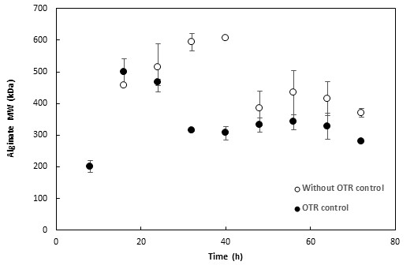  OTR condition µ (h⁻¹ ) Y_{x/s} (g g⁻¹) Y _{Alginate/x} (g g⁻¹) Alginate _{máx} (g L⁻¹)  Without OTR control 0.12 ±0.01 0.31 ±0.03 0.28 ±0.03 2.88 ±0.10 (56 h)  OTR control 0.17 ±0.02 0.16 ±0.02 1.14 ±0.18 5.34 ±0.13 (64 h )  Figure 2. Alginate molecular weight evolution under OTR control and without controlling OTR in 3-L bioreactor.  Table 1. Comparison of specific cell growth rate, biomass yield on sucrose (Y_{x/s}), alginate yield on biomass (Y _{p/x}), and maximum alginate concentration.
Figure 2 shows that the OTR control affected the production and the molecular weight of alginate. In the culture with control of the OTR, the alginate MW during the stationary phase of growth was constant (300 kDa). It is possible that changes in genes involved in alginate polymerization and depolymerization could be affected by variation in the OTR during stationary phase. A higher alginate production under OTR controlled was obtained (Table 1).
4. Conclusions
The strategy implemented for controlling the oxygen transfer rate in A. vinelandii cultures is useful for maintain constant the molecular weight of alginate during the stationary phase of growth. The OTR control could be used in order to produce alginates with particular characteristics.

References
- Hay, I., Rehman, Z., Moradali, MF., Wang, Y., Rehm, BHA. Microbial alginate production, modification and its applications. Microb. Biotechnol. 6 (2013) 637–650.
- Díaz-Barrera, A., Gutiérrez, J., Martínez, F., Altamirano, C. Production of alginate by Azotobacter vinelandii grown at two bioreactor scales under oxygen-limited conditions. Bioprocess Biosyst. Eng. 37 (2014) 1133–1140.

