Flow Cytometry as a Versatile Tool for Monitoring Biomass Agglomerates.
Lukas Veiter^{1,2} and Christoph Herwig*^{1,2}
¹CD Laboratory on Mechanistic and Physiological Methods for Improved Bioprocesses, TU Wien, Gumpendorferstrasse 1a/166, 1060 Vienna, Austria; ²Research Area Biochemical Engineering, Institute for Chemical, Environmental and Biological Engineering, TU Wien, Gumpendorferstrasse 1a/166, 1060 Vienna, Austria
*Corresponding author: christoph.herwig@tuwien.ac.at

Highlights
- Fast and reliable method to characterize biomass agglomerates via flow cytometry
- Insights into morphology and viability of biomass agglomerates
- Method successfully tested on filamentous fungi and yeast

1. Introduction
Process performance, process control strategies and productivity in bioprocesses highly depend on morphological elements of the biomass and therefore calls for a segregated view of biomass. This especially concerns filamentous bioreactor cultivations, where the morphology of the fungi is dependent on process conditions and tightly interlinked with productivity. Filamentous fungi show a large variety of morphological forms in submerged cultures, from dispersed hyphae to denser hyphal aggregates, the so-called pellets. Certain characteristics of morphology are favourable and need to be quantified. However, most common methods to characterise morphology are time consuming and mainly involve some form of image analysis based on microscopy.
In my talk, I will introduce an alternative, reliable and fast method based on flow cytometry for at-line and/or future on-line application. New insights into fungal morphology and viability enable at-line use in production environments, where timely assessment of viable biomass characteristics is of prime importance. Finally, I will show that our measurement principles are also applicable to other agglomeration forming organisms such as yeast, making our method a powerful and versatile tool to characterize biomass agglomerates.
2. Methods
This at-line method employs fluorescent staining of biomass and a high-end flow cytometer equipped with an image-in-flow camera feature. So far, Pichia pastoris biomass agglomerates and filamentous fungi were extensively characterised.

3. Results and discussion

Distinction between morphological classes is based on Flow Cytometry forward-scatter signals (FWS) and sample length, verifiable via microscopy and an integrated camera.
The use of fluorescent stains enables determination of viability in complex biomass agglomerates. Fluorescein diacetate (FDA) measures enzymatic activity producing green fluorescence. Thereby viable cells are detected. Propidium iodide (PI) is a DNA stain not permeant to live cells, dead cells are detected via red fluorescence. As an example, detailed morphological characterization as well as estimation of viability in yeast agglomerates are depicted in Figure 1.

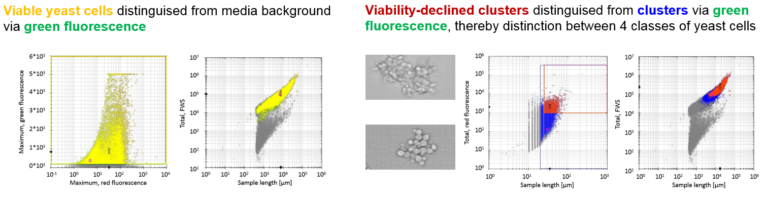
Figure 1. Distinction of yeast cells through employment of fluorescent staining, detection of media background (left) and viability-declined clusters (right)

4. Conclusions
The method’s capabilities encompass discrimination of cells in turbid media and further analysis of biomass morphology. Furthermore, viability of various morphological classes can be determined including identification of viable biomass sections within agglomerates.
Analysis of agglomerates in different organisms presently includes agglomerates in glycol-engineered P. pastoris strains, viability-declined P. pastoris clusters distinguished from viable agglomerates and morphological classification of filamentous fungi.

References
Ehgartner et al. (2017) Morphological analysis of the filamentous fungus Penicillium chrysogenum. Appl Microbiol Biotechnol:1-14 doi:10.1007/s00253-017-8475-2

Pekarsky, Veiter et al. (2018) Production of a recombinant peroxidase in different glyco-engineered Pichia pastoris strains: a morphological and physiological comparison. Microb Cell Fact:17(1) doi:10.1186/s12934-018-1032-6

