Viability, growth and hydrogen production of green microalgae in novel silica hydrogels
S. V. Homburg¹, O. Kruse², A. V. Patel^{1*}
1 Bielefeld University of Applied Sciences, Interaktion 1, 33619 Bielefeld, Germany;
2 Bielefeld University, Universitätsstraße 25, 33615 Bielefeld, Germany
*Corresponding author: anant.patel@fh-bielefeld.de
Highlights
- pH adjustment with Tris resulted in short gelation times and transparent silica hydrogels
- Investigated hydrogels exhibit a 10 times lower stiffness than those in previous reports
- Entrapped microalga C. reinhardtii maintained photosynthetic activity and growth
- In silica lenses entrapped cells produced hydrogen with an effectiveness of nearly 70%

1. Introduction
Immobilization of microalgae via entrapment provides protection against shear forces and contaminations. Potential applications are the continuous production of biohydrogen or secreted high-value products with a molecular tool kit [1]. In contrast to biopolymer gels, silica gels show an improved mechanical and chemical stability. Besides, they resist microbial attacks and are optically transparent which is crucial for photosynthetically active cells.
Following up on previous work [2], we developed novel biocompatible entrapment methods for sensitive hydrogen producing Chlamydomonas reinhardtii strains, based on three silica precursors, namely tetraethylorthosilicate, sodium silicate and tetra(n-propylamino)silane. Therefore, we aimed at improved viability and growth in transparent silica hydrogels by modification of the synthesis through adjustment of the pH with buffers and shortening gelation time. Furthermore, we examined if the entrapped microalgal cells produce hydrogen.
2. Methods
Silica gels and calcium alginate gels were prepared as described in [3]. Briefly, after dilution of precursors tetraethylorthosilicate (TEOS), sodium trisilicate solution and tetra(n-propylamino)silane by-products were removed via evaporation or ion exchanger. For gelation, the pH of the sol was adjusted with KOH, K₂HPO₄ or Tris. Calcium alginate gels as reference were prepared by gelling a 2 wt% sodium alginate solution with 2 wt% CaCl₂ solution.
Stiffness was measured from cylindrical blocks via dynamic mechanical analysis collecting the stress-strain curves at room temperature via compression.
Microalgal growth was determined in hydrogel blocks in cuvettes, overlaid with medium. Changes in the optical density at 750 nm were observed daily with a UV/vis-spectrophotometer. Hydrogen production was investigated with cells entrapped in low-sodium silica lenses and compared to free cells and cells entrapped in calcium alginate beads. Therefore, cultivation was conducted in gas-tight vials at 30 °C and 350 µE in sulfur-depleted medium. Daily, the composition of the gas phase was measured via GC and afterwards flushed with nitrogen.
3. Results and discussion
When KOH was replaced with the buffer substance Tris, gelation times were maintained at 100-150 min for the three sols. Furthermore, absorption at 750 nm decreased by 18-72%. Elevation of precursor concentrations decreased gelation time to 2-3 min.
Stiffness differed between the silica hydrogels, namely 4.23 ± 0.72 kPa for low-ethanol, 0.90 ± 0.19 kPa for low-sodium and 0.04 ± 0.002 kPa for low-propylamine silica hydrogels. In comparison, calcium alginate displayed a stiffness of 0.64 ± 0.17 kPa.
Growth in gel blocks was observed with rates of 0.39 ± 0.02 d⁻¹, 0.25 ± 0.03 d⁻¹ and 0.23 ± 0.01 d⁻¹ for free cells, cells entrapped in calcium alginate and in all silica hydrogels, respectively (figure 1 A). Increased growth rates in silica gels may be attributed to the low stiffness.
Based on further investigations on growth and photosynthetic activity of cells entrapped in silica lenses (data not shown), the low-sodium gel was selected for examination of hydrogen production. The biocatalyst reached an operative effectiveness factor of 69.20 ± 6.35% when compared to a suspension culture with the same OD of 0.8 (figure 1 B).
A | 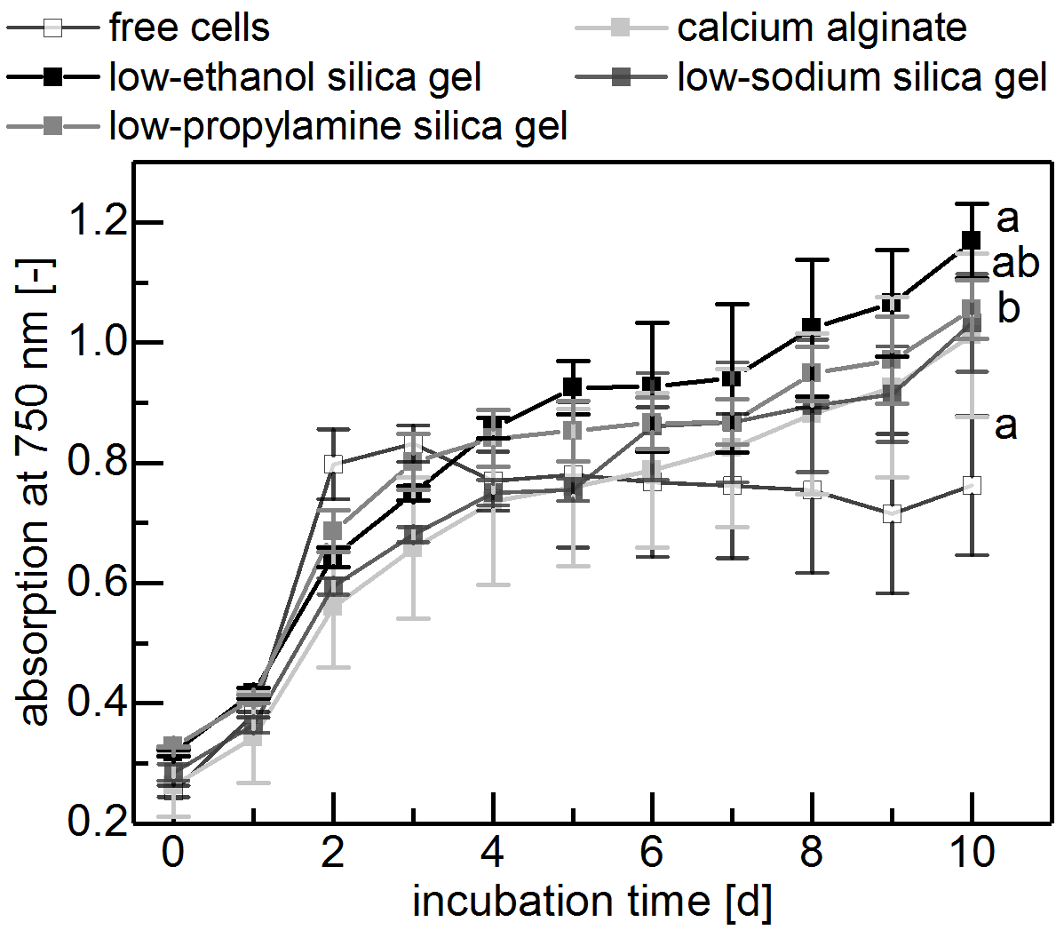 | B | 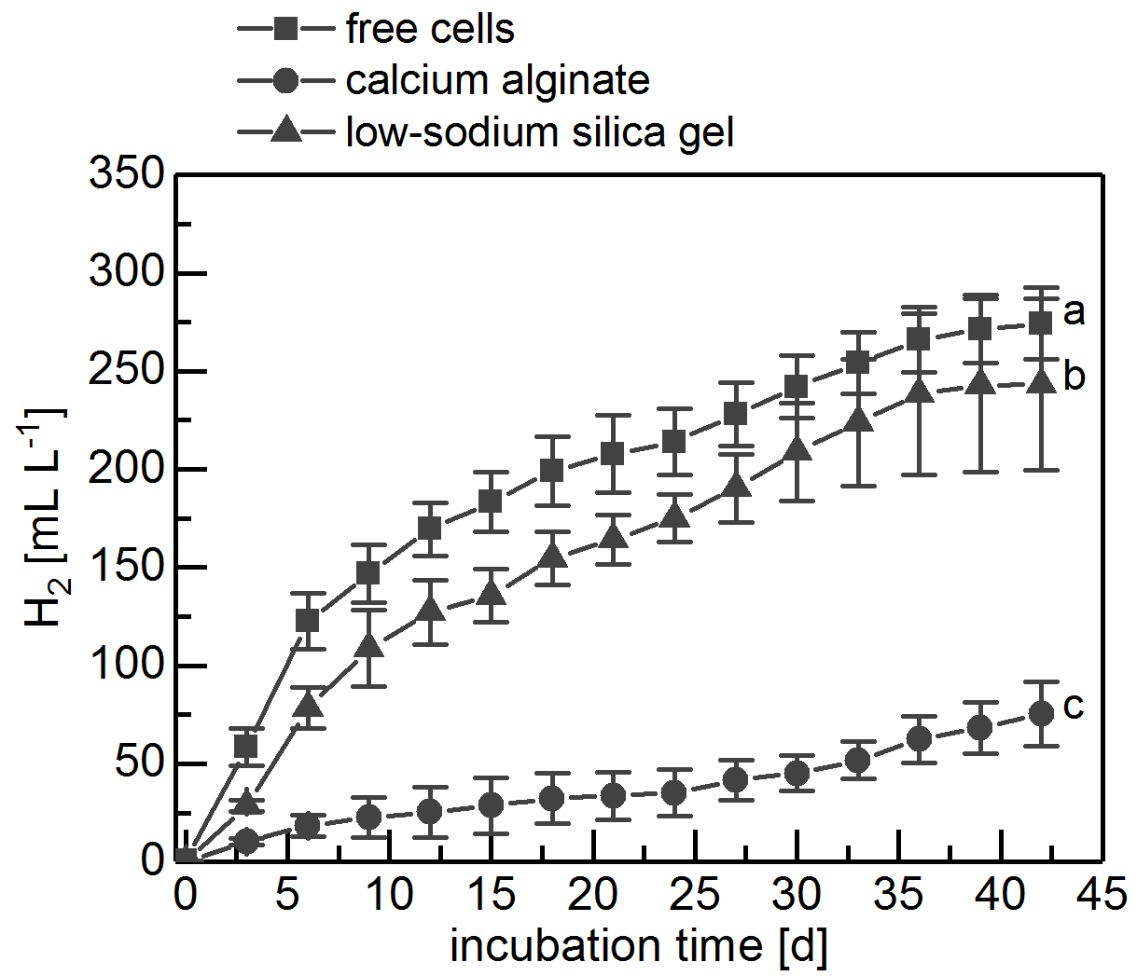
Figure 1. (A) Growth and (B) hydrogen yield of free and entrapped cells (n=5; mean±SD).
4. Conclusions
To the best of our knowledge, this is the first report of entrapment in silica gels that allow cell growth. Furthermore, we reported hydrogen production in lens-shaped particles for the first time. This entrapment method paves the way for transparent silica-gel based biocatalysts that support cell growth and protection against harmful mechanical, biological and/or chemical influences in continuous processes.
References
- Lauersen et al, App. Microbiol. Biotechnol., 99 (2015), 3491-3503
- Müller et al., Chem. Comm., 49 (2013), 10163-10165
- Homburg et al., Colloids Surf. B, 173 (2019), 233-241

