Model development for the gasification of olive mill solid waste.
Janett Ruiz^{1,2,*}, Gaëlle Ducom² , Jean-Philippe Tagutchou³ , Jaques Méhu^{2,3} , Marc Clausse¹
1 Univ Lyon, CNRS, INSA-Lyon, Université Lyon 1, CETHIL, UMR5008, F-69621 Villeurbanne, France
2 Univ Lyon, INSA-Lyon, DEEP, EA7429, 20 avenue Albert Einstein, F-69621 Villeurbanne, France
3 PROVADEMSE, 66 Boulevard Niels Bohr, F-69100 Villeurbanne, France
*Corresponding author: janett-bianca.ruiz-sanchez@insa-lyon.fr
Highlights
- Experimental results on olive mill solid waste gasification.
- Development of a 1D steady state stratified model.
- Validation and parametric study performed.

1. Introduction
Gasification is a promising waste-to-energy technique for waste or solid residues from biomass.
In olive-oil producing countries, large amounts of waste material are generated as by-products for which there is no ready use and which may have a negative value because of the cost of disposal. In this case, waste treatment technologies aimed at energy recovery such as gasification represent an interesting option [1].
In the gasification process, the fuel undergoes thermochemical transformations aiming to produce syngas. However, despite major economic, industrial and scientific interests associated with the development of gasification, several technological issues linked to the understanding of the involved mechanisms (chemical reactions, coupled heat and mass transfers, mechanical phenomena, etc.) continue to hinder the development of gasification process [2]. Therefore, a specific model must be developed for each type of fuel.
The objective of this paper is to provide a reliable numerical fixed-bed gasification model for olive mill solid waste, taking into account the thermochemical and fluid flow phenomena that occur during waste gasification process. The model is validated with experimental data of olive mill solid waste gasification.
2. Experiments
Experimental set up consists of a 100 kW downdraft gasifier equipped with temperature, pressure sensors, air flow controllers and syngas analyzer (figure 1).
For this study, an olive mill solid residue was collected from a two-phase extraction process industrial plant located in Spain. The residues were dried on the facility, further extracted with hexane to recover residual oil contents, and then pelletized. The main characteristics of the residue are given in Table 1.

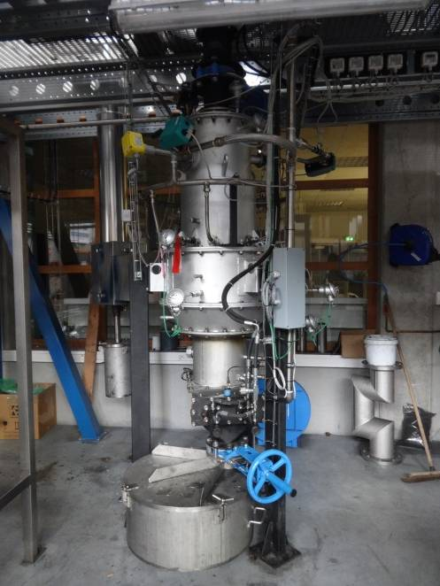
Figure 1. Downdraft gasifier.
Volatile matter (% w/w of DM) | 73.5
Fixed carbon (% w/w of DM) | 17.6
Ash (% w/w of DM) | 8.9
C (% w/w of DM) | 48.4
H (% w/w of DM) | 6.0
O (% w/w of DM) | 34.9
N (% w/w of DM) | 1.5
Cl (mg/kg_{DM}) | 2000
S (mg/kg_{DM}) | 1250
Higher heating value (MJ/kg_{DM}) | 19.7
Extractives (% w/w of DM) | 47.3
Cellulose (% w/w of DM) | 24.8
Hemicellulose (% w/w of DM) | 14.5
Lignin (% w/w of DM) | 13.4
Table 1. Proximate and ultimate analysis, higher heating value and fiber analysis of olive mill solid waste (taken from [3]), DM = dry matter.

3. Model
A 1D steady state stratified model of the gasifier was developed, assuming local thermal equilibrium. The gasifier was divided into four zones: fuel drying, pyrolysis, oxidation and chemical reduction. The following phenomena were taken into account: chemical reactions with solid/gas, heat and mass transfers. For pressure drop calculation, particle shrinkage was also considered. COMSOL Multiphysics® was used to solve the set of equations.
4. Results and discussion
The model was validated thanks to experimental data. Predictions of the temperature profile, pressure drop and syngas composition are in good accordance with experimental values. The influence of operating conditions (relative fuel air ratio, particle diameter, zone length) on producer gas composition was also investigated. The optimal fuel air ratio was identified.
5. Conclusions
A reliable model for olive mill solid waste gasification was developed and validated. Further improvements will consist in taking into account other mechanical phenomena (e.g. channeling). To achieve this objective, a 2D dynamic approach will be taken.
Acknowledgements
This study is part of the research program ECoGaz, aiming to contribute to the development of waste as an alternative fuel for energy production. The authors wish to thank the Auvergne-Rhône-Alpes Region for the financial support.
References
- A.C. Caputo, F. Scacchia, P.M. Pelagagge, Appl. Therm. Eng. 23 (2003) 197–214.
- M. La Villetta, M. Costa, N. Massarotti, Renew. Sustain. Energy Rev. 74 (2017) 71–88.
- G. Ducom, M. Gautier, M. Pietraccini, J.P. Tagutchou, D. Lebouil, R. Gourdon, Renew. Energy 145 (2020) 180–189.

