Analysis of Hydrogen Supply Chains for Swiss Mobility
Cristina Antonini¹, Annalisa Guidolin¹, Paolo Gabrielli¹, Marco Mazzotti^{1*}
1 Institute of Process Engineering, ETH Zurich, Sonneggstrasse 3, 8092 Zurich, Switzerland
*Corresponding author: marco.mazzotti@ipe.mavt.ethz.ch
Highlights
- Blue hydrogen production technologies
- Biogas and natural gas reforming with carbon capture
- Swiss blue hydrogen network

1. Introduction
Most recent climate scenarios from integrated assessment models (IAMs) assessed that to reach the 2°C target in 2100 the amount of CO₂ removal required is in the order of several gigatonnes per year (Gt/a) [1][2]. In Switzerland, one third of the carbon dioxide emissions derives from the transport sector, and corresponds to 16.2 Mt_{CO2} in 2016. Considering the abundance of fossil fuels, low-carbon hydrogen production from natural gas and biogas, coupled with carbon capture and storage, seems a promising solution for reducing the emissions of the mobility sector. This type of hydrogen is the so called blue-hydrogen, and it opposes to green-hydrogen from electrolysis.
The design of a blue-hydrogen supply chain in Switzerland requires models that describe the conversion and capture technologies considered. Therefore, the goal of this work is to model the technologies with the required level of details and introduced them in the supply chain model, which should deliver an optimized configuration of a potential hydrogen network in Switzerland. The selected blue hydrogen production processes are reforming of natural gas and biogas. For CO₂ capture, absorption with methyl diethanolamine is considered as reference technology and the novel in house studied adsorption process, vacuum pressure swing adsorption (VPSA), is considered for comparison. As reference, the production of green hydrogen via electrolysis is considered. The Swiss distribution network is optimized for different criteria, where both carbon dioxide emissions and costs are considered.
2. Methods
The hydrogen production as well as the amine carbon capture process are modelled in Aspen Plus®, the adsorption processes are modelled with an in-house simulation tool. The models in Aspen Plus® are built with a step-wise approach; firstly, the key process variables are identified. Secondly, multi parameters sensitivity analysis are performed to better understand the nature of the interaction among the operation variables. Lastly, mathematical optimization is used as a tool to fine-tune the operating conditions of the process. Those models are subsequently simplified and given as input data to the supply chain problem. The geographical region of interest, in this case Switzerland, is spatially discretized and for each node a specific demand for hydrogen is given. The optimizer will define where hydrogen is produced, with which technology and at which scale. Moreover, the solution of the optimization problem will include the distribution network of hydrogen among the nodes. The Mixed Integer Linear Programming (MILP) model is built in Matlab® and solved with commercial solvers (CPLEX®, GUROBI®).
3. Results and discussion
The technologies have been studied and modelled. The complex process flowsheets have been simplified with linear relationships, easy implementable in the supply chain model. A preliminary version of the supply chain model has been prepared based on previous work done in our group [3]. The spatial discretization has been integrated into the existing model together with the operational specifications of the network. A graphical overview of this procedure is represented in Figure 1.
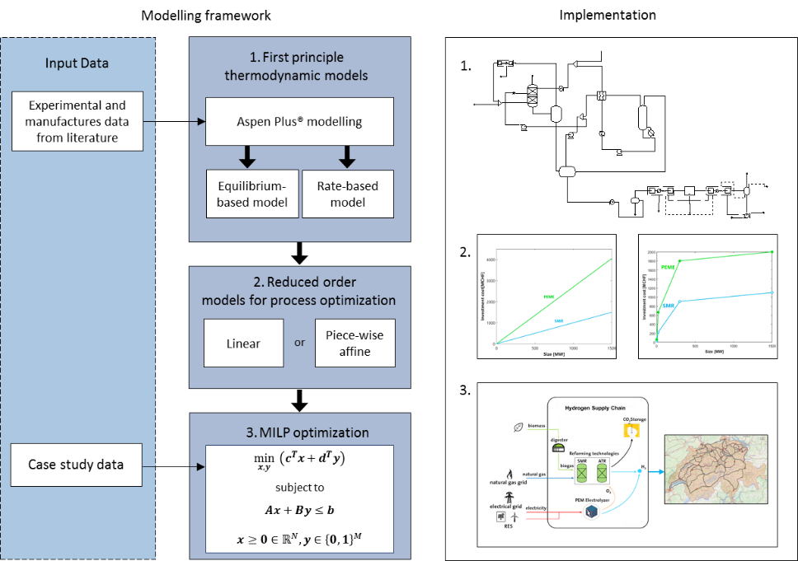
Figure 1. Overview on the modelling framework of this work.
4. Conclusions
This work will focus not only on the construction of a model suitable to shape a Swiss hydrogen network for mobility based on detailed technology descriptions; but it will also focus on the understanding of the trade off deriving from the interactions among the different players. The final goal is to make sure that all the interesting features are considered and adeguately described in the supply chain model.
Acknowledgment
ACT ELEGANCY, Project No 271498, has received funding from DETEC (CH), BMWi (DE), RVO (NL), Gassnova (NO), BEIS (UK), Gassco, Equinor and Total, and is cofunded by the European Commission under the Horizon 2020 programme, ACT Grant Agreement No 691712. This project is supported by the pilot and demonstration programme of the Swiss Federal Office of Energy (SFOE).
References
- PCC. (2014). Fifth Assessment Report.
- Smith, P. D. (2016). Biophysical and economic limits to negative CO2 emissions. Nature Climate Change, 42.
- Gabrielli, P. G. (2018). Electrochemical conversion technologies for optimal design of decentralized multi-energy systems: Modeling framework and technology assessment. Applied Energy, 557-575.

