**Mesoscale Modeling and Experimental Study of Quercetin Organization as a Nanoparticles in Poly-Lactic-Co-Glycolic Acid/Water System.**

Manel Slimane1,2, Mohamed Ghoul1,2, Latifa Chebil1,2

*1 CNRS, Laboratoire Réactions et Génie des Procédés, UMR 7274, 2 avenue de la forêt de Haye, TSA 40602, Vandœuvre-lès-Nancy F-54518, France*

*2 Université de Lorraine, LRGP, UMR 7274, 2 avenue de la forêt de Haye, TSA 40602, Vandœuvre-lès-Nancy F-54518, France*

*\*Corresponding author: latifa.chebil@univ-lorraine.fr*

**Highlights**

* Nanoparticles size is affected by the concentration of the different compounds of the system.
* Quercetin is encapsulated by poly-lactic-co-glycolic acid.
* Experimental investigations are in a good agreement with simulated ones.

**1. Introduction**

Quercetin (2-(3, 4-dihydrohyphenyl)-3, 5, 7-trihydroxy-4H-1-benzopyran-4-one) is a flavonoid widely distributed in plant kingdom. Quercetin has been reported to be an antioxidant and which is known for its anti-carcinogenic effect, antibacterial, anti- antihypertensive and anti-inflammatory properties [1]. Nevertheless, the solubility of quercetin in water and many organic solvents is very weak (<0.01 (g/L)) [2, 3]. Many strategies were developed to improve its solubility and stability by physicochemical approaches [4]. In this work, MesoDyn simulations were used to study the quercetin organization as a nanoparticles in poly-lactic-co-glycolic acid/water system. Results obtained from simulations were compared to experimental data. The effect of the concentrations of quercetin, PLGA, PVA (polyvinyl alcohol) and the lactic acid: glycolic acid ratio on the aggregation phenomena was studied.

**2. Methods**

*2.1. Study of quercetin organization as a nanoparticles in poly-lactic-co-glycolic acid/water system by MesoDyn:* in the MesoDyn method, the molecules are defined on a coarse-grained level as “Gaussian chains of beads”. Each bead is of a certain component type representing covalently bonded groups of atoms (Figure 1). The solubility parameter-dependent method was used to calculate the Flory Huggins (χij) parameter depending on the Hildebrand solubility of the different compounds. The interaction parameters that were used in the MesoDyn simulations were calculated using χij. The aggregation and phase separation behavior of different beads was followed by the order parameter, P. P is a time dependent parameter obtained as an output of the MesoDyn simulation.

*2.2. Nanoparticles preparation and characterization:* PLGA nanoparticles loaded with quercetin were prepared by the solvent displacement method. The mean particle diameter and polydispersity index (PI) of the nanoparticles were determined by dynamic light scattering. The morphology of the PLGA-Q nanoparticles was examined by transmission electron microscopy.



**Figure 1.** Coarse-grained model: molecules and monomer conversion into beads for Quercetin (Q), Poly (Lactic-co-Glycolic acid) (PLGA), Polyvinyl alcohol (PVA) and Water (W).

**3. Results and discussion**

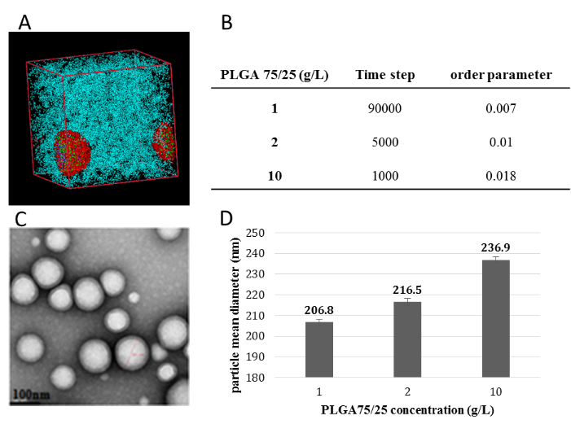Mesoscale simulations indicated that the studied systems allowed to produce nanoparticles well distributed in the continuous medium (water). The rapidity of the formation of nanoparticles is affected by the composition of the system. The fast kinetic of nanoparticle formation is reached with 10 g/L of poly-lactic-co-glycolic acid, 0.5 g/L of quercetin and 0.5% of polyvinyl alcohol. The increasing poly-lactic-co-glycolic acid and quercetin concentrations and LA content in poly-lactic-co-glycolic acid favor the formation of nanoparticles with large size. The formed nanoparticles were composed by quercetin (Q1 and Q2 parts) in the center of the system, poly-lactic-co-glycolic acid (lactic acid and glycolic acid) as a second layer and polyvinyl alcohol as third layer. The water is the continuous phase. The shape and the organization order of nanoparticles were checked experimentally. The obtained results showed that experimental investigations are in a good agreement with simulated ones (Figure 2).

**Figure 2.** Main results obtained from mesoscale simulations (A, B) and experimental data (C, D).

**4. Conclusions**

Computational mesoscopic modeling approach can be used as a successful tool to understand and predict the behavior of quercetin/poly-lactic-co-glycolic acid/water systems under different operating conditions.

**References**

1. C. Chen, J. Zhou, C.Y. Ji, Life Sci. 87 (2010) 333-338.
2. L. Chebil, C. Chipot, F. Archambault, C. Humeau, J.M. Engasser, M. Ghoul, F. Dehez, J. Phys. Chem. B. 114 (2010) 12308-12313.
3. M. Slimane, M. Ghoul, L. Chebil, Ind. Eng. Chem. Res. 57 (2018) 12519-12530.
4. P. Calias, T. Galanopoulos, M. Maxwell, A. Khayat, D. Graves, H.N. Antoniades, M. D’Alarcao, Carbohyd. Res. 292 (1996) 83-90.