Experimental study and CFD simulation of thermal energy storage (TES) in a pilot scale packed-bed
Philippe Béard¹, Ludovic Noël¹, Pierre Balz¹, Sofiane Bekhti¹, Guillaume Vinay², David Teixeira²
1 IFP Energies nouvelles, Etablissement de Lyon, BP 3, 69360 Solaize, France
2 IFP Energies nouvelles, 1 & 4 avenue de Bois-Préau, 92852 Rueil-Malmaison cedex, France
*Corresponding author: philippe.beard@ifpen.fr
Highlights
- Experiments and transient CFD modelling of TES during a full cycle.
- Influence of physical properties variations with temperature.
- Good agreement between experimental and numerical results.

1. Introduction
Compressed air energy storage exists since 1978 in the form of improved gas power-plant with an energy efficiency of only 50 %. In these older Compressed Air Energy System (CAES), heat produced by the compression is lost. A more advanced concept, AA-CAES (Advanced Adiabatic CAES), has the advantage of storing the heat of compression and achieving a much higher efficiency. IFPEN proposes a system (Figure 1) based partly on already existing components such as compressors and turbines but also on new components such as Thermal Energy Storage (TES) systems. The load is achieved by air compression and heat storage. Electricity production is realized through a turbine in which the compressed air is expanded after being reheated in TES.
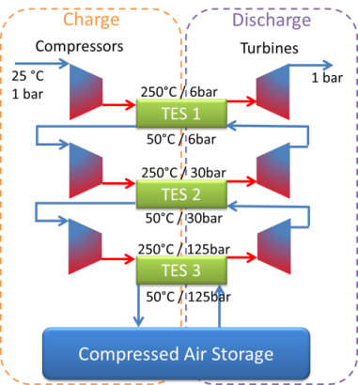
Figure 1. AA-CAES principle.
In recent years, due to the development of AA-CAES and of Concentrated Solar Power (CSP) in particular, sensible heat storage in packed beds has received much interest [1,2].
2. Methods
Complete TES cycles were studied in an insulated glass tank (diameter 0.3 m) filled with uniform 10 mm concrete beads (Figure 2) and equipped with 26 thermocouples to map the temperature.
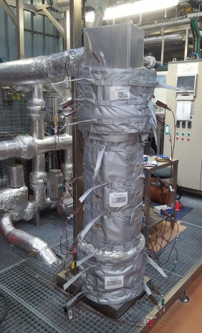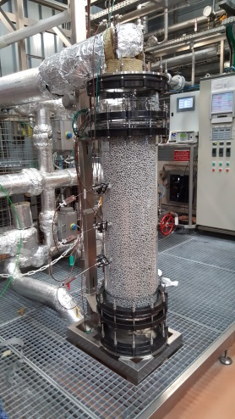
Figure 2. Experimental TES test rig with and w/o insulation.
CFD (Computational Fluid Dynamics) calculations were performed with ANSYS® Fluent® using a non-equilibrium thermal model in the porous bed zone. The sensitivity to physical properties was investigated as few data are available for concrete at high temperatures [3]. The beads specific heat was measured within the considered temperature range (15-250 °C).
3. Results and discussion
The temporal evolution of the temperature in the bed during the different phases of the cycle is well predicted, in particular along the axis (Figure 3). It was shown that the most influencing property is the specific heat and that an accurate description of the insulation is required.
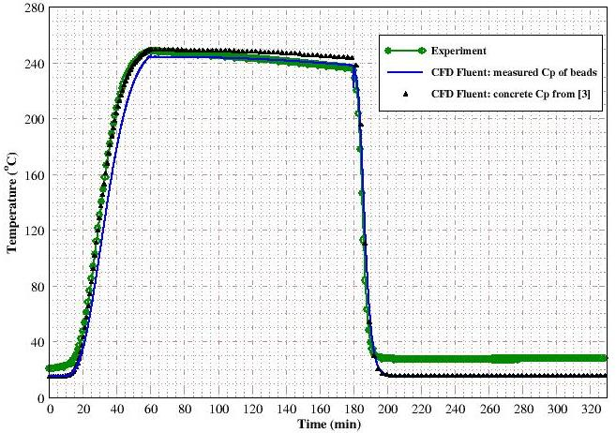
Figure 3. Comparison between experimental and numerical results on the bed axis during a full cycle.
4. Conclusions
The agreement between measured and numerical results during a full TES cycle is quite good. Those results will be assessed in a larger experimental set-up in the near future prior to be able to design industrial systems.
References
- G. Zanganeh, A. Pedretti, S. Zavattoni, M. Barbato, A. Steinfeld, Solar Energy 86 (2012) 3084-3098.
- M. Cascetta, G. Cau, P. Puddu, F. Serra, Aplied Thermal Engineering 98 (2016) 1263–1272.
- J. Pan, R. Zou, F. Jin, Energies 10, 33 (2017).

