Impact of Additives on Mass Transfer in Gas/liquid/liquid Systems
Marc Petold¹, Nona Afraz², Kristin Hecht², Lutz Böhm¹, Matthias Kraume¹
1 Technische Universität Berlin, Chair of Chemical and Process Engineering, Ackerstraße 76, 13355 Berlin, Germany; 2 Otto-von-Guericke Universität Magdeburg, Institute of Instrumental and Environmental Technology, Universitätsplatz 2, 39128 Magdeburg, Germany
*Corresponding author: m.petzold@tu-berlin.de
Highlights
- Characterization of complex behavior of micellar solvent systems and Pickering emulsions
- Influence of phase behavior on the mass transfer in innovative solvent systems
- Quantification of the effect of coverage and drop sizes on the transfer process

1. Introduction
Homogenously catalyzed reactions in multiphase systems, as they are used for example in the Ruhrchemie/Rhône-Poulenc process, offer a promising approach to produce base chemicals from renewable resources. The organic and gaseous educts react with the catalyst, which is designed to be soluble in water to provide a good separation from the likewise organic products. In the resulting gas/liquid/liquid systems, the reaction is controlled through interfacial and transport phenomena. These processes fail for long chained Olefins – e.g. vegetable oils and fats - because of their low solubility in water. Surfactants or nanoparticles can be added as emulsifier to form innovative solvent systems – micellar solvent systems (MSS)[1] or Pickering emulsions (PE)[2] respectively – and increase reaction speed [3,4] and phase separation [5]. The additives adsorb at the interface, increase the mass transfer area but add an additional mass transfer resistance. Furthermore, MSS form up to three liquid phases, depending on temperature and composition, whereas one phase is always a microemulsion. In consequence, the mass transfer in these systems is complex. This work focuses on the quantification of the impact of additives on the mass transfer in these innovative solvent systems.
2. Methods
For simplification reasons, measurements were conducted focusing on the non-reactive system consisting of long chained oils and water with either a non-ionic surfactant or silica nanoparticles. The Gas/liquid mass transfer was measured in a pressurized stirred tank reactor for several temperatures and compositions. Using the dynamic pressure method [6] the k_{L}a values could be determined. The phase behavior of the MSS was characterized using settling experiments and by measuring the conductivity of the emulsions. To determine the interaction of the disperse phases in the stirred reactor, drop and bubble sizes were recorded using optical endoscope measurements [7]. Influence of occurring liquid/liquid mass transfer could be determined with single rising drop experiments [8]. A high speed camera was used to record the fluid dynamics of the drops. A tracer component was added and the drops were collected at different heights to analyze the mass transfer.
3. Results and discussion
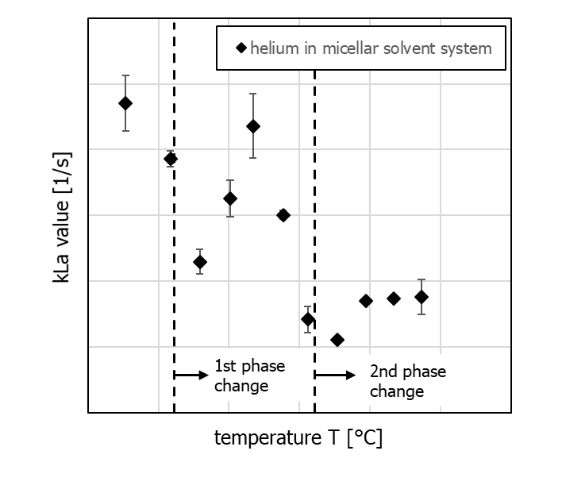
For the gas/liquid mass transfer, the k_{L}a values rose with temperature in pure liquids but experienced a sudden change upon adding small amounts of a liquid dispersed phase. Depending on the formation of a water-in-oil or oil-in-water emulsion, the k_{L}a experienced an increase or decrease, respectively. The change can be credited to the interaction of bubbles and drops. In MSS the mass transfer is up to two times faster. With rising temperature, a first decreases happens and is followed by a mass transfer acceleration and another decrease. For higher surfactant concentrations, a third region with constant k_{L}a follows (see Fig. 1). The behaviour can be credited to the phase behaviour of MSS, where the continuous phase changes with temperature from aqueous to bicontinuous microemulsion to organic phase.
Figure 1. k_{L}a value of micellar solvent system for different temperatures
Liquid/liquid mass transfer showed strong reduction due to interfacial coverage in both solvent systems, partly even falling below the expected results of a fully covered drop.
4. Conclusions
Phase behavior as well as drop and bubble interactions and coverage play an important role for the gas/liquid mass transfer in a stirred system with several dispersed phases. Both effects can significantly change the mass transfer and therefore reaction rates.
References
- M. Kahlweit, R. Strey, Angew. Chem. Int. Ed. Engl. 24 (1985), 654-668.
- S. U. Pickering, J. Chem. Soc. Trans. 91 (1907), 2001-2021.
- T. Pogrzeba, M. Schmidt, N. Milojevic, C. Urban, M. Illner, J.-U. Repke, R. Schomäcker, Ind. Eng. Chem. Res. 56 (2017), 9934-9941.
- R. v. Klitzing, D. Stehl, T. Pogrzeba, R. Schomäcker, R. Minullina, A. Panchal, S. Konnova, R. Fakhrullin, J. Koetz, H. Möhwald, Y. Lvov, Adv. Mater. Interface 4 (2017).
- L. Hohl, M. Knossalla, M. Kraume, Chem. Eng. Sci. 171 (2017), 76-87.
- A. Lekhal, R. V. Chaudhari, A. M. Wilhelm, H. Delmas, Chem. Eng. Sci. 52 (1997), 4069-4077.
- S. Maaß, N. Paul, M. Kraume, Chem. Eng. Sci. 76 (2012), 140-153.
- M. Wegener, N. Paul, M. Kraume, Int. J. Heat Mass Transfer 71 (2014), 475-495.

