Simulation of a two-stage membrane system for the recovery of hydrogen from a flue gas stream
Fernando Pardo*, Gabriel Zarca, Ane Urtiaga
Department of Chemical and Biomolecular Engineering, University of Cantabria,
Av. de Los Castros s/n. Santander 39005, Spain
*Corresponding author: pardof@unican.es
Highlights
- Efficiency of the overall process was evaluated in terms of H₂ purity and recovery.
- Operation conditions can be optimized towards H₂ purity or H₂ recovery.
- Maximum H₂ purity of 95% could be achieved at feed gas pressure of 12 bar.
- Maximum recovery of 83% could be achieved at feed gas pressure of 12 bar.
1. Introduction
Given the current global context of progressive depletion of fossil fuels and increasing environmental concerns for global warming, research efforts towards shifting from a linear production model to a circular economy model are a priority. In this sense, industrial processes must look for a better efficiency of resource use and waste management, not only to minimize their environmental impact, but also to increase the competitiveness of the productive process. In particular, this study is focused on the valorization of the flue gas generated in carbon black manufacturing. Considerable amounts of hydrogen (up to 20% vol on dry basis) can be found in this type of gaseous stream [1], thus its recovery could provide a competitive advantage towards a more sustainable production. In this sense, membrane technology offers a cost-effective alternative over other separation technologies such as cryogenic distillation and pressure swing adsorption. There is extensive knowledge in the use of H₂ selective materials for hydrogen recovery from ammonia purge gas, syngas ratio adjustment or H₂ recovery in the steam methane reforming process. Nevertheless, available data for the material valorization of tail gas from the carbon black manufacturing process is scarce. Therefore, the novelty of this work focuses its attention on the simulation of a two-stage membrane process with recirculation (Figure 1) to improve both material and energy management of the carbon black manufacturing process. The effect of critical variables such as feed pressure, permeation area and type of polymeric material on the effectiveness of the overall process, evaluated in terms of H₂ purity in the permeate stream and H₂ recovery, is assessed.
2. Methods
The tail gas data composition considered in this work corresponds to reference values included in the Best Available Techniques for the manufacture of carbon black [1]: water vapor (30–50%), N₂ (30–50%), H₂ (7–14%), CO (6–12%), CO₂ (1–5%) and CH₄ (0.1-1 %), as well as traces of sulphur and nitrogen compounds. Membrane modules of polyphenylene oxide (PPO) and polyimide (PI) in hollow fiber configuration were considered [2]. Permeability values for N₂, H₂, CO, CO₂ and CH₄ gas were obtained from literature [3,4]. A mathematical model describing gas permeation through the hollow fiber membrane module has been implemented in Aspen Custom Modeler. Permeation of gases though the polymeric material are described by the solution-diffusion model [5]. This model was then exported to Aspen Plus to simulate the gas separation processes with a two stage membrane system.
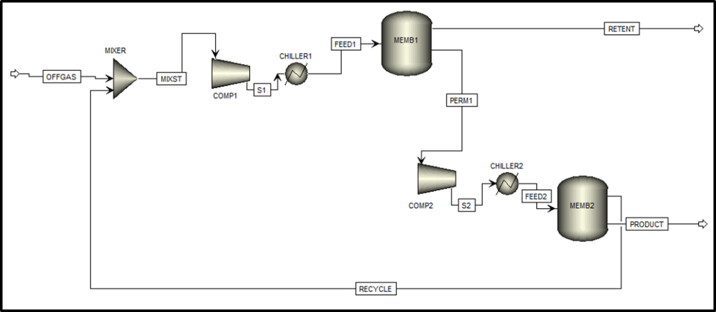
Figure 1. Configuration of the two-stage membrane process.
3. Results and discussion
According to the simulated results, 95% H₂ purity can be obtained in the product stream at a reachable feed pressure up to 12 bar using a 2-stages system consisting of two polyimide hollow fiber membrane modules. The highest hydrogen recovery (80%) was obtained when the PPO polymer was used as material for the first membranes module.
4. Conclusions
This work provides valuable data of the extent of the potential application of membrane technology for the recovery of hydrogen from a tail gas stream. Despite the limitations to deal with the trade-off between H₂ purity and recovery, the results show that polymer membrane technology can be successful for obtaining H₂ enriched streams with sufficient quality to be used in applications that do not require ultra-high purity H₂ as feedstock, such as hydrodesulphurization or hydrocracking.
Financial support from the Spanish Ministry of Economy and Competitiveness (CTM2016-75509-R and CTQ2015-66078, MINECO-AEI/FEDER) is gratefully acknowledged.
References
- European Commission, Integrated Pollution Prevention and Control, best available techniques for the manufacture of large volume inorganic chemicals – Solids and Other. August 2007.
- L. Wang, Doctoral Thesis. Cyclic Membrane Gas Separation Processes. July 2012.
- A. Alentiev, E. Drioli, M. Gokzhaev, G. Golemme, O. Ilinich, A. Lapkin, V. Volkov, Yu. Yampolskii, Journal of Membrane Science 138 (1998) 99-107.
- O. C.David, D. Gorri, K. Nijmeijer, I. Ortiz, A. Urtiaga, Journal of Membrane Science 419–420 (2012) 49–56.
- G. Zarca, A. Urtiaga, L. Biegler, I. Ortiz, Journal of Membrane Science 563 (2018) 83–92.

