Autohydrolysis of Wheat Straw for Antioxidants and Cellulosic Fiber Recovery
Andrea Bassani^{1,*}, Cecilia Fiorentini¹, Vellingiri Vadivel², Flavio Manenti³, Giorgia Spigno¹
1 Università Cattolica del Sacro Cuore, Department for Sustainable Food Process (DiSTAS), Via Emilia Parmense 84, 29122 Piacenza, Italy; 2 Centre for Advanced Research in Indian System of Medicine (CARISM), SASTRA University, Thanjavur, Tamil Nadu, India; 3 Politecnico di Milano, Department of Chemistry, Materials and Chemical Engineering, Piazza Leonardo da Vinci 32, 20133
*Corresponding author: andrea.bassani@unicatt.it
Highlights
- Autohydrolysis as suitable process for antioxidants and fibers recovery.
- Antioxidant capacity is more than twice compared to acid hydrolysis.
- Cellulose yield and recovery are 15.88% and 47.01% respectively.

1. Introduction
Wheat straw (WS) is an agricultural residue that presents many interesting characteristics that facilitate its biotechnological upgrade in a bio-refinery framework [1]. Based on the data from FAO, world annual WS production is about 577 million tons in 2016 and is supposed to be higher in the next years. Plant cell walls of wheat straw are formed with a polysaccharide network of which cellulose, hemicelluloses and pectin are the most important components [2]. The antioxidant phenolics and cellulosic fiber were conventionally separated using acid/alkaline hydrolysis [3]. However, from the environmental point of view, it is better to avoid the use of toxic chemicals, like sulfuric acid. For these reason, autohydrolysis process is gaining more attention nowadays and was already tested to recover bound phenols from grape stalks [4]. Hence, in the present study an environmental friendly autohydrolytic process was applied for the recovery of both antioxidants and cellulosic fiber in a single process from wheat straw. The cellulose and antioxidant recovery were compared with the traditional process value.
2. Methods
Acid hydrolysis, alkaline hydrolysis and bleaching steps were described in-deep in our previous work [3]. On the other hand, autohydrolysis was carried out as follow. Wheat straw sample (20 g) was taken with 400 ml of distilled water in a Teflon container and placed inside of high pressure reactor that was operated at 190 ºC and 11 bar for 15 min under agitation. Then, the reactor was slowly cooled down at ambient temperature. The following alkaline hydrolysis and bleaching steps were the same as in the traditional process [3]. The solid recovered was weighed to calculate the cellulose residue yield while the liquid, coming from autohydrolysis reaction, was used for the analysis of antioxidant capacity using ABTS analytical method [3]. Finally, the structural carbohydrates including total reducing sugars, acid soluble and insoluble lignins, glucose, xylose and acetic acid were investigated in the cellulose residue obtained from autohydrolysis [5].
3. Results and discussion
The obtained results are reported in Figure 1. The ABTS inhibition capacity of WS autohydrolyzed liquid is very high when compared to acid hydrolysis liquid, because in the acid hydrolyzed liquid achieved only 40% AOP at 1200 mg GAE/L concentration, whereas WS autohydrolyzed liquid has exhibited 94% AOP at 766 mg GAE/L concentration and thereafter the antioxidant activity attained plateau. The autohydrolysis process yielded slightly lower amount of fiber residue (86%) than the acid hydrolysis process (95%). The cellulose content calculated based on glucose concentration was slightly lower in autohydrolysis process when compared to acid hydrolysis method. However, the cellulose yield (15.88%) and recovery (47.01%) of WS fiber obtained from autohydrolysis is closer to that of acid hydrolysis step. Interestingly, the hemicelluloses, acetic acid, acid soluble and acid insoluble lignins content of autohydrolyzed fiber is lower than acid hydrolyzed sample.
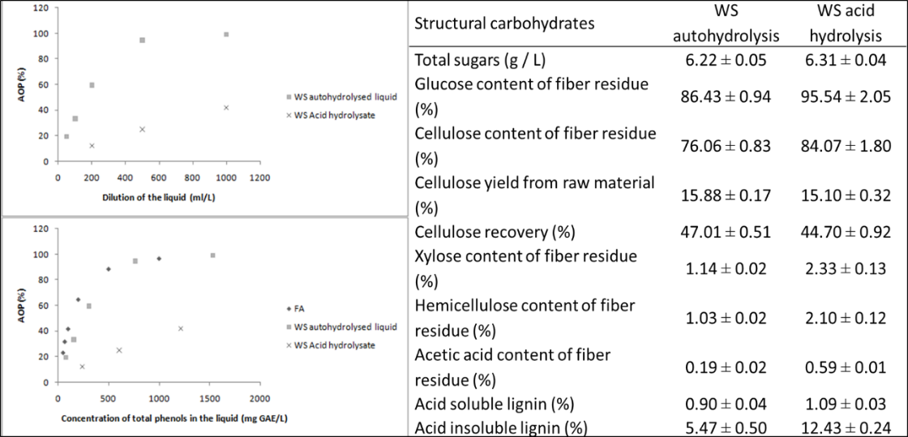
Figure 1. Comparison of AOP and structural carbohydrates of WS autohydrolysis with acid hydrolysis.
4. Conclusions
Autohydrolysis was found to be highly suitable and environmental friendly process compared to conventional acid/alkali hydrolysis process to obtain the antioxidants and fibers from WS. Future investigation on the use of these antioxidants and cellulosic fibers in the development of active and biodegradable food packaging material is necessary for the utilization of agro-food byproducts towards the enhancement of food industry.
Acknowledgments
This project has received funding from the Bio Based Industries Joint Undertaking under the European Union’s Horizon 2020 research and innovation programme under grant agreement No 792261.
References
- E. Tomas-Pejo, J. Fermoso, E. Herrador, H. Hernando, S. Jiménez-Sánchez, M. Ballesteros, D. Serrano, Fuel 199 (2017) 403-412.
- F. Carvalheiro, T. Silva-Fernandes, L. C. Duarte, F. M. Gírio, Applied biochemistry and biotechnology, 153 (1-3) (2009) 84-93.
- V. Vadivel, A. Moncalvo, R. Dordoni, G. Spigno, Waste Management 64 (2017) 305-314.
- D. Amendola, D. M. De Faveri, I. Egües, L. Serrano, J. Labidi, G. Spigno, G, Bioresource Technology 107 (2012) 267-274.
- A. Sluiter, B. Hames, R. Ruiz, C. Scarlata, J. Sluiter, D. Templeton, D. Crocker, Laboratory analytical procedure, (2010) TP-510-42618

