Influence of working parameters on mixing time values in single-use culture bag rocked in WAVETM 25 bioreactor
Maciej Pilarek¹, Kamil Wierzchowski¹
¹Warsaw University of Technology, Faculty of Chemical and Process Engineering,
Waryńskiego 1, 00-645 Warsaw, Poland
*Corresponding author: maciej.pilarek@pw.edu.pl
Highlights
- Mixing time ranged from 3s to 500s characterizes mixing efficiency in WAVETM bioreactor
- Oscillations angle and frequency robustly impacting on mixing time in WAVETM
- Influence of aqueous phase volume in culture bag is irrelevant to mixing time in WAVETM

1. Introduction
Applications of disposable bioreactors for scaling-up of in vitro bioprocesses involving fragile animal cells became common in biopharmaceutical industry. In wave-induced agitation systems, mixing is achieved by horizontal oscillation of a single-use culture bag, which is fixed in a rocker unit. An interfacial area between gas and liquid phases filing the culture bag is continuously renewed, what accomplishes gentle and bubble-free surface aeration of a culture medium [1]. Furthermore, the wave-induced agitation notably limits shear stress effects negatively influencing on shear-sensitive animal cells or aggregates of them. A mixing time is a parameter commonly used to quantify mixing efficiency, and its value represents to the time necessary to reach a defined mixing quality [2]. The mixing time values determined for various types of disposable wave-type agitated bioreactors depended on the volume of culture bag, and presets of working parameters of the rocker.
The aim of the study was to determine influence of working parameters defining wave-induced agitation, on values of the mixing time reached in 2-litre culture bag (i.e. CellbagTM 2L) oscillatingly rocked in ReadyToProcess WAVETM 25 bioreactor (GE Healthcare, USA). Based on our previously published data, i.e. [3], only the impact of aqueous phase volume inside the culture bag (V_{L}), and angle of oscillations (α), as well as their frequency (ω), were analysed and their influence on the mixing time values have been quantitatively determined. All the experiments were performed and evaluated according to DoE-standards of statistical data processing.
2. Methods
ReadyToProcess WAVETM25 bioreactor (WAVE 25) equipped with disposable, polymer-based culture bag (CellbagTM 2L; GE Healthcare, USA) with a total volume of 2 dm³ has been used as an experimental setup. The following values of the operational parameters established for the mixing time determination have been evaluated: V_{L} equalled to 0.2 dm³, 0.6 dm³ and 1.0 dm³; α equalled to 2°, 7° and 12°; as well as ω equalled to 2 min⁻¹, 21 min⁻¹, 40 min⁻¹.
The decolourisation iodometry method has been applied for determination of the mixing time in the system [4]. Prior to measurement, 2 cm³/dm³ iodine potassium iodide (40 g KI + 20 g I₂/dm³), and then 5 cm³/dm³ starch solution (10 g/dm³), were added to the constantly waving aqueous phase (37°C) inside the culture bag, to obtain the deep blue coloured aqueous phase. Next, 4 cm³/dm³ sodium thiosulfate solution (24.6 g/dm³) has been pipetted under continuous wave-type agitation, with the immediately started time measurement of the aqueous phase decolourization process. The timing was stopped when the colour change of aqueous phase from deep blue to colourless has been completely achieved.
All experiments were planned and evaluated in STATISTICA® Data Miner 13 (StatSoft Polska, PL) software. The DoE-aided analysis comprising in total 135 experiments (i.e. 27 single experiments repeated in 5 series, three levels of varied factors has been applied to statistical data processing.
3. Results and discussion
The range of experimentally measured values of the mixing time reached for the aqueous phase waving in CellbagTM 2L, which have been performed in the rocker of WAVE 25 system, i.e. from values of less than 5 s to over two orders of magnitude more (Figure 1), was consistent with previously published literature data on the mixing time determined for other single-use bags variously agitated by the other oscillating devices. Moreover, just α and ω have been identified as the working parameters which relevantly and robustly influencing on the value of the mixing time determined in the studied experimental setup of WAVE 25 bioreactor.
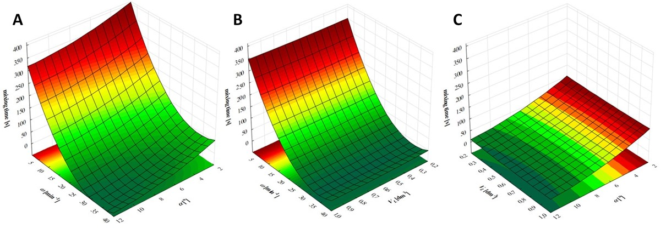
Figure 1. Response surface plots for the mixing time: the influence of α and ω (for V_{L} = 0.6 dm³) (A), the influence of ω and V_{L} (for α = 7°) (B), and the influence of V_{L} and α (for ω = 21 min⁻¹) (C).
4. Conclusions
The results of the DoE-aided analysis has identified just α and ω as the working parameters which relevantly and robustly influencing on the value of the mixing time determined in the studied experimental setup of WAVE 25 bioreactor. The influence of V_{L} has been rather minor and may be interpreted as negligible.
References
- A.A. Shukla, U. Gottschalk, Trends Biotechnol. 31 (2013) 147-154.
- R Eibl, D. Eibl, Single-Use Technology in Biopharmaceutical Manufacture, first ed., Wiley, Hoboken, 2011.
- M. Pilarek, P. Sobieszuk, K. Wierzchowski, K. Dąbkowska, Chem. Eng. Res. Des. 136 (2018) 1-10.
- W. Meusel, C. Löffelholz, U. Husemann et al., Dechema Biotechnologie, Frankfurt am Mein, 2016.

