Evaluating bioreactor performance of a surface-aerated novel horizontal tubular bioreactor with spiral impeller for mammalian cells
Rajesh Sharma¹, Sylva L. Schwager², Edward D. Sturrock², Susan T. L. Harrison¹, Siew L. Tai¹
¹Centre for Bioprocess Engineering Research (CeBER), Department of Chemical Engineering, University of Cape Town, South Africa
2Department of Integrative Biomedical Sciences and Institute of Infectious Disease and Molecular Medicine, University of Cape Town, South Africa
*Corresponding author: siew.tai@uct.ac.za
Highlights
- Spiral impeller enhances mixing and homogeneity due to bidirectional fluid flow
- Spiral impeller improve mass transfer efficiency by increasing surface renewal rate
- Achieved mass-transfer $k_{L}a$ of 16 hr⁻¹ with cell density exceeding 4x10⁶ cells/mL
- Achieved high ACE protein expression of 465 mU/mL

1. Introduction
Mammalian cells are often the preferred choice for expressing recombinant proteins because of their superior cellular machinery for post-translational modifications. However, they are very shear-sensitive and prone to hydrodynamic shear as they do not have a cell wall. Increasing demand for the production of large quantities of recombinant protein has driven the development of new bioreactor designs and processes, but small changes in the microenvironment during fermentation can produce heterogeneity in protein structure and varying biological activity [1]. This leads to inter- and intra- batch variation and inconsistent yields and product quality. Liquid shear forces from stirring, bubble formation and direct sparging have drastic effects on the overall cell growth and productivity of the fermentation batch. There is a growing need for a bioreactor design suitable for a wide variety of cell-lines to produce biologics at the lowest cost and with minimum risk. Therefore, a horizontal tubular bioreactor (HTB) with a spiral impeller was designed and fabricated for the propagation of mammalian cells at CeBER. The engineering characterization of the HTB was presented [2] and in continuation of this work, the HTB was further evaluated by growing CHO-K1 cells expressing angiotensin-converting enzyme (ACE) to assess its suitability for the growth of mammalian cells.
2. Methods
The HTB batch was run at 3.0 L capacity which is around 70 % of the total capacity of the bioreactor. Initially, 2.0 L complete serum-free medium (SFM4CHO +4 mM stable glutamine + 0.1 % Poloxamer 188) was charged into the bioreactor for sterility check for 48 h following which the bioreactor was seeded with CHO cells expressing somatic ACE with initial cell density of 0.3 x 10⁶ cells/mL. Periodic sampling was done after every 24 h for the determination of cell density, viability percentage and for the spent media analysis. Termination of the batch was carried out when the percentage viability dropped below 85 %. The bioreactor was operated at a speed of 150 rpm, at the set temperature of 37 ºC, pH maintained in the range of 7.0-7.2 during growth phase and reduced to 6.85 - 6.95 after 5th day of protein expression and the air flow rate was kept at 0.2 LPM to maintain the 40 - 50 % of saturation of air. ACE activity was determined by a fluorimetric assay [3]. Spent media was analyzed for glucose consumption and lactate production using HPLC, ammonium ion by a calorimetric method [4] and osmolality with a SLAMED 800 CL Osmometer.
3. Results and discussion
The bioreactor batches were taken at a speed of 150 rpm to avoid hydrodynamic shear to the cells. The cell density achieved was 4.2 x 10⁶ cell/mL (Figure 1 a). It is also evident from the cell density and the morphology of the cells that the bioreactor conditions were conducive for cell growth and exerted low shear conditions which result in prolonged longevity of the culture. The ACE maximum ACE activity was 465 mU/mL. The mobility of the proteins on SDS PAGE, using a polyclonal antibody to identify ACE, corresponded to that of purified somatic ACE (Figure 1 b). The glucose concentration decreased over time and the lactate production increased as expected but lactate did not exceed 3.0 g/L. The ammonia concentration and osmolality were 200-250 µg/mL and 300-380 mOsmol/kg respectively, presumably due to the base addition and lactate production during the batch run.
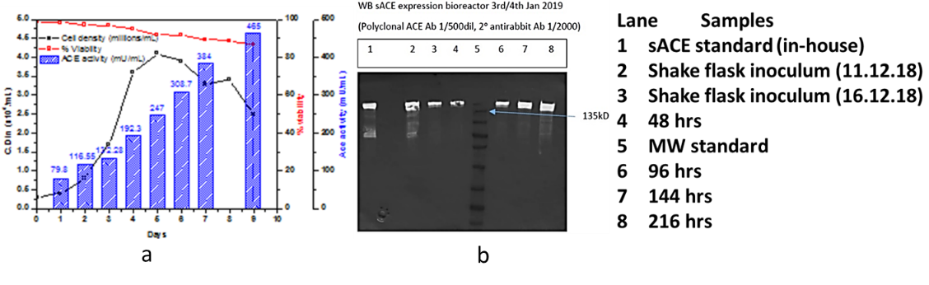 Figure 1. sACE protein expression (a) w.r.t. CHO growth profile in HTB (b) Cell medium was resolved by SDS PAGE and analysed by Western blotting with a sACE polyclonal antibody.
4. Conclusions
Hydrodynamic conditions of the bioreactor are dictated by the aeration-agitation regimen. The horizontal tubular bioreactor with spiral impeller has an edge over traditional STR bioreactor where rising bubbles and high impeller speeds damage the cells while maintaining a high cell density. HTB with spiral impeller is a combination of surface aeration and impeller mixing with enhanced surface renewal rates which resulted in cell density of more than 4 x 10⁶ cells/mL with extended longevity. It could be predicted that in fed-batch mode, target cell densities of more than 10 x 10⁶ cells/mL is achievable based the obtained ($k_{L}a$) value of 16 hr⁻¹ for this reactor.
References
- D. Fernandes, Reducing risk in biopharmaceutical production by controlling glycosylation, Eur. Biopharm. Rev. (2004) 92–97.
- R. Sharma, S.T.L. Harrison, S.L. Tai, Evaluating process parameters of surface-aerated horizontal tubular bioreactors for the growth of animal cells, 10th World Congress of Chemical Engineering at Barcelona, Spain (2017).
- S.L. Schwager, A.K. Carmona, E.D. Sturrock, A high-throughput fluorimetric assay for angiotensin I-converting enzyme, Nat. Protoc. 1 (2006) 1961–1964.
- R. Cramp, M. Gilmour, D.A. Cowan, Novel thermophilic bacteria producing nitrile-degrading enzymes, Microbiology. 143 (1997) 2313–2320.

