Flexibility Analysis and Economic Assessment of a Distillation Train
Martina Raymo², Alessandro Di Pretoro^{1,2}, Ludovic Montastruc¹, Flavio Manenti², Xavier Joulia¹
1. Laboratoire de Génie Chimique, Université de Toulouse, CNRS/INP/UPS, Toulouse, France.
2. Politecnico di Milano, Dipartimento di Chimica, Materiali e Ingegneria Chimica “Giulio Natta”, Piazza Leonardo da Vinci 32, 20133 Milano;
* ludovic.montastruc@ensiacet.fr
Highlights
- Under perturbated conditions the flexibility analysis assesses the system performance.
- The price of an higher flexibility is a system oversizing.
- The total cost vs flexibility trend helps the engineer decision making.

1. Introduction
In process engineering the leading separation process is distillation. The standard procedure for distillation columns design is based on the economic and operational aspects. However, this optimal design is strictly related to the operating conditions, i.e. perturbations, when present, can seriously turn the tables.
Flexibility analysis is an important part of process design seldom included in the standard procedure. Even if sometimes a sensitivity analysis is performed afterwards, there are some differences between the two that can’t be neglected.
The flexibility, for a chemical plant, is defined as the ability of the system to cope with any change of the operating conditions. To achieve higher values of flexibility it is necessary to perform a structured analysis. The analysis can be applied to existing plants and to plants in the design phase [1]. These higher values guarantee a reduction of the risk of money losses and of the stand-by period.
2. Methods
From the available literature about this topic it is clear that the flexibility analysis has been deeply studied and well defined as well as the resulting economic considerations.
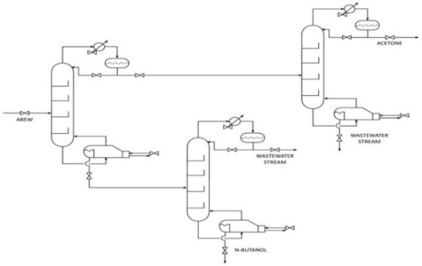
Figure 1: Distillation columns in a midsplit configuration
The mathematical procedure used to assess the flexibility of the selected case study system is the one developed by Saboo and Morari [2], i.e. the Resilience Index (RI). It is assessed by calculating the largest total disturbance load, independent from the direction of disturbance, a system is able to withstand without becoming unfeasible. The RI is then defined as the lowest of the aforementioned withstood perturbations so that every parameter value can change within the +/- RI range without compromising the system operation. This index has been applied to a complex system made of three distillation columns in a midsplit configuration, used to separate a water, ethanol, n-butanol and acetone mixture. Figure 1 shows the system under study.
3. Results and discussion
The flexibility analysis has been carried out and the maximum withstood load for each variable has been assessed. The most constraining parameters result to be water (8%) and butanol (13%), while ethanol and acetone flexibility limits can be neglected, since they are 32% and 45%. The price for a higher flexibility is linked to a system oversizing (column diameter, condenser and reboiler exchanger surface). The economic assessment has been performed and the corresponding total cost vs flexibility trend is plotted in Figure 2 as suggested by Di Pretoro et al (2019) [3].

Figure 2. Total Cost
4. Conclusions
The article shows that an a priori flexibility analysis can lead the designer engineer to the optimal compromise between a flexible plant and an affordable investment.
References [Calibri 10]
[1] I. E. Grossmann and M. Morari, ‘Operability, Resiliency, and Flexibility: Process Design Objectives for a Changing World’, Department of Chemical Engineering, (1983).
[2] A. K. Saboo, M. Morari, and D. C. Woodcock, `Design of Resilient Processing Plants .8. a Resilience Index for Heat-Exchanger Networks', Chemical Engineering Science, 40.8 (1985), 1553-65.
[3] A. Di Pretoro , L. Montastruc, F. Manenti, X. Joulia, 2019, ‘Flexibility analysis of a distillation column: indexes comparison and economic assessment’, Submitted to Computers and Chemical Engineering.

