Impact of oxygenation and glucose concentration on succinate production by Corynebacterium glutamicum
Amani Briki^{1,2}, Eric Olmos^{1,2*}, Sabine Bosselaar^{1,2}, Frantz Fournier^{1,2}, Stéphane Delaunay^{1,2}
1 CNRS, Laboratoire Réactions et Génie des Procédés, UMR 7274; 2 Université de Lorraine, LRGP, UMR 7274, 2 avenue de la forêt de Haye, TSA 40602, Vandœuvre-lès-Nancy, F-54518, France.
*Corresponding author: eric.olmos@univ-lorraine.fr
Highlights
- Sequential production of organic acids according to the oxygen uptake rate
- The succinate re-consumption depends on the glucose concentration
- Kinetic modelling of succinate production/consumption

1. Introduction
Corynebacterium glutamicum is widely used in industry for the production of amino acids and for a few years, it is known that C. glutamicum is also capable of producing organic acids under oxygen-limited and anaerobic conditions [1]. Therefore, this work aimed to understand the physiological behavior of C. glutamicum in defined and limiting oxygenation conditions and then to give clues concerning the optimal conditions for succinate production.
2. Methods
Batch cultures of Corynebacterium glutamicum 2262 were performed in a minimal medium in glass unbaffled shake flasks [1]. For the estimation of the volumetric gas-liquid mass transfer coefficient (k_{L}a), the following correlation was used [2].
$k_{L}a=0.024*N^{1.16}*V^{-0.83}*d_{0}^{0.38}*d^{1.92}$ (eq.1)
with K_{L}a, the volumetric gas-liquid mass transfer coefficient (h⁻¹), N the shaking frequency (s⁻¹), V the filling volume (mL), d₀ the shaking diameter (cm) and d the maximal shake flask diameter (cm).
It was previously demonstrated that the k_{L}a values calculated from eq.1 or determined experimentally were in very good agreement [1]. In the present work, by modifying the shaking frequency, the filling volume and the maximal shake flask diameter, different k_{L}a conditions (5, 11, 15, 20, 31, 44, 77, 90 and 118h⁻¹) could be imposed.
3. Results and discussion
All the cultures were performed in limiting oxygen condition. This one was noticed 2h after the beginning of the culture with k_{L}a values above 77 h⁻¹ and after only a few minutes when the k_{L}a values were below 33 h⁻¹ [1]. The maximal organic acid concentrations differed according to the oxygenation conditions. Indeed, the succinate maximal concentration (42 mM) was measured for k_{L}a = 5 h⁻¹ with a conversion yield of 0.22 mol succinate/mol glucose. The lactate, which was the major fermentation product in all the culture conditions, reached its maximal concentrations (170mM) for k_{L}a values between 5 and 31 h⁻¹. The highest acetic acid concentration (88 mM) occurred when k_{L}a values were between 31 and 77 h⁻¹. For k_{L}a ≥90 h⁻¹, the biomass concentration (12 g/l) was maximal. A similar impact of oxygenation conditions on the organic acids was previously observed with C. glutamicum ATCC13032 (2) and with a mutant strain of C. glutamicum 2262 deleted for ldhA (1). Interestingly, succinate production occurred in all the culture conditions with a similar specific production rate in the first hours of the cultures. However, the higher the k_{L}a, the earlier the production ceased and the earlier the succinate was consumed (fig. 1).
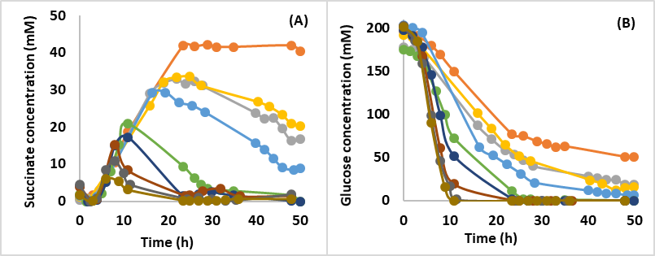
Figure 1. Kinetics of succinate production (A) and glucose consumption (B) by Corynebacterium glutamicum 2262 for k_{L}a values of 5 h⁻¹ (▬), 11 h⁻¹ (▬), 15 h⁻¹ (▬), 20 h⁻¹ (▬), 31 h⁻¹ (▬), 44 h⁻¹ (▬), 77 h⁻¹ (▬), 90 h⁻¹ (▬) and 118 h⁻¹ (▬).
The stop in the succinate production was concomitant with a threshold glucose concentration of 50 mM. Glucose and succinate were then both co-consumed until the end of the culture. No growth of C. glutamicum was observed with succinate as a unique substrate meaning that the succinate is likely an energy source for this bacterium (complementary data). The specific rates of succinate production were then modeled using Luedeking-Piret equation [3] in which a term modeling the succinate consumption as an energy source was added. The specific rates of succinate production predicted using this model were in accordance with the experimental rates for the different k_{L}a conditions.
4. Conclusions
In oxygen-limited conditions, the specific succinate production by C. glutamicum depended on the oxygen uptake rate but its consumption was only observed for concentrations of glucose lower than 50 mM. To identify the metabolic changes responsible for this physiological behavior, the designed kinetic model will be coupled with a FBA simulation using a simplified metabolic model of C. glutamicum.
References
- A.K. Kaboré, E. Olmos, F. Blanchard, M. Fick, S. Delaunay, Biochem. Eng. J. 101 (2015)237-247.
- Y. Shinfuku, N. Sorpitipom, M. Sono, C. Furusawa, T. Hirasawa, U. Shimizu, Microb. Cell Fact (2009)8-43.
- R. Luedeking & E.L. Piret, Biotechnol. Bioeng. 67 (2000)636-644.

