# Analysis of the Microstructure of Particles Obtained by Evaporating Acoustically Levitated Single Droplets Using X-Ray Computed Tomography.

Hassan Abdullahi 1, Thomas Vetter1*, Christopher L. Burcham2

*1 School of Chemical Engineering and Analytical Science, University of Manchester, Manchester, UK;*

*2 Eli Lilly & Company, Indianapolis, IN, USA*

*\*Corresponding author: thomas.vetter@Manchester.ac.uk*

**Highlights**

* Drying of acoustically levitated droplets is investigated.
* Characterization of the microstructure of the formed particles through X-ray tomography.
* Drying conditions and particle microstructures have been mapped against each other.

**1. Introduction**

The flowability and tabletability of powders is an important consideration in the manufacturing of pharmaceutical products. These properties can be successfully tuned by crystallising particles of a desired morphology, or, more flexibly, by engineering the microstructure of the individual particles in a spray drying process it can be tuned by altering the formulation and process conditions [1][2]. Therefore, spray drying offers a unique opportunity to design tailor made particles in a single step process involving simultaneous droplet drying and particle formation. However, carrying out an in-depth investigation of particle morphology and microstructure directly on the scale of a typical spray dryer (that contains millions of droplets at any time) is infeasible. Instead, single droplet studies are often used to understand how drying conditions affect the microstructure of the resulting dried particles [3][4].

**2. Methods**

In the present work, an acoustic levitation approach is used to suspend single droplets in an atmosphere of controlled relative saturation and temperature (Figure 1). Through a camera and automated image analysis, we study the droplet drying dynamics, as well as the macroscopic morphology of the resulting particle. We have further applied Raman spectroscopy and scanning electron microscopy to study the solid state form, as well as the surface characteristics. By applying X-ray computed tomography, we have elucidated the internal microstructure of the formed particles and have uncovered a fascinating variety of structures, depending on the mixture dried (we have investigated combinations of different solutes, solvents, and polymers acting as excipients), as well as the processing conditions (temperature and relative saturation of nitrogen used as drying gas). The results can be correlated with formulation and process conditions to produce drying maps for different systems.

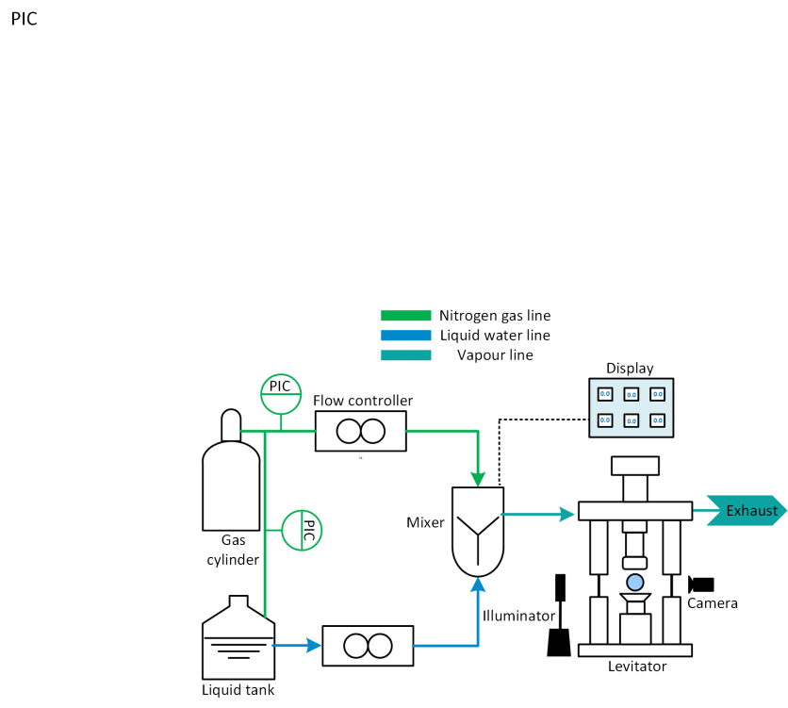

**3. Results and discussion**

Figure 1: Suspension of a droplet in a controlled atmosphere using an acoustic levitator.

The droplet drying history during evaporation is shown in Figure 2a for an aqueous formulation of mannitol (4.5 wt%) and PVP (0.9 wt%). In the first drying stage, the diameter of the droplet decreases as solvent is evaporated from the droplet surface. In the second drying stage, a shell forms and evaporation occurs through interstices in the shell. The evaporation rate hence reduces significantly due to the added resistance of the crust. When presented as a plot of normalised squared diameter ${D^{2}}/{D_{o}^{2}}$ against time, the two drying regimes can be clearly identified. We have performed such characterisation for a variety of process conditions and the particles obtained can be subsequently analysed to provide useful information on particle properties such as size, shape, porosity, roughness and crystal structure. Figure 2b and 2c shows exemplary images of particles obtained using SEM and micro X-ray computed tomography. By investigating the droplet drying dynamics and resulting particle microstructure, for a variety of mixtures and operating conditions enables us to gain deep insight into the process behaviour and the properties of the resulting particles.



Figure 2: a) Droplet drying history and particle obtained from drying an aqueous formulation containing 0.9%w/w polymer, 4.5%w/w mannitol at 60C and 0% relative humidity b) SEM image c) cut-away surface from micro X-ray tomography.

**References**

1. Carver, K. M., & Snyder, R. C. (2012). Ind. Eng. Chem. Res, *51*(48), 15720.
2. Mönckedieck, M., Kamplade, J., Fakner, P., Urbanetz, N. A. (2017). *Drying Technology*, *35*(15), 1843.
3. Osman, A., Goehring, L., Patti, A., Stitt, H., & Shokri, N. (2017). Ind. Eng. Chem. Res, *56*(37), 10506.
4. Sugiyama, Y., Larsen, R. J., Kim, J., & Weitz, D. A. (2006). Polymer Suspensions, (8), 6024.