Efficient assessment of combined crystallization, milling, and dissolution cycles for crystal size and shape manipulation
Pietro Binel¹*, Fabio Salvatori¹, and Marco Mazzotti¹
¹ Institute of Process Engineering, ETH Zurich, 8092 Zurich, Switzerland
*Corresponding author: binel@ipe.mavt.ethz.ch
Highlights
- Crystallization, dissolution, and milling selectively manipulate crystal shape
- The simulations identify general trends used for process characterization
- The interplay of critical operating variables and system parameters is elucidated

1. Introduction
The size and shape of crystals in a powder are important properties that significantly contribute to determining the quality of the final commercialized product and that affect several steps in the downstream process [1]. Different approaches have been proposed to modify the morphology of crystalline products. Here, we assess the effectiveness of a 3-stage process [2] consisting of cycles of crystallization, milling, and dissolution for products with different features, aiming at a robust and quick process design [3].
2. Methods
The 3-stage process is investigated through simulations and experimental work. A lab-scale setup is used to perform crystallization, wet milling, and dissolution while monitoring the solute concentration with the ATR-FTIR technology. The number of cycles performed and the rotor speed of the wet mill device are chosen as process variables. To measure the particle size and shape distribution (PSSD) of the population after each step of the process, the optical imaging device μDISCO [4] is employed. The simulations are based on two-dimensional morphological PBEs tailored to best describe every step of the process.
3. Results and discussion
Two model compounds featuring a needle-like crystal habit, namely β L-Glutamic acid and γ D-Mannitol, are used to map the design space spanned by the process variables onto the space plane, i.e. the plane where average length L₁ and width L₂ of the crystal population are plotted. For this purpose, a factorial design approach is adopted to minimize the experimental effort. It is observed that, although with β L-Glutamic acid a broad range of sizes and aspect ratios can be reached, γ D-Mannitol exhibits a very narrow attainable region for the same combination of operating variables. Simulations allow us to demonstrate that the different behavior or β L-Glutamic acid and γ D-Mannitol, which affects the shape of the attainable region (Fig. 1), is due to a major difference in the kinetics of growth and dissolution, then validated through direct experimental measurements or by comparison with values reported in literature.

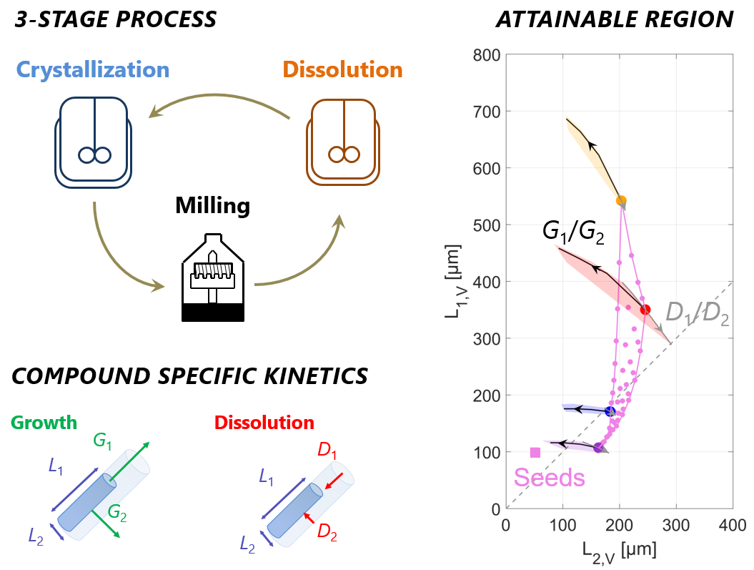
Figure 1. The 3-stage process consists of cycles of crystallization, milling, and dissolution. The attainable region in shape and size of the final population heavily depends on the kinetics of growth and dissolution of the product.
4. Conclusions
The outcome of the 3-stage process and its effectiveness in manipulating the shape and size of the crystals are related to both operating variables and system parameters, namely the growth and dissolution rate ratios. Simulations allowed determining generally valid compound-dependent features which relate the type of attainable region to the magnitude of the aforementioned ratios. The observation resulting from the in-silico work is demonstrated by running an experimental campaign.

References
- M. A. Lovette, A. Robben Browning, D. W. Griffin, J. P. Sizemore, R. C. Snyder, M. F. Doherty Ind. Eng. Chem. Res. 47 (2008) 9812– 9833.
- F. Salvatori, M. Mazzotti, Ind. Eng. Chem. Res. 56 (2017) 9188–9201.
- F. Salvatori, P. Binel, M. Mazzotti, Chem. Eng. Sci. X, in press, DOI 10.1016/j.cesx.2018.100004
- A. K. Rajagopalan, J. Schneeberger, F. Salvatori, S. Bötschi, D. R. Ochsenbein, M. R. Oswald, M. Pollefeys, M. Mazzotti, Powder Technol. 321 (2017) 479‒493.

