Assessing different modelling approaches for secondary nucleation
Luca Bosetti, Marco Mazzotti*
Institute of Process Engineering, ETH Zurich, 8092 Zurich, Switzerland
*bosettil@ethz.ch
Highlights
- Attrition considered as a breakage phenomenon and as the source of secondary nucleation
- Physical expression of breakage rate, daughter distribution and secondary nucleation rate
- Comparison of secondary nucleation and breakage by attrition
- Combination of numerical methods: finite volume, fixed pivot, fractional step

1. Introduction
The production of active pharmaceutical compounds relies upon continuous crystallisation, during which the crystals produced are formed via secondary nucleation. A precise physical and mathematical description of the phenomena occurring during secondary nucleation has been neither fully understood, nor fully described yet. One of the possible mechanisms for the formation of nuclei is attrition[1], which is a purely mechanical process that generates fragments that are removed from the crystal surface and then grow or dissolve in the bulk solution. In this study, the formation of secondary nuclei is considered to be a consequence of the detachment of small fragments from a mother crystal, because of impact with the stirrer, which is the most common phenomenon[1].

2. Methods
The scope of this work is to compare two approaches to include secondary nucleation in a mono-dimensional population balance equation model (PBE). The first approach is the one usually used in the literature [1], where a semi-empirical expression for secondary nucleation is included as a boundary condition of the PBE model, in analogy with primary nucleation. Such an expression is usually dependent on the energy input, e.g. stirring intensity, supersaturation and an integral property of the crystals’ population, e.g. the total area or the total mass [2,3]. The second approach consists in considering secondary nucleation as a pure attrition mechanism, thus accounting for it through a source term in the PBE, namely an integral term.
In order to model attrition as a source term, we have defined a daughter distribution of fragments [2] and an attrition frequency to quantify the size distribution and occurrence of the attrition events, respectively. Moreover, not all the particles produced through attrition evolve in the same way. In fact, a particle will grow depending on its size according to a size-dependent growth expression. The entire process has been modelled at isothermal conditions, in a batch crystallizer.
The phenomena considered are growth, dissolution, breakage and secondary nucleation. The numerical methods used are hybrids between finite volume[4] for growth, dissolution, and secondary nucleation and fixed pivot[5] for breakage. In presence of source terms, a fractional-step method has been applied[4].
3. Results and discussion
The phenomenon of formation of nuclei (or fragments) has been successfully described by the two modelling approaches, even though they are conceptually very different, since one is active only in the presence of supersaturation, i.e. secondary nucleation, and the other is always active. The results show that we can achieve similar results regarding the production of fines, but the effect of supersaturation is obviously different. Thanks to this result, we are able to have an insight into the two phenomena, starting from physical properties of the system, and physical operative conditions. The study has been conducted in a fully parametric way, which make the model very flexible to change in operating conditions and in changes of the material to crystallize.
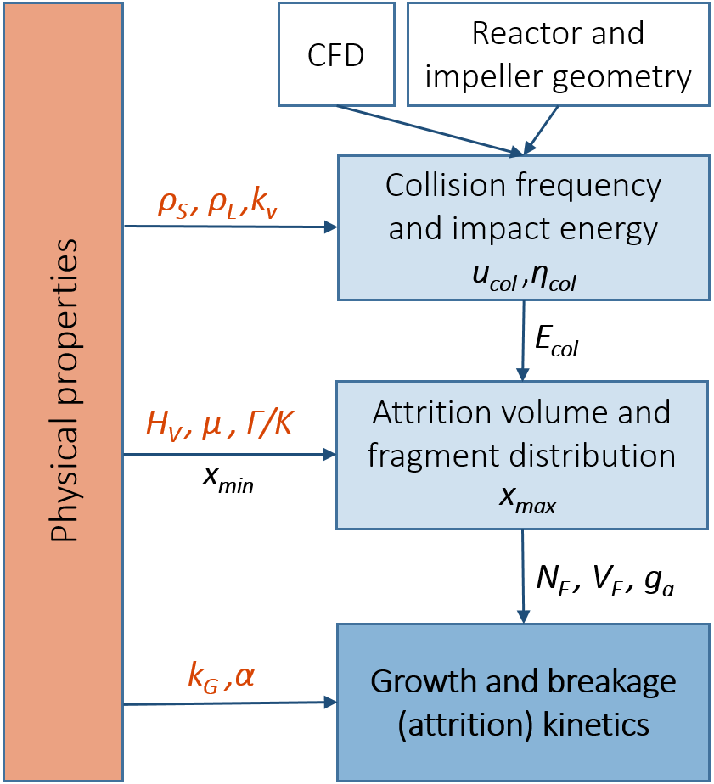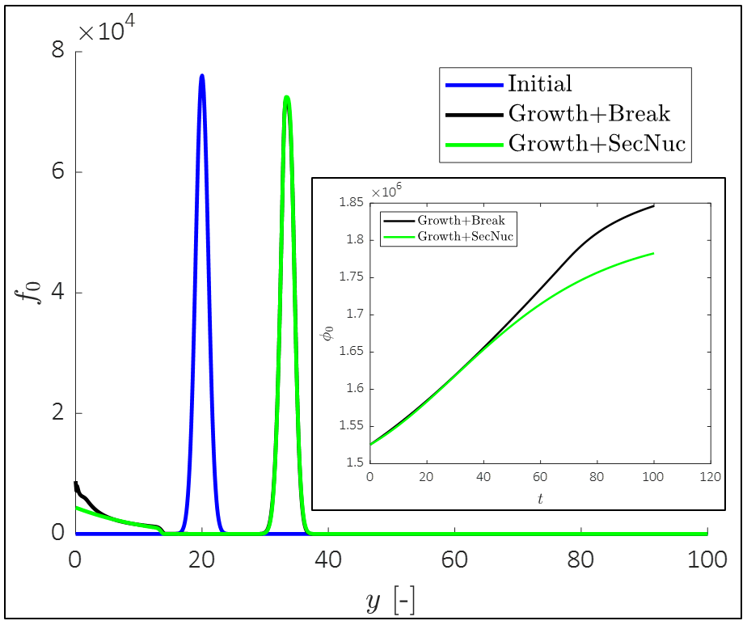
Figure 1. (a) Schema for the physical determination of the breakage rate and of the daughter distribution. (b) Comparison of the final populations obtained with the model with growth and breakage (black) and with the one with growth and secondary nucleation (green).
4. Conclusions
In this work, it has been shown how the two modelling approaches lead to similar conclusions, when the expressions for secondary nucleation and that for breakage by attrition have been derived from the physical properties of the system and its operative conditions. Experimental validation of the model will allow to clarify which approach is more suitable to describe continuous crystallization.
References
- Agrawal, S. G., & Paterson, A. H. J. (2015). Chemical Engineering Communications, 202(5), 698–706.
- Mersmann, A. (Ed.). (2001). Crystallization technology handbook. CRC Press.
- Gahn, C., & Mersmann, A. (1999). Chemical Engineering Science, 54(9), 1273–1282.
- Leveque, R. J. (2002). Finite volume methods for hyperbolic problems (Vol. M).
- Iggland, M., & Mazzotti, M. (2011). Crystal Growth and Design, 11(10), 4611–4622.

This project has received funding from the European Research Council (ERC) under the European Union's Horizon 2020 research and innovation programme under grant agreement No 2-73959-18.

