Simulation of Developing Bubbly Pipe Flows with a Coupled Multi-Fluid/Population Balance Solver
Mohsen Shiea¹, Marco Vanni¹, Daniele Marchisio¹, Antonio Buffo¹
1 Dipartimento di Scienza Applicata e Tecnologia, Politecnico di Torino, 10129 Torino, Italia.
*Corresponding author: mohsen.shiea@polito.it
Highlights
- CFD with population balance equation is a powerful tool to simulate bubbly flows.
- QMOM with two-fluid approach predicts the average bubble size satisfactorily.
- Multi-fluid approach is necessary when the bubble size distribution is wide.

1. Introduction
Comprehensive CFD simulation of disperse gas-liquid flows requires the knowledge about the evolution of the disperse phase, i.e. gas bubbles, that can be achieved by solving the population balance equation (PBE) along with the relevant governing equations, which are limited, in this work, to mass and momentum balance equations. The PBE can be solved to predict how the population of the bubbles are distributed over the properties of interest, e.g. bubble size and bubble velocity. If the bubble size is the only property under study, i.e. assuming constant velocity for bubbles of different sizes, then the PBE can be integrated into a two-fluid model (TFM) solver. However, if the constant velocity assumption is not valid, for instance if the bubble size distribution (BSD) is wide, bubbles of different sizes should be transported with different velocities, hence the necessity of adopting a multi-fluid approach. This work aims at analyzing and comparing the simulation predictions of a developing turbulent air/water pipe flow using both two-fluid and multi-fluid approaches. The comparison of the predictions in this specific system is interesting since the lift force plays an important role in the radial distribution of the air as the flow develops. On the other hand, both the magnitude and the direction of the lift force depend on the bubble size [1]. Therefore, the effect of considering different velocities for bubbles of different sizes can be studied.
2. Methods and Experimental Data
The experimental data was adopted from the work by Bayer and co-workers [2]. The setup is a vertical air/water pipe flow with the inner diameter of 0.1953 (m). The air enters from the injection points located on the wall into the upward-flowing water. The flow develops gradually until it reaches a wire-mesh sensor that measures air volume fraction, air velocity and bubble size distribution. The injection points have different distances from the sensor, therefore, the information about how the flow develops in the pipe is available.
The simulations are performed with both two- and multi-fluid approaches. The two-fluid model consists of the momentum balance equations for the liquid and gas phases in addition to the volume fraction balance equation for the gas phase. The interfacial forces and corresponding models are selected based on some preliminary mono-disperse simulations, which include drag, lift, turbulent dispersion and wall lubrication. The PBE is solved using the Quadrature method of moments (QMOM). It considers the effects of hydrostatic pressure, bubble coalescence and bubble breakage (modelled on the assumption of homogeneous isotropic turbulence) on the BSD. In this work, the QMOM approximates the BSD with three groups of bubbles (three-node quadrature). In multi-fluid model, the balance equations are written for each group as if there are three disperse phases with different characteristic lengths. All the simulations were performed using the modified versions of twoPhaseEulerFoam and reactingMultiphaseEulerFoam solvers of OpenFOAM v5.0 and v6.0. Further details of the implementation are described by Buffo and co-workers [3].
3. Results and discussion
Figure 1 depicts the radial profile of the air volume fraction (left) and the axial changes of the Sauter mean diameter, SMD, (right) obtained by the two-fluid approach for the operating condition with the inlet water and air velocities equal to 0.405 and 0.0368 m/s respectively. The predicted radial profiles of the air volume fraction show good agreement with the experimental data, particularly at the higher section where the flow is almost developed. The discrepancies, such as those seen at the lower section, could be attributed to fact that according to the experimental data, the BSD near the air injection point is wider in comparison to the higher sections, where the flow is more developed. It suggests using the multi-fluid approach to allow the bubbles to move with different velocities and assess its effect on the radial air distribution. Nevertheless, the PBE coupled with the two-fluid approach provides satisfactory predictions for the change of the SMD in the axial direction by using coalescence/breakage kernels based on the homogeneous isotropic turbulence.
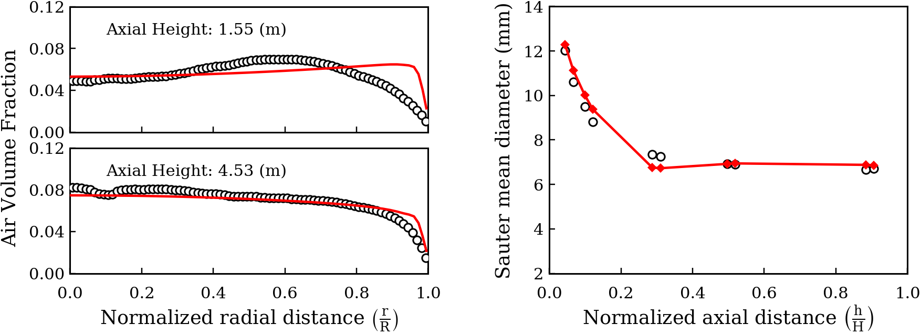
Figure 1. The radial profiles of the air volume fraction at two axial heights (left) and the axial profile of the average SMD (right) predicted by the two-fluid approach. Experimental measurements are shown by the circular markers.
4. Conclusions
A developing turbulent bubbly pipe flow was simulated using CFD-PBE method. Satisfactory predictions, particularly for higher sections (developed flow) were obtained by assuming one velocity for bubbles of different sizes. The multi-fluid approach will be used to assign different velocities to bubbles of different sizes, which is necessary when the BSD is wide.
References
- A. Tomiyama, H. Tamai, I. Zun, S. Hosokawa, Chem. Eng. Sci. 57 (2002) 1849–1858.
- M. Beyer, D. Lucas, J. Kussin, P. Schütz, Report FZD-505, 2008.
- A. Buffo, D. Marchisio, Rev. Chem. Eng. 30(1) (2014) 73–126.

