Numerical prediction of a turbulent diﬀusion ﬂame by rhoReactingFoam.
Esteban Maya¹, Jairo Valdés¹, Alexander Ladino^{1*}, Omar López²
1 School of Mechanical Engineering, Universidad del Valle, Calle 13, No. 100-00, Cali 760032, Colombia
2 Department of Mechanical Engineering, Universidad de los Andes, Cra 1 Este N 19A-40, Bogotá, Colombia
*Corresponding author: jair.ladino@correounivalle.edu.co
Highlights
- Density-based solver rhoReactingFoam was validated against experimental and computational data.
- Flame prediction performed via RANS, one step global reaction and PaSR as combustion model
- Four single step global reactions evaluated.
- rhoReactingFoam provides good agreement with available data for the reaction kinetics considered
- rhoReactingFoam is capable to predict small diffusion flames at low-moderate Re.

1. Introduction

One of the most basic structure in combustion is a ﬂame, widely used as heating mechanism in industry equipment like boilers and furnaces. However, even for the simplest geometries, its nature of turbulent combustion and ﬂame instability downstream represents a complex process cannot be treated analytically but numerical models widely validated with experimental data.
In this work, experimental data from the literature of SANDIA D ﬂame [1] was used to validate the numerical model of density-based thermodynamics package compressible reacting flow solver rhoReactingFoam, implemented in OpenFOAM package. Numerical model implemented involves Reynolds Averaged Navier-Stokes equations and k-ε for turbulence modeling, Partially Stirred reactor (PaSR) for chemistry-turbulence interaction with a single-step global reaction considered [2]. Finally, the rhoReactingFoam results for flame temperature and species were compared with experimental data [1] and previous computational studies widely developed by Lysenko and given in [3].
2. Methods
The Sandia ﬂame D [1], is a piloted free non-premixed methane-air burner in which the ﬂame is established between an internal ﬂow of fuel and an external ﬂow of a lean mixture of methane and air. The Main fuel jet is composed of 25% methane and 75% air by volume with a Reynolds number at the burner exit of 22400. The pilot is a lean mixture (φ = 0.77) of methane and air.
Numerical implementation in rhoReactingFoam involves an axisymmetric domain, spatial discretization of first/second order TVD schemes for advection and second order central diﬀerences for diﬀusion terms. Also, a stabilized local time-step (STLS) and Rosenbrook23 schemes for temporal discretization were employed for transport equations and species reaction rates respectively. Convergence criteria were 10⁻⁶ and 10⁻¹⁰ for transport quantities and reaction rate respectively.
3. Results and discussion
The Figure 1 shows results for mean temperature and methane mass fractions at flame centerline of this study for the global reaction that best fits the experimental data given [1] and also the results given by Lysenko in [3] which used the Eddy Dissipation Concept (EDC) as chemistry-turbulence interaction, one-step global reaction mechanism and Large Eddy Simulation (LES) for turbulence modelling. Results show that rhoReactingFoam reproduces the dynamics of the flame as [3], but in reasonable agreement with the experimental data due to the restriction of the limited reaction kinetics simulated which involves only a one step global reaction.
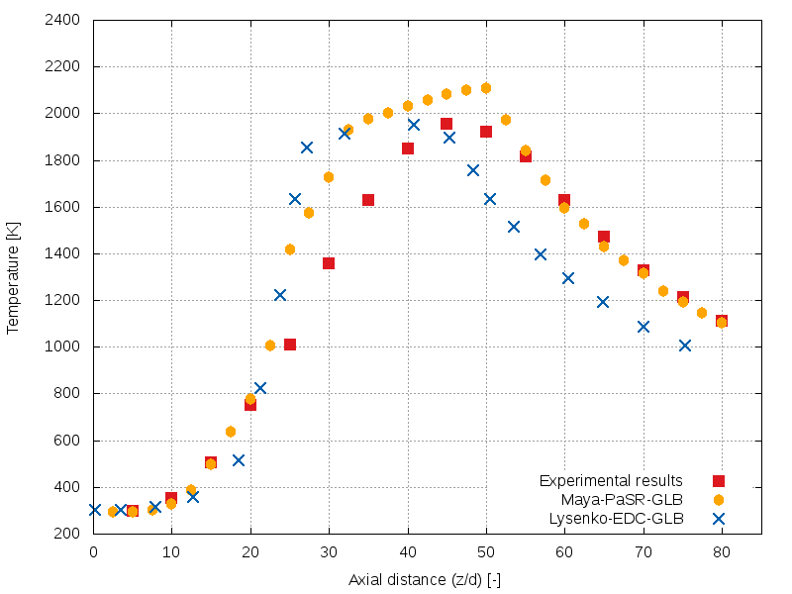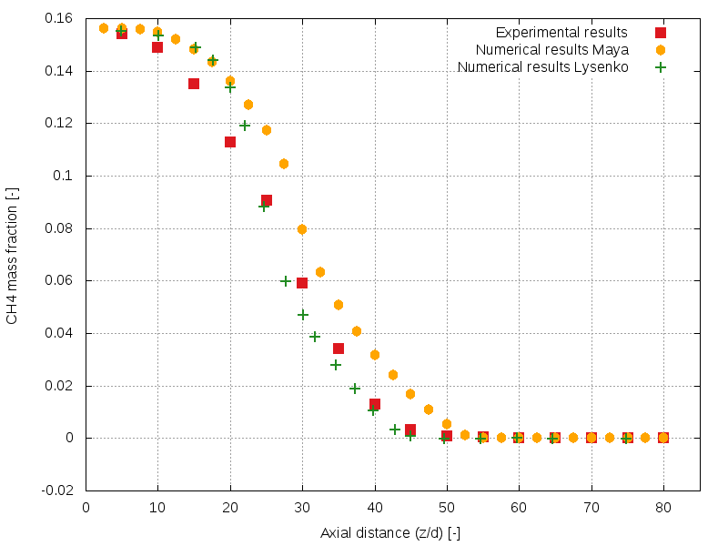
Figure 1. Mean flame temperature (left), and methane mass fraction (right) at centerline. This study: One step global reaction A=6.7x10¹², E_{a}=48.4, a=0.2, b=1.3. See Table II [2].
4. Conclusions
Overall agreement between the simulated results, computational ones from [3] and the experimental data given [1], validate the rhoReactingFoam solver for small methane diffusion ﬂames. The coupling of RANS k-ε, PaSR model with single-step reaction demonstrates to provide reliable results as same as [3] for axial temperature with some over prediction of peak temperature but with better performance at flame positions downstream from that point. Also, the most relevant discrepancy is the reactant mixing prediction mainly due to turbulence formulation but in agreement with other studies and solvers. Finally, further research involves the validation and testing of rhoReactingFoam with GRI detailed chemistry.
References
[1] R. Barlow and J. Frank, “Piloted CH4 /Air Flames C, D, E, and F Release 2.1,” 2007.
[2] C. K. Westbrook and F. L. Dryer, “Simplified reaction mechanisms for the oxidation of hydrocarbon fuels in flames,” Combust. Sci. Technol., vol. 27, no. 1–2, pp. 31–43, 1981.
[3] D. A. Lysenko, I. S. Ertesvag, and K. E. Rian, “Numerical Simulations of the Sandia Flame D Using the Eddy Dissipation Concept,” Flow Turbul. Combust., vol. 93, pp. 665–687, 2014.

