Multiphase CFD Simulation of Small-Scale Crystallization Reactors
Ramona Achermann¹, Pawel M. Orlewski¹, Marco Mazzotti^{1*}
1 ETH Zurich, Institute of Process Engineering, Sonneggstrasse 3, CH-8092 Zurich, Switzerland;
*Corresponding author: marco.mazzotti@ipe.mavt.ethz.ch
Highlights
- Multiphase CFD simulation of small-scale crystallization reactors
- Qualitative and quantitative information on flow and mixing behavior
- Better design of high-throughput crystallization experiments

1. Introduction
Crystallization is a widely used purification step in the fine chemical and the pharmaceutical industry. Reducing the reactor volume to study crystallization processes is especially beneficial at an early stage of research since it saves valuable compounds, reduces costs and allows for high-throughput screening¹. Thus, in recent years small-scale crystallization reactors have gained increasing popularity within the crystallization community^{1,2}. However, compared to large-scale crystallizers, different hydrodynamic properties of these miniaturized reactors have not yet been thoroughly studied. Therefore, to close the gap, by performing a multi-phase modelling using CFD (Computational Fluid Dynamics), a better understanding of the effect of operating conditions on the flow properties in such small reactors could be obtained. In this work, two commercially available micro reactors using different stirrers, namely the overhead stirrer and the stirrer bar, have been modelled with and without the addition of solid particles. Knowing the hydrodynamics of such small stirred vials will improve the overall understanding of the occurring crystallization phenomena such as nucleation, growth or breakage since shear forces or mixing can have a significant influence on them^{3,4}.
2. Methods
The commercial CFD code ANSYS Fluent 18.2 was used to conduct the simulations. To model the turbulence, the Reynold’s stress model (RSM) was applied and standard multiphase models were used to model the effects of solids on the flow field. An enhanced wall treatment model was added to better capture the behavior near the wall and the grid was refined until mesh-independent results were obtained. For both stirrers, a single reference frame (SRF) was used and the simulations were run at steady state.
3. Results and discussion
A complete qualitative and quantitative comparison of the two investigated stirrers was performed with and without solids for a wide range of operating conditions. This gave information on the distributions in the reactor of the velocity, of the turbulent energy dissipation rate, as well as of the solids together with their exposure to shear forces and the homogeneity of the system. Figure 1 shows the velocity distribution for the two configurations investigated.
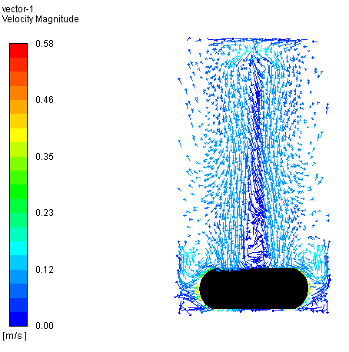
Figure 1. Comparison of the velocity distribution in the stirrer bar (left) and overhead stirrer (right).
4. Conclusions
In this work, the mixing and flow behavior of the overhead stirrer as well as the stirrer bar used in commercially available micro reactors were studied with and without solid addition using CFD modelling. Obtained results allowed for a better understanding of the hydrodynamics in the system and of their dependence on the operating conditions, which could then allow for an improved overall understanding of the phenomena occurring in the crystallization processes studied in those systems.
References
- E. Simone, J. McVeigh, N. M. Reis, and Z. K. Nagy. A high-throughput multi-microfluidic crystal generator (mmicrocrygen) platform for facile screening of polymorphism and crystal morphology for pharmaceutical compounds. Lab Chip, 18:2235–2245, 2018.
- Giovanni M. Maggioni, Luca Bosetti, Elena Dos Santos, and Marco Mazzotti. Statistical analysis of series of detection time measurements for the estimation of nucleation rates. Crystal Growth and Design, 17(10):5488-5498, 2017.
- Christian Lindenberg, Jochen Schöll, Lars Vicum, Marco Mazzotti, and Jörg Brozio. L-Glutamic Acid Precipitation: Agglomeration Effects. Crystal Growth & Design, 8(1):224-237, 2008.
- Pawel M. Orlewski, Yan Wang, Mercedeh Sadat Hosseinalipour, David Kryscio, Martin Iggland, and Marco Mazzotti. Characterization of a vibromixer: Experimental and modelling study of mixing in a batch reactor. Chemical Engineering Research and Design, 137:534–543, 2018.
Acknowledgement
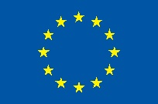
This project has received funding from the European Research Council (ERC) under the European Union's Horizon 2020 research and innovation programme under grant agreement No 2-73959-18.

