Development of a high velocity co-flowing stratified microfluidic process to obtain kinetic constants for reactive liquid-liquid extraction.
Florian Corne¹, Anne Lélias-Vanderperre^{1*}, Alastair Magnaldo¹, Christian Sorel¹, Nathalie Di Miceli Raimondi², Laurent Prat²
1 CEA - DEN, DMRC, Research Service for Dissolution and Separation Processes, Laboratory of Conception of Extraction Processes, F-30207 Bagnols-sur-Cèze, France; 2 Laboratoire de Génie Chimique, Université de Toulouse, CNRS, INPT, UPS, Toulouse, France
*Corresponding author: anne.lelias@cea.fr
Highlights
- Uranium(VI) extraction from nitric acid by TBP 30% with contact time lower than 50 ms.
- Estimation of the chemical mass transfer constant using the microfluidic device: over 4.2 10⁻⁴ m.s⁻¹.
- Difference between the results and a 2D COMSOL model: presence of an acceleration factor?

1. Introduction
Kinetic constants in reactive liquid-liquid extraction processes are generally determined using constant interfacial area methods such as the single drop method the Nitsch cell or the Lewis cell. These techniques only allow reaching the overall kinetics of the process that is the result of two basic phenomena: the intrinsic reaction and the overall mass transfer of the components that participate to the reaction. The determination of the intrinsic kinetics of the reaction is necessary for the design and extraction process modelling. Mass transfer limitation is quite hard to be restrained in a device to determine intrinsic chemical kinetics since molecular diffusion contributes in majority to the overall mass transfer resistance. Hence, the field of microfluidic devices appears as an interesting way to study such kinetics by reducing the molecular diffusion. In this context, our study considers the well-known solvent TBP 30% in TPH used to reprocess nuclear spent fuels as a reference solvent to study mass transfer kinetics [1-4].
2. Methods
The extraction of uranium(VI) in nitric acid by tributylphosphate (TBP) diluted at 30% in TPH (hydrogenated tetrapropylene) was carried out using a Y-Y microfluidic chip with a 1.25 cm straight microchannel (dolomite). Two stratified flows in co-flowing configuration were generated with high fluid velocities to aim chemical kinetics constant determination, thanks to both diffusive length reduction and fine flow control in the microfluidic technology. Liquid-liquid stratified flow configuration with a centered interface avoids any tangential convective movements. Therefore, the hydrodynamics in the device is perfectly controlled and predictable using CFD codes, as for the mass transfer phenomenon. The experimental hypothesis of a centered interface along the microchannel depth was validated thanks to confocal experiments.
3. Results and discussion
First, the influence of inlet uranium concentration and total fluid velocity on the extraction yield has been studied as shown in Figure 1. The observed extraction yields are quite good considering the short contact time inside the microchip (lower than 0.05 s).
Then the results have been exploited to determine if diffusion still occurs in such conditions thus allowing the estimation of the chemical mass transfer constant (k_{e}), which is expected to be over 4.2 10⁻⁴ m.s⁻¹ for a 0.12 M U(VI) aqueous solution. The results hardly fit with a preliminary 2D COMSOL model even by increasing the supposed k_{e} twice and the U(VI) molecular diffusion coefficient (DU) by a decade. Another solution to fit the experimental results consists on taking into account an acceleration factor, provided whether from a Hatta acceleration or from Marangoni instabilities.

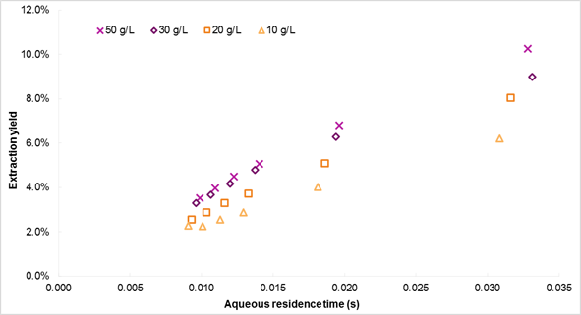
Increasing velocity
Figure 1. Comparison between the extraction rates of uranium(VI) in HNO₃ 3M extracted by TBP 30% in TPH.
4. Conclusions
Attempts to determine the chemical kinetics constant of uranium(VI) from nitric acid by TBP 30% in TPH were carried out by means of microfluidics device at high flow velocities in order to limit the impact of diffusion phenomena on the global mass transfer. The intrinsic chemical kinetic constant was performed thanks to COMSOL modelling. When only chemical phenomenon is taken into account, all the numerical results are below the experimental data in the process modelling. Hence, both reaction and molecular diffusion have to be taken into account in the modelling of the microfluidic experiment through the presence of an acceleration phenomenon enhancing the overall kinetic constant.
References
- B. Dinh, PhD thesis from Ecole centrale des Arts et Manufactures, Paris, 1987.
- D. Horner et al., Ind. Eng. Chem. Fundamen., 19 (1980) 103-109.
- J.-P. Jasmin et al., Solvent Extr. Ion Exch., 35 (2017) 174-186.
- M. Yamamoto et al., J. Sep. Sci., 38 (2015) 1807-1812.

