Comparison of Miniaturized Draft Tube Baffle
and Coiled Flow Inverter Crystallizer Construction
Mira Schmalenberg*¹, Anna Nocon¹, Felix Buckmann¹, Norbert Kockmann¹
1 TU Dortmund, Emil-Figge-Straße 68 44227 Dortmund
*Corresponding author: mira.schmalenberg@tu-dortmund.de
Highlights
- Continuous crystallization for process development
- Comparison of design methods
- Down-scale of a draft tube baffle crystallizer
- Residence time behavior in comparison

1. Introduction
To develop processes as quickly and easily as possible, continuous apparatuses are required even for very small quantities. This is especially valid for crystallization, which is still frequently carried out in batch mode^{[1]}.
The procedure for constructing two different cooling crystallizers is to be compared here. A Draft Tube Baffle (DTB) crystallizer as a stirred tank is compared to a Coiled Flow Inverter Crystallizer (CFIC), which belongs to the tube crystallizers. In addition to the different construction methods, the main features of the crystallizers will also be compared.

2. Methods
In order to ensure a homogeneous suspension flow in the CFIC, Hohmann et al. ^{[2]} has already developed a flow chart to identify homogenous suspension flow. The CFIC presented here has been developed on the basis of this map^{[3]}. The most important parameter here is the densimetric Froude number based on flow velocity and density difference between fluid and solid.
Regarding the DTB an already known DTB^{[4]} crystallizer has been down scaled from 1100 L to 1 L to allow the same suspension characteristics. With the help of different particles (glass particles and acetylsalicylic acid) and solid weight fractions it is possible to determine an operating range for the DTB. Here the densimetric Froude number is an important parameter, too.
3. Results and discussion
A tube-in-tube CFIC has been designed with an internal process tube diameter d_{i} of 1.6 mm (Figure 1, left). This was designed for a suspension flow rate of 15 – 20 g∙min⁻¹. The CFIC can be varied by identical units so that the coiled tube length (7.8 - 54.6 m) and thus the mean residence time (1 – 7 min) can be varied. The special feature of this crystallizer is the very narrow residence time distribution, which is close to an ideal plug flow. ^{[3]}
In contrast, the constructed DTB (Figure 1, right) obviously behaves similarly to the residence time distribution of an ideal continuous stirring vessel. Thus, despite a similar mass flow rate (around 15 g∙min⁻¹), significantly longer residence times of about 67 min are possible. This should make it possible to produce much larger crystals than in the CFIC.
The special feature of the DTB is that it has a classifying function. This is induced by the baffles so that fine grain can be removed and a narrower crystal size distribution (CSD) be reached. In this work, the achievable CSD, which should be narrow, of the two crystallizers will be compared although the crystallizers are of two different types.
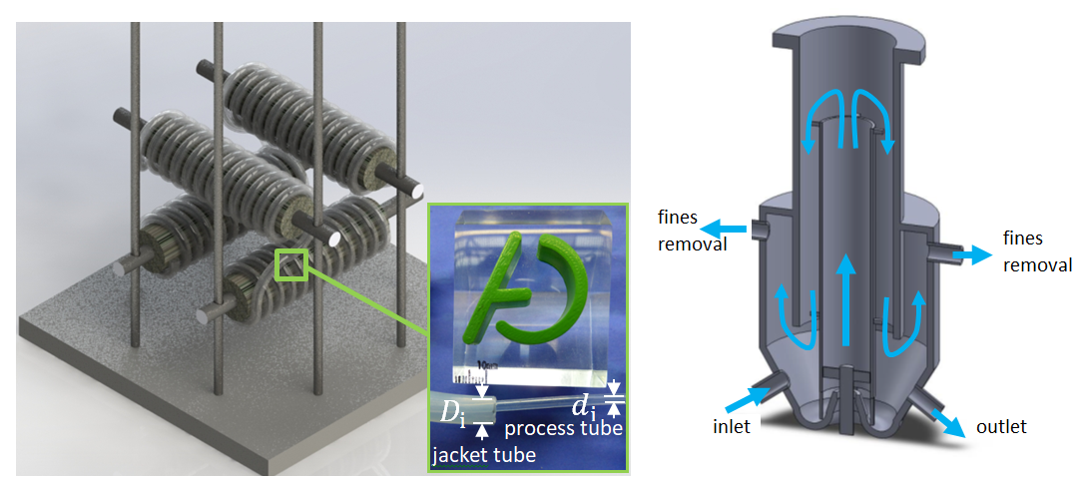
Figure 1. Single CFIC unit with coiled tube length of 7.8 m with tube-in-tube construction of the CFIC (left);
Down-scaled DTB prototype with flow direction (right)
4. Conclusions
Two different continuous cooling crystallizers have been designed for small quantities of about 15 g∙min⁻¹, where for both a complete homogenous suspension behavior is a design criterion. To characterize the crystallizers, the residence time behavior was compared. This shows that the different apparatuses are suitable for various crystallization tasks.
The German Federal Ministry for Economic Affairs and Energy (BMWi) is acknowledged for funding this research as part of the ENPRO2.0 initiative. (Support code: 03ET1528A)

References
- P. Kleinbudde, J. Khinast, J. Rantanen, Continuous Manufacturing of Pharmaceuticals, 2017.
- L. Hohmann, M. Schmalenberg, M. Prasanna, M. Matuschek, N. Kockmann, Chemical Engineering Journal, 2018
- M. Schmalenberg, L. Hohmann, N. Kockmann, ASME ICNMM2018-7660, 2018
- A. ten Cate, S. K. Bermingham, J. J. Derksen, H. M. J. Kramer, 10th European Conference on Mixing, 2000

