**Visualization of Mixing Performance and Measurement of Power Input in Aerated Stirred Tank Reactors on a lab and industrial scale**

Jürgen Fitschen1, Annika Rosseburg1, Johannes Wutz2, Thomas Wucherpfennig2, Michael Schlüter1

*1 Institute of Multiphase Flows, Hamburg University of Technology, Hamburg, Germany; 2 Boehringer Ingelheim Pharma GmbH & Co. KG, Biberach an der Riß, Germany*

*\*Corresponding author: juergen.fitschen@tuhh.de*

**Highlights**

* Deep insights into industrial scale aerated stirred tank reactors
* Comparison of mixing performances for different scales
* Challenges of scale-up process from lab- to industrial scale

**1. Introduction**

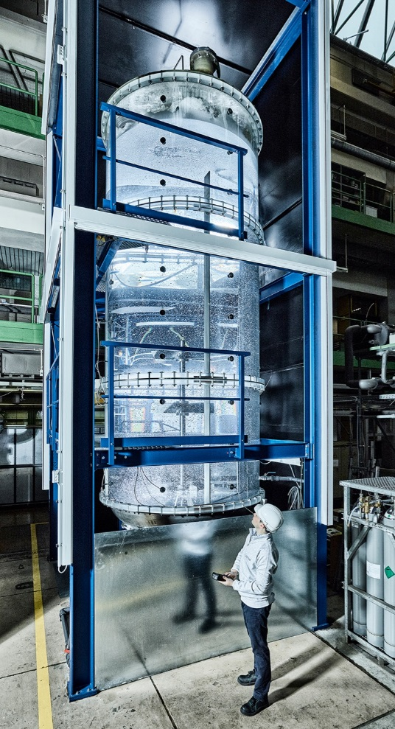Aerated stirred tank reactors (STR) are often used for mixing, heat- and mass transfer processes in chemical and biochemical engineering due to their robust operation and extensive description in the past. However, in case of mammalian cell expression systems special requirements have to be fulfilled. Beside media and feed, the hydrodynamic properties like power input, mixing and mass transfer performance have to be customized for each individual cell line [1] as well as reactor size during the upstream process.

Commonly used scale up parameters are constant geometrical ratios, constant volumetric power input P/V, constant superficial gas velocities w0g as well as constant volumetric gassing rates vvm. Whereas the scale-up of stirred tank reactors is still challenging justified by the fact that most design criteria as well as correlations are based on measurements on small scale reactors [3]. Especially for mixing time correlations, most investigations are based on operation conditions for bacterial or yeast fermentation with power inputs over 100 W/m3 and gas flow rates over 1 vvm [2].

To overcome this gap, an acrylic glass reactor has been designed and erected on industrial scale (15 m3) at Hamburg University of Technology in cooperation with Boehringer Ingelheim Pharma GmbH & Co.KG. With the help of the acrylic glass reactor (Figure 1) of industrial scale it is possible to visualize global and local flow structures and to investigate the influence of heterogeneities of the flow on the mass transfer as well as the mixing time. Furthermore, it is possible to investigate the influence of different stirrer geometries and configurations on the hydrodynamic behavior of an industrial scale aerated stirred tank reactor.

Figure 1: 15 m3 acrylic glass reactor at TUHH

**2. Methods**

The acrylic glass reactor with an inner diameter of *D* = 2 m and a total volume of *V*R = 15 m3 is equipped with a bottom mounted magnetic agitator as well as three baffles. The agitator can be equipped with either up to three Rushton turbines or pitched blade turbines (*d*/*D* = 1/3). An open tube sparger is used, which is located below the Rushton turbine [2].

The gas flow rate is controlled by an F-203AV mass flow controller from Bronkhorst®. The power input is measured at the stirrer shaft using a DR-3000 torque measuring instrument from Lorenz®.

The mixing time is determined by a decolorization method in combination with a high spatial and time resolution image processing [2].

**3. Results and discussion**

First investigations have been performed with a two stage impeller system. In figure 2 two different mixing processes of two different flow regimes are presented. On the left hand side a homogeneous bubbly flow is present where the bubbles are rising homogeneously dispersed over the cross section. The axial mixing is reduced and two compartments are forming.

This leads further to a high mixing time. On the right hand side a heterogeneous flow regime with large bubbles is presented. These large bubbles are rising with a much higher velocity and are not equally dispersed over the cross section of the reactor. This leads to a buoyancy driven flow structure and thus better axial mixing [2].

Further investigation into the hydrodynamics of different impeller combinations will be presented.

Figure 2: Exemplary decolourization processes after t = tmix ∙ 0.5 for two different flow regime: homogeneous (left), heterogeneous (right).

**4. Conclusions**

A first characterization can be done by taking into account buoyancy driven flows superimposing the flow induced by the impeller. A correlation is presented to estimate the transition between a loading and flooding regime on large scale. This correlation enables the calculation of mixing times for a wide range of stirrer frequencies and superficial gas velocities. Furthermore, this presentation will emphasize the challenges of scale-up on the basis of laboratory experiments in small scale.

**Reference**

1. Lalonde, M. & Durocher Y. Therapeutic glycoprotein production in mammalian cells, Journal of Biotechnology, Volume 251, 2017, Pages 128-140
2. Rosseburg, A., Fitschen J., Wutz, J., Wucherpfennig, T. & Schlüter, M. Hydrodynamic inhomogeneities in large scale stirred tanks – Influence on mixing time, Chemical Engineering Science, Volume 188, 2018, Pages 208-220
3. Nauha, E. K., Visuri, O., Vermasvuori, R. & Alopaeus, V. A new simple approach for the scale-up of aerated stirred tanks, Chemical Engineering Research and Design, Volume 95, 2015, Pages 150-161