Poly(ionic liquid)/ionic liquid composite membranes with anions based on fluorosulfonyl derivatives: characterization and CO₂/H₂ separation
Andreia S. L. Gouveia,^{1,2} Alexander S. Shaplov,³ Liliana C. Tomé,^{2,4,*} and Isabel M. Marrucho^{1,*}
1 Centro de Química Estrutural, Instituto Superior Técnico, Universidade de Lisboa, Avenida Rovisco Pais, 1049-001 Lisboa, Portugal; 2 Instituto de Tecnologia Química e Biológica António Xavier, Universidade Nova de Lisboa, Av. da República, 2780-157 Oeiras, Portugal; 3 Luxembourg Institute of Science and Technology (LIST), 5 avenue des Hauts-Fourneaux, L-4362 Esch-sur-Alzette, Luxembourg; 4 POLYMAT, University of the Basque Country UPV/EHU, Joxe Mari Korta Center, Avda. Tolosa 72, 20018 Donostia-San Sebastian, Spain.
*Corresponding authors: liliana.tome@itqb.unl.pt; isabel.marrucho@tecnico.ulisboa.pt
Highlights
- Poly(ionic liquid)s containing anions based on fluorosulfonyl derivatives were synthesized.
- PIL–IL composite membranes were prepared by solvent casting.
- Pure PILs and ILs and their composites were characterized by different techniques.
- The CO₂/H₂ separation through the studied PIL–IL membranes was evaluated.
1. Introduction
Despite the recognized potential of biohydrogen (bioH₂) for sustainable development, there are still issues regarding its production and purification, such as the elimination of CO₂, N₂, and other impurities (H₂O and H₂S), so that an enriched H₂ stream can be obtained for efficient energy generation [1].
Ionic liquids (ILs) have been used as a successful platform to design novel task-specific materials for CO₂ separation [2]. In an effort to improve the CO₂ permeability and permselectivity properties of supported ionic liquid membranes (SILMs), we recently reported the CO₂/N₂ separation performance of different ILs based on the [C₂mim]⁺ cation and different fluorinated-based anions, such as [TFSAM]⁻ or [C₄F₉SO₃]⁻. The results showed that both [C₂mim][TFSAM] and [C₂mim][FSI]-based SILMs present remarkable CO₂ permeabilities and CO₂/N₂ permselectivities [3]. However, and considering that the long-term stability and industrial operation of SILMs are still compromised due to the risk of IL draining from the membrane pores, different studies have been unveiling that the use of poly(ionic liquid)s (PILs) and their composites (PIL–IL) is a powerful strategy to design improved CO₂ separation membranes [2].
In this work, PIL–IL membranes composed of pyrrolidinium-based PILs with [TFSAM]⁻, [FSI]⁻ and [TSAC]⁻ anions were prepared by the incorporation of ILs containing the same anions. The composite membranes as well as both PIL and IL components were characterized by different techniques (TGA, DSC, FT-IR and RAMAN) and their CO₂/H₂ separation performance was evaluated using the time-lag method at biohydrogen production conditions.
2. Methods
The free-standing PIL–IL membranes were prepared by solvent casting. The 6 (w/v)% solutions were
mixed until complete dissolution of the PIL and IL components and then poured into Petri dishes for slow evaporation of the solvent. The gas permeation properties were evaluated using the time-lag method at T=35°C and P_{feed} of 1 bar.
3. Results and discussion
From the thermogravimetric analysis results, and depending of the PIL used, different trends were observed for degradation temperatures of the PIL–IL composites with the addition of free IL, which led to the conclusion that the thermal stability of the studied PIL–IL membranes not always follows a simple mixing rule.
From CO₂ and H₂ permeation results, and taking into account that it was not possible to prepare PIL–IL composites with more than 40 wt% of free IL incorporated, both PIL TFSAM – 40 IL TFSAM and PIL FSI – 40 IL FSI membranes presented higher CO₂/H₂ selectivities (Figure 1) compared to the already reported PIL–IL membranes containing the conventional [NTf₂]⁻ anion with 60 wt% of free IL.
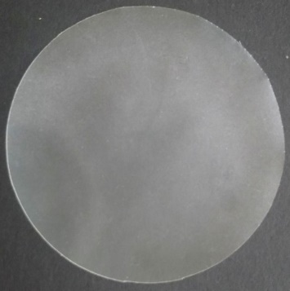
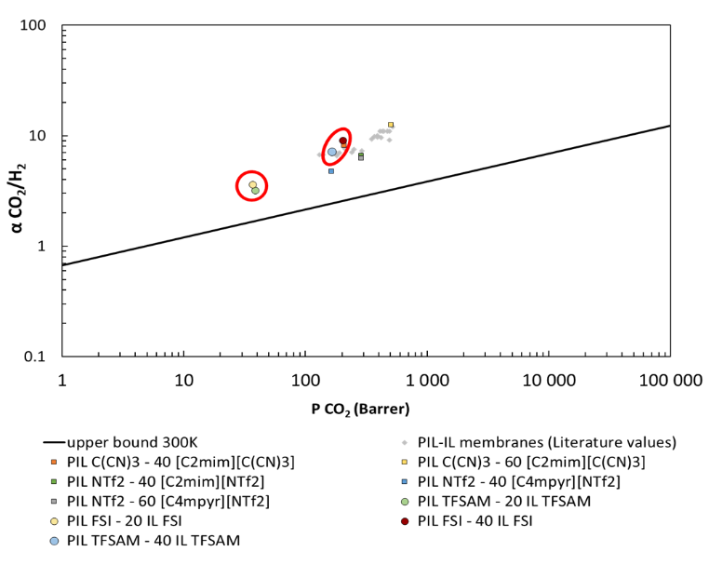
20% IL
40% IL
PIL–IL FSI composites
Figure 1. CO₂/H₂ separation performance of the PIL–IL membranes studied.
4. Conclusions
PILs and ILs containing anions based on fluorosulfonyl derivatives were synthesized and characterized. PIL–IL membranes were prepared to evaluate their CO₂/H₂ separation performance. In sum, higher CO₂/H₂ selectivities were obtained for both PIL FSI– 40 [C₂mim][FSI] (α = 9.0) and PIL TFSAM– 40 [C₂mim][TFSAM] (α = 7.1) compared to those of composites containing the conventional [NTf₂]⁻ anion (PIL NTf₂ – 40 [C₂mim][NTf₂] (α = 6.5) and PIL NTf₂ – 60 [Pyr₁₄][NTf₂] (α = 6.3).
References
- Merkel T.C., Zhou M., Baker R.W., J. Memb. Sci., 389 (2012) 441–450.
- Tomé L.C., Marrucho, I. M., Chem. Soc. Rev., 45 (2016) 2785.
- Gouveia A.S.L., Tomé L.C., Lozinskaya E.I., Shaplov A.S., Vygodskii Y.S., Marrucho I. M., Phys. Chem. Chem. Phys., 19 (2017) 28876-28884.
Acknowledgments
Andreia S. L. Gouveia is grateful to FCT (Fundação para a Ciência e a Tecnologia) for her Doctoral (SFRH/BD/116600/2016). This work was supported by FCT through the project PTDC/CTM-POL/2676/2014 and R&D units UID/QUI/00100/2013 (CQE) and UID/Multi/04551/2013 (GreenIT). This project has received funding from the European Union’s Horizon 2020 research and innovation programme under the Marie Sklodowska-Curie grant agreement No 745734.

