An Novel Electrochemical Sensor Based on ErGO/MWCNTs to
Detect 2, 4-dinitroanisole.
Shasha Feng, Yong Ding, Wu Lei*
School of Chemical Engineering, Nanjing University of Science and Technology, Nanjing 210094,
People’s Republic of China
*Corresponding author: leiwuhao@njust.edu.cn
Highlights
- Detection of 2, 4-dinitroanisole by the electrochemical method for the first time.
- Construct a sensor based on electrochemical reduced graphene oxide–multiwalled carbon nanotubes nanocomposite.
- Facile, cost-effective, and rapid manufacturing route.

1. Introduction
2, 4-Dinitroanisole (DNAN) as a low sensitivity melt-cast formulation, is a promising replacement for 2, 4, 6-trinitrotoluene (TNT). It is reported that DNAN is metabolized to 2, 4-dinitrophenol (2, 4-DNP) in the body, which is a chemical with high acute and chronic toxicity^{[1, 2]}. Graphene is a two-dimensional material with a single layer of carbon atoms tightly arranged honeycomb lattice^{[3]}. The conductivity of the electrochemical reduced graphene oxide (ErGO) is higher than that of graphene oxide^{[4]}. Carbon nanotube is a kind of one-dimensional material, which is made of single-layer graphene reel^{[5]}. The combination of the two materials not only preserves their respective properties, but also increases the energy transfer force of the electron and the binding sites to the electrically active substance^{[6]}. The synergistic effect of ErGO and multiwalled carbon nanotubes (MWCNTs) obviously increases the catalytic activity for DNAN. In this work, a novel electrochemical sensor was developed based on ErGO/MWCNTs to detect DNAN by linear sweep stripping voltammetry (LSSV).
2. Methods
The prepared GO/MWCNT/GCE was electroreduced to obtain ErGO/MWCNTs/GCE by cyclic voltammetry. Sensitivity of the sensor was quantified through the LSSV method using electrochemical workstation. Measurements were taken at a constant potential of -0.4 V and in 0.1 M PBS (pH = 7.0, containing 0.1 M NaCl).
3. Results and discussion
Experimental conditions are optimized, such as accumulation time and accumulation potential. Under optimal experimental conditions, as depicted in Figure 1, the current linearly increased with incremental DNAN concentration from 0.1 to 30 µM, and the limit of detection (LOD) was calculated to be 0.084 µM（S/N = 3）.
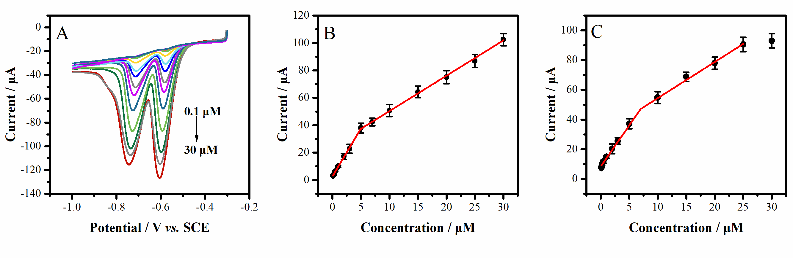
Figure 1. LSSV curves of the sensor in the presence of DNAN with different concentrations (A).
The calibration curves for DNAN detection about peak α (B) and peak β (C).
DNAN concentrations: 0.1, 0.2, 0.3, 0.5, 1.0, 2.0, 3.0, 5.0, 7.0, 10.0, 15. 0, 20.0, 25.0, 30.0 μM.
4. Conclusions
A novel efficient electrochemical sensor, ErGO/MWCNTs/GCE, was successfully constructed to analyse the low concentration levels of DNAN. The sensor got high sensitivity due to the excellent catalytic activity of ErGO/MWCNTs nanocomposite. The sensor was successfully applied to determine DNAN in water samples with the advantages of anti-interference performance, good reproducibility, and acceptable stability.
References
- N.N. Perreault, D. Manno, A. Halasz, S. Thiboutot, G. Ampleman, J. Hawari. Biodegradation. 23 (2012) 287-295.
- V.M. Boddu, K. Abburi, S.W. Maloney, R. Damavarapu. J. Chem. Eng. Data. 53 (2008) 1120-1125.
- V. Singh, D. Joung, L. Zhai, S. Das, S. I. Khondaker, S. Seal. Prog. Mater. Sci. 56 (2011) 1178-1271.
- M. Pumera. Chem. Soc. Rev. 39 (2010) 4146-4157.
- T. Nosaka, R. S. Lankone, Y. Bi, D. H. Fairbrother, P.Westerhoff, P. Herckes. Anal. Methods. 10 (2018) 1032-1037.
- Y. Vlamidis, I. Gualandi, D. Tonelli. J. Electroanal. Chem. 799 (2017) 285-292.

