AUTOMATIC DETECTION OF SCORCHED OR OTHER FOREIGN PARTICLES IN GRANULATION PROCESS USING INLINE PROBES
Mirco Wegener¹, Sebastian Maaß¹
1 SOPAT GmbH, Boyenstraße 41, 10115 Berlin, Germany
*Corresponding author: mirco.wegener@sopat.de
Highlights
- Live imaging ensures the view into the process
- Differentiation of different colors, shapes and sizes possible in a real time monitoring
- Quality assurance is used for optimization and feedback control

1. Introduction
Granulation, the process of particle enlargement by agglomeration technique, is one of the most significant unit operations in the production of pharmaceutical, chemical or food products. These process transforms fine powders into free-flowing, dust-free granules that are easy to compress. Nevertheless, granulation poses numerous challenges due to high quality requirement of the formed granules in terms of content uniformity and physicochemical properties such as granule size, bulk density, porosity, hardness, moisture, compressibility, nonexistence of foreign particles etc. together with physical and chemical stability of the drug, the chemical component or food ingredient.
Realtime monitoring of the named parameters using inline measurement technologies was discussed in general but not implemented throughout the industrial community due to severe technical challenges. Especially the measurement of granule size, granule shape and colour (implying scorched or other foreign particles) has not been implemented successfully in industrial granulation processes. The presentation will give a brief overview of existing measurement techniques developed for the above mentioned tasks, as different techniques based on different physical principles for measuring particle size distributions are available. The authors did compare several measurement techniques and will provide those results.
2. Methods
The mainly used system for this presentation is a newly developed photo optical in-line measurement technology combined with an innovative image processing and analysis software. These analyses show exactly the size, shape and colour of the granules. Additional parameters like local concentration or moisture can be derived from the image analysis. This makes it possible to monitor and to optimize granulation processes in a feedback loop, as the particle data are available in real time.
3. Results and discussion
The quality and variability in quality of the images obtained by the camera computer system (see Fig. 1) greatly influences the success of the automated interpretation. All important step will be discussed and presented in detail. A first example is given in the following figure.
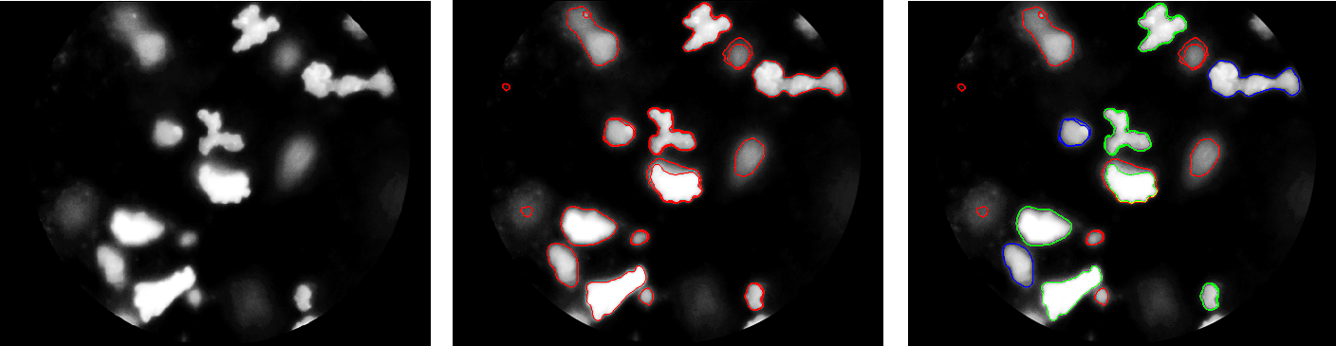
Fig. 1 image analysis steps for irregular shaped particles: (a) – original image; (b) – segmented image; (c) – classified image; only classified particles are used for the size distribution (green and blue; red are excluded)

The particle size and number are tracked over time and the information of the amount of foreign particles did lead to significant savings.
(c)
(b)
(a)

