Advection-dominated reactive species transport at fluid interfaces via data-driven Subgrid-scale modeling

Andre Weiner¹, Dennis Hillenbrand¹ , Holger Marschall¹ , Dieter Bothe¹*
1 Institute for Mathematical Modeling and Analysis, TU Darmstadt
Alarich-Weiss-Straße 10, 64287 Darmstadt
*Corresponding author: bothe@mma.tu-darmstadt.de
Highlights
- Subgrid-scale modeling for reactive concentration boundary layers
- Data-driven approach for approximate functions
- Significant reduction of mesh resolution and computation time

The transport of chemical species close to the gas-liquid interface of a rising bubble is typically characterized by strong advection along the interface and molecular diffusion normal to it. Consequently thin boundary layers form, which have to be resolved in numerical methods to evaluate local reaction-engineering quantities like enhancement factor, selectivity or yield accurately. In [1,2] we introduced a non-reactive subgrid-scale (SGS) model that mitigates this high-Schmidt-number problem significantly. This model was used successfully in [3] to validate numerical simulations against experimental results of species transport at small rising bubbles. The basic idea is to derive an analytical solution for a substitute problem which describes the main features of an advection-dominated boundary layer. This analytical solution is used to correct diffusive and convective fluxes in interface cells of the numerical simulation.
However, in the general case of reactive boundary layers it is not possible to derive closed-form solutions. Our new approach to extend the SGS modeling for reactive systems is based on a machine-learning algorithm which represents an approximate solution of the substitute problem over a chosen range for characteristic parameters like Peclet or Damkohler numbers. The machine learning algorithm - a multi-layer-perceptron - has adjustable weights which are optimized to reflect the numerical input data. As before, the approximate solution is used to correct the numerical fluxes near the interface in simulations. This approach was validated for the transport of a specie from a rising axisymmetric bubble followed by a first-order decay reaction in [4]. Figure 1 shows the improvement of the species transport via the local Sherwood number profile along the polar angle of the bubble. The flux corrections from the data-driven SGS model enable the representation of the reference profile even for coarse meshes. Additionally, the evaluation of the data-driven SGS model produces almost no computational overhead. This results in a significant reduction of computation time while introducing an error of less than 5% for the overall species transport. Due to the flexibility of this approach it can be adjusted to the required parameter ranges and extended to more complex reaction systems.

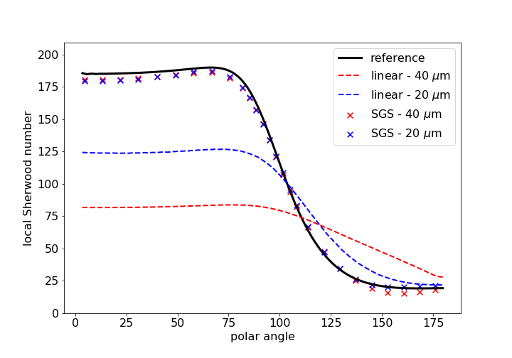
Figure 1. Local Sherwood number profiles for coarse meshes with and without using the SGS model.
References
- C. Pesci, A. Weiner, H. Marschall, D. Bothe, Computational analysis of single rising bubbles influenced by soluble surfactant, Journal of Fluid Mechanics, vol. 856, (2018), 709–763.
- A. Weiner, D. Bothe, Advanced subgrid-scale modeling for convection-dominated species transport at fluid interfaces with application to rising bubbles, J. Comput. Phys., 347, (2017), 261-289.
- A. Weiner, J.Timmermann, C. Pesci, J. Grewe, M. Hoffmann, M. Schlüter, D. Bothe, Experimental and numerical investigation of reactive species transport around a small rising bubble, arXiv e-prints,
p. arXiv:1811.03851, Nov. 2018
- A. Weiner, D. Hillenbrand, H. Marschall, D. Bothe, Data-driven subgrid-scale modeling for convection-dominated reactive boundary layers, submitted 2019

