A new methodology for the process monitoring of enzymatic proteolysis by size-exclusion chromatography

  - Sophie Beaubier^{1,2}, Irina Ioannou¹, Xavier Framboisier¹,
  - Olivier Galet², Romain Kapel¹*

1 Laboratoire Réactions et Génie des Procédés, Université de Lorraine, CNRS, LRGP, F-54000 Nancy, France
2 Avril SCA, 11 rue de Monceau, F-75008 Paris, France
Corresponding author: * romain.kapel@univ-lorraine.fr
Highlights
- A method for monitoring enzymatic proteolysis by SE-HPLC is developed
- The method assesses protein conversion rate, peptide size and DH in a single run
- The approach was tested on various proteins and hydrolysis conditions
- The method is as efficiently as TNBS or pH stat methods for DH quantification

1. Introduction
Enzymatic proteolysis is an industrial process used in a wide range of applications [1]. The extent of the enzymatic proteolysis process is usually quantified as the degree of hydrolysis (DH), which represents the percentage of peptide bonds cleaved compared to the initial number of peptide bonds of the protein [2]. An effective follow-up of the enzymatic proteolysis process requires the quantification of 2 others parameters: the protein conversion rate (Xp) and the mean peptide size released (Naa). These three different parameters are classically determined by three distinct analysis. The DH can be either determined by a method based on a spectrophotometric reaction with amino groups released during hydrolysis or based on a titration of protons released during a peptide bond hydrolysis. To determine Xp, the protein concentration must be specifically quantified by Reversed-Phase High-Performance Liquid Chromatography (RP-HPLC) or Kjeldahl method after protein precipitation with TCA. Molecular weight distribution of peptides is classically achieved by Size-Exclusion High-Performance Liquid Chromatography (SE-HPLC) based on the UV signal at 214 nm. This makes the enzymatic proteolysis process laborious to monitor. In this way, the communication describes an original methodology to quantify simultaneously these three criteria by size-exclusion chromatography (SE-HPLC).
2. Methods
The protein conversion rate is simply deduced from the evolution of the protein peak area in the course of the reaction. With the chosen column (Superdex peptide 10/300 GL column), proteins are eluted in the column dead volume due to the column separation domain (< 7 kDa). For the mean peptide size and DH, the methodology consists in converting peptide UV absorbances of chromatograms into concentrations by applying Beer-Lambert law [4]. To do so, a molar extinction coefficient is assessed for each chromatogram point (Eq. 1). The coefficient depends on the hydrolysate aminoacid compositions and the molar weight corresponding to the considered point (deduced from SE column calibration).
$ε_{x}= ε_{bond}× \left(\frac{{10}^{a×V_{x}+b}}{{\overline{MM}}_{aa}}-1\right)+{\overline{ε}}_{aa}\left(\frac{{10}^{a×V_{x}+b}}{{\overline{MM}}_{aa}}\right)$ (Eq. 1)
With$ε_{bond}$, the molar extinction coefficient of peptide bond and $\overline{\text{MM}}\text{aa}$, the mean amino acid molar mass of the hydrolysate.
The overall concentration signal is integrated and Naa is calculated with the ratio of the molar quantities of amino acids (determined with Eq. 2) to peptides (determined with Eq. 3) in the hydrolysate. DH is deduced from the ratio of Xp and the mean size of peptide.
$n_{p}= Qv\int{\left({Cp}_{x}\right) dt}$ (Eq. 2) $n_{aa}= Qv\int{\left({Cp}_{x} \overline{\text{N}}{aa}_{x}\right) dt}$ (Eq. 3)
with Q_{v} the elution flow rate and dt a fraction of the elution time.
3. Results and discussion
As a first step, the approach was tested on the hydrolysis of bovine serum albumin (BSA) and rapeseed albumin (RA) by Alcalase 2.4L because of their different origin, structure, isoelectric point and composition. Hydrolysis kinetics were monitored by SE-HPLC (Figure 1A) and the 3 parameters were determined in the course of reaction as described above. Values of DH were also determined by TNBS and pH-stat methods. Most of the hydrolysates obtained showed relative differences <20% with the reference methods (Figure 1B). The method was also adapted to fit the TNBS assay.
B
A
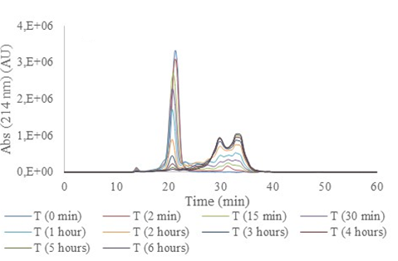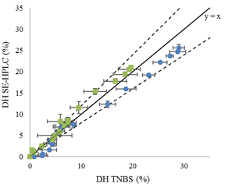
Figure 1. (A) Size exclusion chromatograms obtained for the hydrolysis of 1 % (w/v) RA with Alcalase 2.4 L over 6 h; (B) Comparison of the DH values obtained with the SE-HPLC and TNBS methods for the hydrolysis of 1 % (w/v) BSA () and RA () with Alcalase 2.4 L. Values are means of triplicate determinations. Error bars show standard deviation.

Then, validation of the methodology was realized through a statistical comparison between the DH values obtained by the method and those obtained with TNBS and pH stat methods for BSA, RA and lysozyme substrates. 39 experimental validation tests were analysed by SE-HPLC, TNBS and pH stat methods. 90% of the validation data show non-significant differences between the DH predicted and the DH measured by TNBS method.
4. Conclusions
The proposed methodology can be efficient for the process monitoring of enzymatic proteolysis while minimizing time and quantity of sample assay required. Moreover, it could be used for functionalities or bioactivities analysis of produced hydrolysates.
References
[1] Tavano, O. L. (2013). Protein hydrolysis using proteases: an important tool for food biotechnology. Journal of Molecular Catalysis B: Enzymatic, 90, 1-11.
[2] Adler-Nissen, J. (1986). Enzymatic Hydrolysis of Food Proteins, Elsevier Applied Science Pub., New York.
[3] Bodin, A., Framboisier, X., Alonso, D., Marc, I., Kapel, R. (2015). Size-exclusion HPLC as a sensitive and calibrationless method for complex peptide mixtures quantification. Journal of Chromatography B, 1006, 71–79.

