Investigating Deep-Sea Oil Spills – Transfer of Engineering Methods to an Environmental Issue in Experiments and Modeling
Simeon Pesch^{1*}, Claire Paris², Zachary Aman³, Philip Jaeger⁴, Marko Hoffmann¹, Michael Schlüter¹
1 Hamburg University of Technology, Institute of Multiphase Flows, Eissendorfer Str. 38, 21073 Hamburg, Germany; 2 University of Miami, Rosenstiel School of Marine and Atmospheric Science, 4600 Rickenbacker Causeway, Miami, FL 33149, USA; 3 University of Western Australia, Dept. of Chemical Engineering, 35 Stirling Hwy., Perth WA 6009 Australia; 4 Eurotechnica GmbH, An den Stücken 55, 22941 Bargteheide, Germany
*Corresponding author: simeon.pesch@tuhh.de
Highlights
- Scale-up of oil-in-water DSD and effects of pressure are examined experimentally.
- New approach for prediction and scale-up of jet DSD based on TKE dissipation rate.
- Rise of gas-saturated oil droplets is accelerated by pressure-induced degassing.

1. Introduction
The depletion of readily accessible oil reservoirs in conjunction with the unabated demand for fossil fuels leads to the exploration and production of remote deposits, esp. in deep-sea regions. Such operations at hard-to-reach locations far beyond atmospheric conditions are extremely challenging and associated with elevated risk, which became clear when the Deepwater Horizon drilling rig ignited and sank in 2010 in the Gulf of Mexico, causing one of the largest oil spills in human history. The depiction and prediction of the multiphase plume’s behavior under deep-sea conditions and the oil fate is critical for the development of mitigation strategies in case of a subsea blowout. Some of the most important input parameters for accurate oil fate modeling are the ensuing droplet size distribution (DSD), the rise velocity of the present droplets and bubbles plus the physical properties and phase behavior of the involved substances. The highly turbulent flow structure and the multiphase nature of the system as well as the specific deep-sea conditions must be accounted for when experimental facilities are designed or when oil-spill models are developed and tuned^{[1]}.
2. Methods
Extensive experimental research on the oil and gas behavior under ambient and in-situ conditions is done at Hamburg University of Technology (TUHH). The DSD of oil-in-water free jets at varying nozzle sizes, measuring positions and exit velocities as well as appropriate scale-up rules for the prediction of the DSD are investigated under ambient conditions. For this purpose, a lab-scale and a pilot-plant-scale experimental plant with direct optical access have been designed, commissioned and used, covering nozzle diameters from 1 mm to 74 mm and volume flow rates from 0.28 to 200 L/min. Particle image velocimetry is applied for the investigation of flow characteristics like the turbulent kinetic energy (TKE) dissipation rate. A colorized white oil (H&R PIONIER 7467) is used as dispersed and DI water as continuous phase. The DSD is determined by means of endoscopic imaging techniques. A high-pressure counter-current flow cell is used in order to simulate the rise of gas-saturated crude oil droplets (Louisiana Sweet Crude oil, saturated with CH₄, in seawater). Reservoir conditions (~250 bar) and depth-dependent hydrostatic pressures of up to 150 bar, corresponding to the 1,500 m water column of the Deepwater Horizon blowout, can be adjusted. Temperatures range from 4 to 25 °C, also corresponding to the real conditions. The droplet’s size, shape and motion is captured by means of high-speed imaging and evaluated over time^{[1]}.
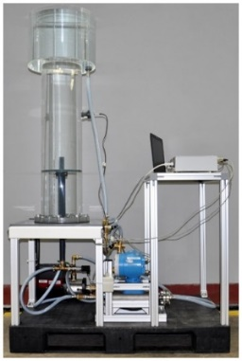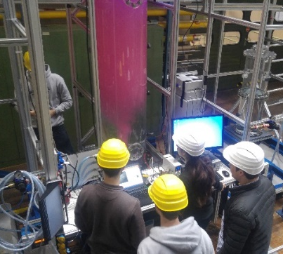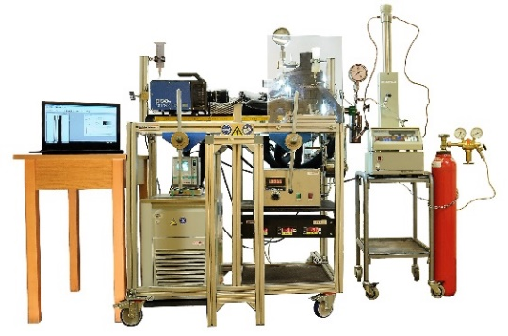
a b c
Figure 1. Experimental facilities for the investigation of submarine oil spills at TUHH: a. Lab-scale jet facility with direct optical access and variable nozzle size; b. Oil-in-water jet experiment in the pilot-plant-scale jet facility; c. High-pressure counter-current flow cell for the investigation of single rising live-oil droplets under simulated deep-sea conditions.
3. Results and discussion
The recorded droplet sizes of the oil-in-water jets are approximately log-normally distributed. In collaboration with the University of Western Australia, a new model correlation for the prediction and scale-up of the jet DSD based on the TKE dissipation rate (TDR) and incorporating the recent experimental results as well as older datasets is developed at TUHH. The model correlates the mean diameter with the TDR, which is calculated by means of literature equations, using a power-law function. The results are independent of the nozzle size but scale with the TDR value, which enables scale-up. In contrast to models available in literature, this quite fundamental correlation is capable of accounting for high-pressure effects, like pressure drop at the blowout site and outgassing of dissolved natural gas from the liquid oil. In the drop-rise experiments, gradually decreasing the pressure leads to the formation of gas bubbles inside the initially gas-saturated but purely liquid crude oil droplets. This internal degassing causes a substantial growth of the two-phase particles and a significant decrease of their average density. Both effects lead to an increased buoyancy and therefore a higher rise velocity of the droplets. The enhanced buoyancy of gas-saturated droplets is implemented into the 3D Lagrangian oil fate model by Paris et al. at the University of Miami^{[2]}.
4. Conclusions
The presented experimental results and modeling approaches help to understand and predict the fate of the oil masses in case of a subsea blowout. The multiphase nature of the oil and gas jet in question that determines the droplet size distribution as well as pressure-dependent effects like enhanced buoyancy due to degassing are critical for accurate oil fate modeling. This research was made possible by a grant from the Gulf of Mexico Research Initiative, C-IMAGE III.
References
- S. Pesch, P. Jaeger, A. Jaggi, K. Malone, M. Hoffmann, D. Krause, T.B.P. Oldenburg, M. Schlüter, Environ. Eng. Sci. 35(4), 2018, 289–299.
- C. Paris, M. Le Henaff, Z. Aman, A. Subramaniam, J. Helgers, D.-P. Wang, V. Kourafalou, A. Srinivasan, Environ. Sci. Technol. 46(24), 2012, 13293–13302.

