Application of the sale-down methodology to study the effect of mixing on Trichoderma reesei physiology and enzyme production
Tamiris Roque¹, Fadhel Ben Chaabane¹, Frédéric Augier², Catherine Béal³, A. W Nienow⁴
1 IFP Energies nouvelles, 1 et 4 avenue de Bois-Préau, 92852 Rueil-Malmaison, France ; 2 IFP Energies nouvelles, Rond-point de l’échangeur de Solaize, BP3, 69360 Solaize, France ; 2 UMR 782 AgroParisTech INRA, 1 avenue Lucien Brétignières, 78850 Thiverval-Grignon, France ; 3 School of Chemical Engineering, University of Birmingham, Edgbaston, Birmingham B15 2TT, United Kingdom
*Corresponding author: tamiris.goncalves-roque@ifpen.fr
Highlights
- Trichoderma reesei is sensitive to anaerobiosis
- Oxygen gradients in T. reesei cultures lead to a complex metabolic response
- Long exposure of T.reesei to anaerobiosis decrease the cellulases production

1. Introduction
Techno-economic evaluations of processes for ethanol production from lignocellulosic biomass show that reducing the cost of the cellulases used to hydrolyze the cellulose into glucose is a prerequisite to bring the ethanol cost to values close to the ethanol produced from starch. A very attractive option is to perform the production of enzymes on site in order to substitute expensive and pure carbon sources by lignocellulosic waste generated by the agri-food or forestry activity.
Industrial cellulases are mainly produced by an aerobic filamentous fungus, Trichoderma reesei, because of its high secretion capacity. Scaling-up this process is very challenging because of the complex links that exist between the process conditions, the morphology of this fungus and its productivity. Actually, the filamentous morphology induces an increase of the medium viscosity that strongly reduces the oxygen mass transfer rate. To ensure a sufficient rate, the power input has to be increased, which increase the fluid dynamic stresses on the mycelial structures. Carrying out fermentations with these microorganisms is complicated as the fungal morphology impacts process parameters, whereas process conditions affect in return the morphology and possibly the process productivity. Moreover, with increasing scale, the media experiences ever increasing spatial and temporal variations, especially in dissolved oxygen and sugar concentration compared to the bench scale. Scale-down techniques are a way of establishing at the bench scale the large scale behavior and their implications for the economics of the process. The goal of this work is to better understand and evaluate the impact of the upscaling on the physiology of T. reesei.
2. Methods
The effect of physical-chemical heterogeneities induced by the scale-up on the behavior of the microorganism are investigated using 2 scale-down approaches : a two-compartment system (2STR) and a single compartment system (1STR). The enzyme production follows a two-steps process: growth and production. The growth step is operated in batch mode in excess of sugar to reach biomass concentrations of 15g/L. Cultures medium, preculture and operating conditions in growth step are similar to those reported in [1]. The production step is carried out in fed-batch mode. For the 2STR experiment, a 3.5L aerobic bioreactor (2.5L of culture medium) kept at 40% of dissolved oxygen saturation (pO₂) is connected to a 2.0L anaerobic bioreactor (0.5L of culture media) where the pO₂ is kept at 0% by injecting nitrogen. Two peristaltic pumps keep the broth circulating between the two bioreactors throughout the experiment. Two different cycling residence times in the anaerobic zone are tested by changing the volume of the bioreactors. For the 1STR experiment, cycling oscillations in the pO₂ (0-40%) are produced in a single 3.5L bioreactor by injecting a mix of air and nitrogen. For both scale down approaches, the temperature is 27°C and pH is 4.0 for all the experiments. The gas flow rate in the 3.5L bioreactors is constant and equal to 0.25 l/mn. A determination of the secreted proteins concentration is achieved on the medium filtrate by using the DCTM Protein Assay kit (Biorad, Hercules, United States of America) and is based on a range of bovine serum albumin (BSA, 0-1.5 gL-1) [2].
3. Results and discussion
As reported in figure 1.I & II, results indicated a decrease of 20% in the specific production rate and yield for longtime cycling exposures (15min) to anaerobic conditions in the 2STR experiments. This effect is quite low because heterogeneities of 15min are unlikely to occur in full-scale bioreactors. The comparison of the two different scale down approaches (2STR and 1STR) in figure 1.III showed very different results for the same characteristic times (3,4min) in the anaerobic zone. This indicates a) the sensitivity of T. reesei to anaerobiosis and b) the fact that the metabolic response is complex and not immediate because it depends on the distribution of the residence times of the microorganisms in the aerated or non-aerated zones.
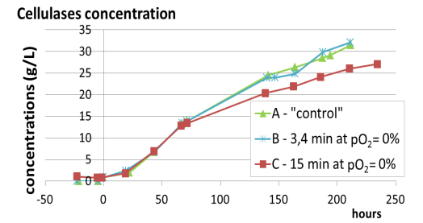 | 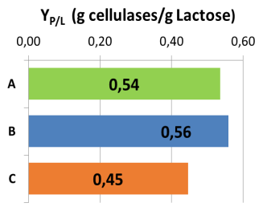 | 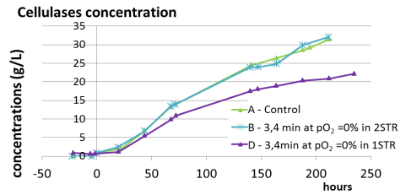
I | II | III

Figure 1. I & II) Comparison of cellulases production and yield (respectively) for three cultures in 2STR : A - control (no oxygen oscillations), B - 3,4 min and C - 15 min of cycling exposure to pO₂=0% ; III) Comparison of two different scale-down approaches for 3,4 min of cycling exposure to pO₂=0% : B - 2STR and D - 1STR
4. Conclusions
In this study, the effect of oxygen oscillations on enzyme production has been investigated during cultures of T. reesei. The possible low sensitivity of the fungus with respect to oxygen heterogeneities in production phase, opens perspectives in terms of technological choice on an industrial scale. However, its complex biological response to oxygen oscillations seems to be correlated with the distribution of the residence time in anaerobic zones inside large bioreactors.
References
- Hardy, N., Augier, F., Nienow, A., Béal, C., Ben Chaabane F. (2017), Chem. Eng.Sci., 172: 158-168.
- Lowry, O.H., Rosebrough, N.J., Farr, A.L. and Randall, R.J. (1951), J. Biol. Chem., 193: 265–275.

