Electrochemical reduction of CO₂ paired with Cl₂ production.
Amanda Cristina Garcia*, Roman Latsuzbaia, Elena Pérez-Gallent, Susan Turk, Anca Anastasopol, Erwin Giling, Earl Goetheer.
Department of Sustainable Process and Energy Systems, TNO, Leeghwaterstraat 44, 2628 CA Delft, The Netherlands
*amanda.garcia@tno.nl
Highlights
- Electrochemical carbon dioxide reduction.
- Electrochemical chlorine production.
- Paired electrolysis.
- Sustainable energy.

1. Introduction
Organic electrosynthesis is a potentially cost-effective, scalable and green method of synthesizing organic products using renewable electricity. In most cases, however, the chemistry that occurs at the counter electrode yields a waste product, which holds little economic value. To overcome this issue, paired electrolysis seems promising since it forms useful products at both electrodes. The electrochemical reduction of CO₂ has become one of the most interesting topics because of the worldwide interest in its conversion into valuable chemicals and fuels. The use of CO₂ as a C1 feedstock for the formation of more valuable chemicals offers the use of an easy, available and renewable carbon source, which is non-toxic and abundant.
On the other side, chlorine (Cl), the second most abundant halogen, is incorporated in about 70% of all manufactured chemical products. Nevertheless, some of the chlorine frequently combines with hydrogen, becoming hydrogen chloride (HCl) – a corrosive and hazardous waste material. In this context, pairing electro-oxidation of chloride with electro-reduction of CO₂ offers the possibility to make valuable chemicals on both electrodes.

2. Methods
Electrochemical measurements were carried out with an Autolab potentiostat connected to an H-type two compartment electrochemistry cell, which were separated by a Nafion 117 membrane. The anodic compartment was fed with 0.1 M HCl while the cathodic compartment was fed with 0.5 M KHCO₃ saturated with CO₂ gas. Platinum wire (Φ = 11 cm²) , Au wire (Φ = 6.44 cm²) and Ag/AgCl were used as working, counter and reference electrodes, respectively. Before electrolysis, cyclic voltammograms were performed for each reaction in a single cell. After matching the current density obtained for each single reaction, electrolysis was performed in galvanostatic mode during 1.5 hour. In order to compare the results with a more realistic system, electrochemical measurements were also carried out in a micro flow cell purchased from ElectroCell with two different compartments separated by a anionic exchange membrane (Nafion). The working electrode (WE) was a platinum plate (Alfa Aesar, 99.9%) with a surface area of 10 cm² and the counter electrode (CE) was a gold foil with a surface area of 10 cm². The anolyte and the catholyte were both recirculated through the electrochemical cell with a flow rate of 25 L/h. In both cell, the cathodic compartment was connected to the gas chromatograph (Interscience) (GC) in order to identify gaseous products, while the anodic compartment was connected to a filter containing 1.0 M NaOH in order to collect the gas chlorine (Cl₂) produced. The concentration of Cl₂ was analyzed by using UV-vis.
3. Results and discussion
Based on the cyclic voltammograms (Figure 1) obtained for each single reaction, we found that a current density of 8 mA cm⁻² matches for both electrochemical CO₂ reduction and Cl⁻ oxidation. The following discussion is based on the results obtained by using flow cell setup. Electrolysis electrolysis was performed by applying the corresponding current during 1.5 h. The cell voltage measured during electrolysis was 4.3 V vs. Ag/AgCl, which was stable from the beginning to the end of measurements. The anode potential (Pt – Cl₂ production) was 1.85 V vs. Ag/AgCl while the measured cathode potential (Au – CO₂ reduction)) was -2.5 V vs. Ag/AgCl (not showed).
During the simultaneous redox reaction, hydrogen and carbon monoxide were detected by GC as gaseous products from CO₂ reduction on Au electrode. The data are showed in Figure 2. According to the results, higher concentration of CO was obtained in the beginning of the reaction (3200 ppm) and it decreases to around 500 ppm over time, however the concentration of hydrogen increases. According to Surendranath et al.[1] it happens because of gold electrode deactivates during reaction due to the adsorption of metal impurities on the surface of the electrode leading to a decrease in product formation. Aliquots of NaOH solution, used to capture the Cl₂ produced at the anode was analyzed before and at the end of the electrolyses. The measured concentration of Cl₂ found was 930 mg / L.
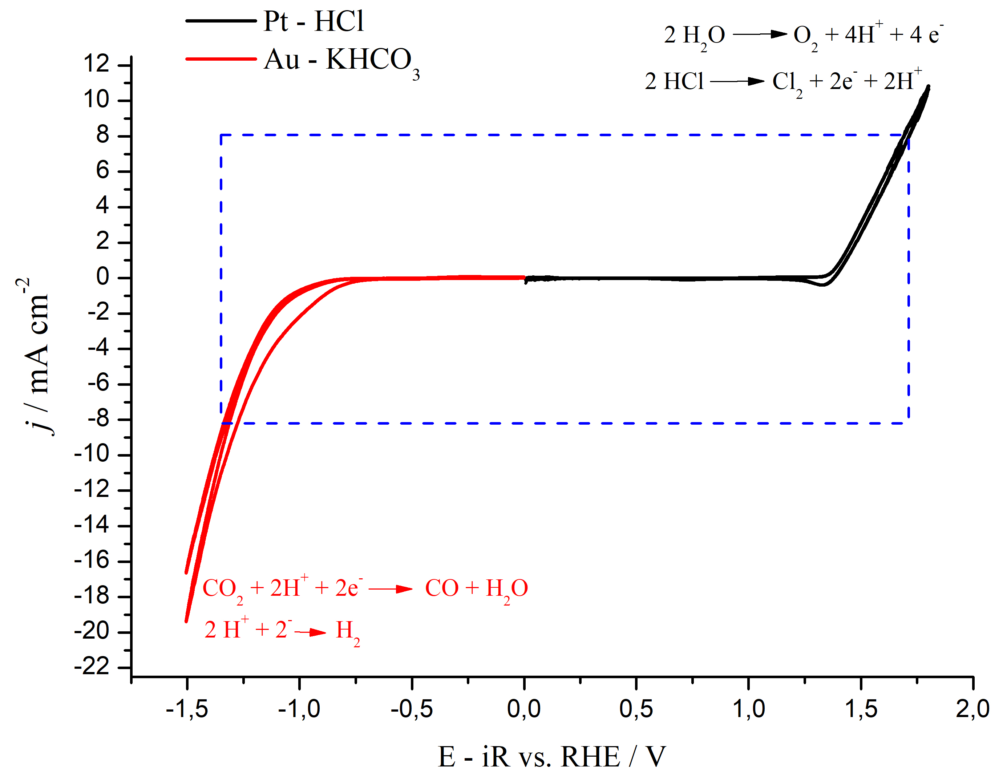  Figure 1. Cyclic voltammograms obtained at 10 mV s⁻¹ for electrochemical CO₂ reduction (red line) and Cl⁻ oxidation (black line) on Au and Pt, respectively. | 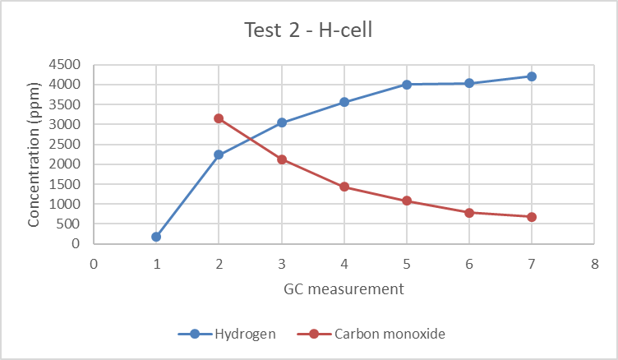  Figure 2. Concentration of CO and H₂ measured during electrochemical reduction of CO₂ on gold electrode paired with Cl₂ production.

4. Conclusions
Despite the low concentration of CO produced during the CO₂ electro-reduction reaction, our results proved the principle of the paired electrolysis of CO₂ reduction and Cl₂ production. New tests will be done in order to optimize the system, moreover this is a technology which can be applied not only for production of CO but also to other CO₂ electro-reduction products, such as ethylene, formic acid, ethanol and etc.
References
[1] Wuttig, A.; Surendranath, Y., Impurity Ion Complexation Enhances Carbon Dioxide Reduction Catalysis. ACS Catalysis 2015, 5 (7), 4479-4484.

