Nano-structural modification of calcium alginate membrane for high performance separation of mono/oligosaccharide
Kaito Yoshida¹, Keita Kashima^{1†}, Masanao Imai²
1 Department of Materials Chemistry and Bioengineering, National Institute of Technology, Oyama College, 771 Nakakuki, Oyama, Tochigi, 323-0806, Japan;
2 Graduate School of Bioresource Sciences, Nihon University, 1866 Kameino, Fujisawa, Kanagawa, 252-0880, Japan
Corresponding author: † keitakashima@oyama-ct.ac.jp
Highlights
- Calcium alginate membrane for mono/oligosaccharide separation was successfully prepared.
- The structure of membrane was modified using polyethylene glycol in low-molecular-weight.
- Improvement of water permeability and sustention of glucose rejection were achieved.
- Introduction
High-yield purification of monosaccharide and oligosaccharide is still demanded for advanced research in biological chemistry and bioengineering. Separation membrane from calcium alginate known as biopolymer has promising ability for molecular-size-screening of monosaccharide and oligosaccharide. ^{[1-2]} This study demonstrates nano-structural modification of calcium alginate membrane using polyethylene glycol in low-molecular-weight (PEG, M_{n} = 200 Da) for high-performance separation of mono/oligosaccharide.
- Methods
2.1 Preparation of the calcium alginate membrane
A mixed solution of 10 g L⁻¹ of the sodium alginate and 0 to 13 g L⁻¹ of PEG was placed in a petri dish (φ 90 mm), which was dried at 303 K for 48 h in an electrical drying machine. The dried membrane was immersed in 20 mL of 1 M aqueous calcium chloride solution to cross-link alginate polymer for 40 min. The formed calcium alginate membrane was washed to remove PEG with 100 mL of deionized water at 333 K for 30 min repeated twice within a shaking bath.
2.2 Membrane permeation of aqueous solution of glucose
The prepared membrane was installed in a membrane holder (KST-90-UH, ADVANTEC). 10 mM glucose aqueous solution was permeated to the membrane with an operating pressure of 300 kPa using nitrogen gas. The mass of glucose solution permeated through the membrane was measured by electrical balance and was converted to permeated volume using density. The volumetric permeation flux, J_{V} [m³ · m⁻² · s⁻¹] was determined using the following equation (1).
$$J_{v}=\frac{V}{At} (1)$$
Where, V, A, and t are the volume of permeated solution [m³], permeation area [m²] (A = 0.00453 m²), and permeation time [s], respectively. In addition, the concentration of permeated glucose solution was quantified through a mutarotase-glucose oxidase method with UV-Visible spectrophotometer (λ= 505 nm). The rejection of glucose molecules (R [-]) by the calcium alginate membrane was evaluated from the equation (2).
$$R=1-\frac{C_{s}}{C_{f}} (2)$$
Where, C_{s} and C_{f} are the concentration of permeated solution [M] and the concentration of feed solution [M].
- Results and discussion
Figure 1 shows the effect of added/removed PEG concentration on the permeation flux of glucose aqueous solution. The permeation flux remarkably increased with the increase of added concentration of PEG when the membrane was prepared. The water permeation was improved by the structural modification of membrane.
Figure 2 depicts the effect of added/removed PEG concentration on the rejection of glucose. The rejection was almost constant although the permeation flux was increased by the PEG modification, which indicates the size of mass transfer channel for glucose permeation was kept as well as the volume of channel increased. Addition and removal of low-molecular-weight PEG performed nano-structural modification.

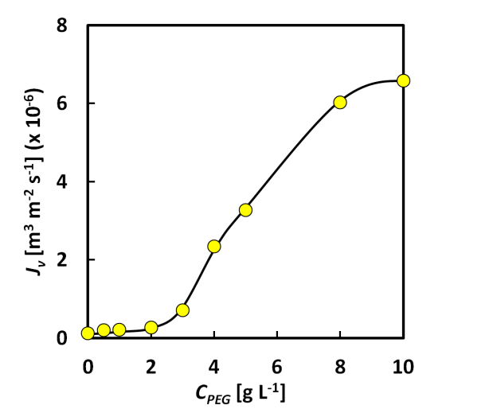
Fig. 1 Effect of the added/removed concentration of PEG (C_{PEG}) on the permeation flux of glucose aqueous solution (J_{V})
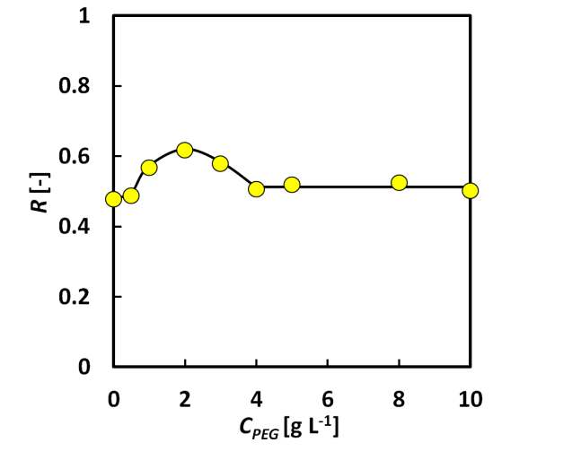
Fig. 2 Effect of the added/removed concentration of PEG (C_{PEG}) on the rejection of glucose molecules (R)

- Conclusions
The improvement of water permeability and the sustention of glucose rejection were achieved by the nano-structural modification of calcium alginate membrane using low-molecular-weight polyethylene glycol. The modified membrane is expected to exert high performance on the separation of monosaccharide and oligosaccharide.
References
- K. Kashima, M. Imai, Desalination and Water Treatment, 34 (2011) 257-265.
- K. Kashima, M. Imai, Food and Bioproducts Processing, 102 (2017) 213-221.

