Oil-Water Biphase Chaotic Mixing Enhanced by Elastic Combination Impeller in Mixer-Settler.
Zuohua Liu¹, Chuang Wang¹, Deyin Gu¹, Facheng Qiu¹, Changyuan Tao¹, Yundong Wang²
1 School of Chemistry and Chemical Engineering, Chongqing University,Chongqing400044,China; 2 State Key Laboratory of Chemical Engineering, Department of Chemical Engineering, Tsinghua University, Beijing 100084,China
*Corresponding author: Prof. LIU Zuohua, liuzuohua@cqu.edu.cn
Highlights
- The spring of the elastic impeller is easy to stretch and bend, which can change the way of impeller disturbing the flow field structure.
- The elastic combined impeller strengthens the energy dissipation mode of the flow field through the deformation and energy storage of the spring, and improves the chaotic mixing degree of the liquid and liquid biphases.

1. Introduction
The problem of low energy consumption and high efficiency exists in the traditional liquid-liquid biphase extraction in the mixer-settler. By means of Lab View software, pressure pulsation signals in the mixed fluid in the disturbing and clarifying tank of the rigid impeller, rigid -flexible combined impeller and elastic combined impeller are respectively collected. And then get the largest Lyapunov exponent (LLE) and multiscale entropy (MSE) which are reflects the degree of chaos in the fluid. At the same time, the fluid field’s visualization technology was adopted to observe fluid mixing performance, the influence of the length, diameter and outer diameter of the spring on the chaotic characteristics of the flow field is also investigated. The results indicated that compared with the rigid impeller and the rigid-flexible combined impeller, the elastic combined impeller strengthens the energy dissipation mode of the flow field through the deformation and energy storage of the spring, and improves the chaotic mixing degree of the liquid and liquid biphases. The LLE was over zero, testifying the fluid mixing system in chaotic state. In the elastic combination impeller system, not only are the values of LLE and MSE significantly higher, but also the time of complete decolorization is the shortest in the visualization experiment.
2. Methods
Experiments are conducted in the mixer settler and control room temperature 24 ℃ - 27 ℃, water and kerosene as experiment medium oil-water and two chaotic mixing experiment, the experimental process control the volume flow of water and kerosene ratio of 1:1. The pressure pulsation signal is collected on the mixed indoor wall of the mixing clarifying tank. After that, the pressure sensor, data acquisition card and data acquisition system composed of workstation are converted and processed on the Lab View working platform and then output. The output data are programmed and calculated by Matlab software. Where, each group of experiments was sampled for 15 min with a sampling frequency of 65 Hz. The mixer-settler and impellers used in the experiment are shown in Fig. 1 and Fig. 2 respectively.

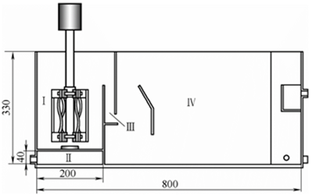
Figure 1. Structure of mixer-settler
Ⅰ-mixing chamber; Ⅱ-submersible mixing chamber;
Ⅲ-overflow area; Ⅳ-clarification chamber

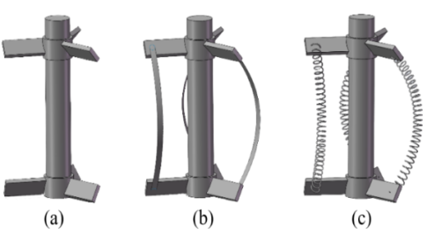

Figure2. Impellers used in experiment
(a)rigid combination impeller (b)rigid-flexible combination impeller (c)elastic combination impeller

3. Results and discussion
The LLE is an important parameter to measure the dynamic characteristics of the system. It reflects the average exponential rate of convergence or divergence between adjacent orbits in the phase space system [1]. Multi-scale entropy (MSE) is to calculate the sample entropy of time series at multiple scales, which reflects the irregularity of time series at different scales. It has good anti-noise and anti-interference ability, and the analysis of time series is more systematic. The experimental results are shown in figure 3 and 4.
Figure 3. Effect of impeller type on LLE
Figure4. Effect of impeller type on MSE
4. Conclusions
Due to the spring's characteristics of being easy to stretch and bend, the elastic combination impeller can effectively destroy the stability of the flow field structure near education and regulate the flow field, thus strengthening the chaotic mixing of the flow field. The mixing effect is obviously better than that of the rigid-flexible combination impeller and rigid combination impeller.
References
- LIU Z H, ZHENG X P, LIU D, et al. Enhancement of liquid-liquid mixing in a mixer-settler by a double rigid-flexible combination impeller [J].Chemical Engineering and Processing: Process Intensification, 2014, 86: 69-77. A. Bianchi, N.C. Jones, Chem. Eng. J. 157 (2019) 326–337.

