**Multidimensional fractionation of finely dispersed particles using the cross-flow filtration with superimposed electric field**

Philipp Lösch, Kai Nikolaus, Sergiy Antonyuk

*Institute of Particle Process Engineering, Technische Universität Kaiserslautern, 67663 Kaiserslautern*

*\*Corresponding author: Philipp.loesch@mv.uni-kl.de*

**Highlights**

* Fractionation of fine particles by hydrodynamic effects
* Affect the separation method by adding additives
* CFD simulation of a crossflow filtration with electric field

**1. Introduction**

The separation of particle fractions with highly specific physical properties from suspensions has great importance for process success in various engineering processes. The physical properties of a particle collective are directly related to the particle size, particle shape, surface properties and chemical composition of the individual particles. Frequently, suspensions form highly complex particle collectives, which contain all of these features in different distributions. Since the characteristic dimensions of the technical structures in the raw materials are continuously decreasing, ever finer, more highly specific particle systems will be produced, processed and recycled. In known separation processes, such as e.g. Sedimentation, filtration or centrifugation, the particles are either classified according to a certain grain size or sorted by a physical characteristic. However, in many applications in which finely dispersed multicomponent mixtures of particles with sizes < 10 μm with different properties are to be separated in industrially relevant quantities, the use of a single separating feature is often no longer sufficient. Therefore this present study focusses on the utilization of multiple separating features to amplify the separation process.

**2. Methods**

In this research project, a novel cross-sectional superficial electric field filtration technique is being developed, which is a promising method for the highly specific separation of micro- and sub-micron suspensions. The particles are thus subject both to an electric field and to the lift and drag force. The method not only allows fractionation with regard to the particle size, but also the particle shape, the chemical composition and the physical properties of the individual particles. In most theoretical and experimental studies, individual separation features were only studied separately, but the development of a multidimensional fractionation method requires knowledge of the relationships between the superimposed effects. The construction and operation of suitable facilities should be made possible by the knowledge gained in the research project.

**3. Results and discussion**

First studies on the hydrodynamic effects of different particle distributions and concentrations showed, that a classification is possible. To achieve a multidimensional fractionating, an electric field across the filter media add an electrophorese force. The multidimensional fractionation of a suspension according to the separation characteristics grain size, particle shape and zeta potential can be achieved by the combination of lift force, drag force and electrophoretic force. Therefore, the isoelectric point and the charge of the particles of the used stable suspensions were investigated.



**Figure 1.** scheme of the fractionation process

Beside the experiments, the adjustment of the macroscale particle transport process is supplemented by CFD simulations with the Euler-Lagrange approach. This will help to find the operation point for the experimental investigations.

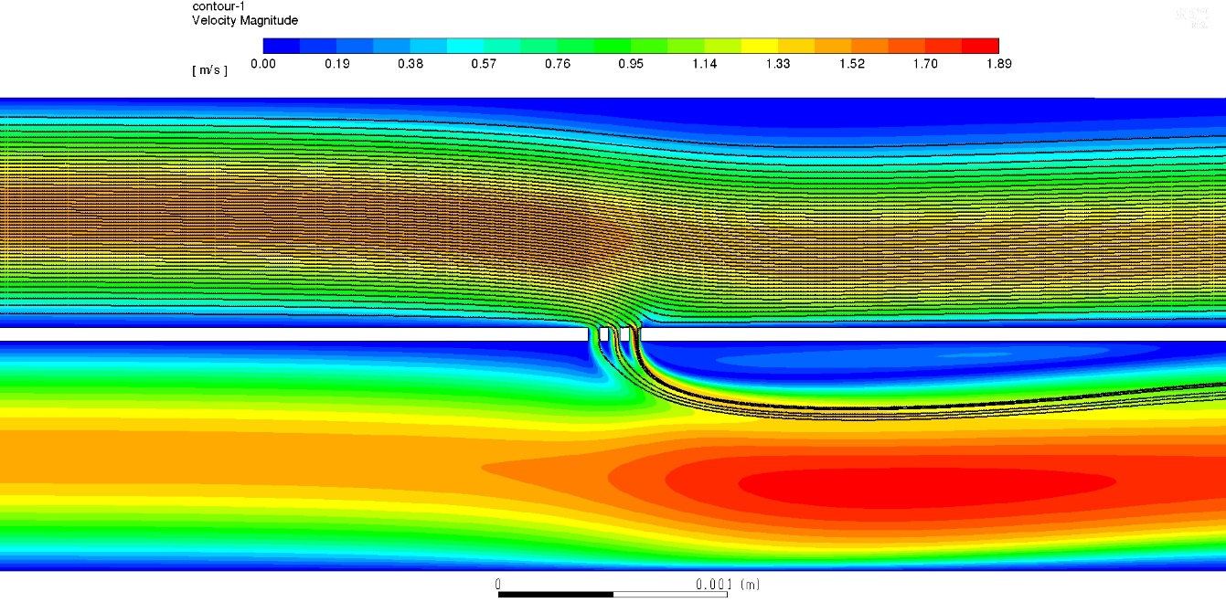

**x = 10 µm**

**v = 1 m/s**

**Δp = 2000Pa**

**Figure 2.** CFD simulation of the flow channel with particle tracking

Here, with the flow velocity and the electric field strength the hydrodynamic and electrophoretic forces can be adjusted, to achieve a classification.

**4. Conclusions**

A new method of fractionation finest particles using the crossfow-filtration is investigated. The effect of a hydrodynamic classification is shown. By using CFD-methods, the operating parameters are figured out. Due to the scalability of the process, which is based on membrane technology, the large-scale feasibility of the process is guaranteed. The individual effects used in the process and plant components needed for the process are known from filtration and membrane technology, but are still not used today for fractionation.