Selective separation of n-butanol from ABE solutions with polymeric inclusion membranes
Carla A. Arregoitia¹, Marcos Fallanza¹, Daniel Gorri¹, Inmaculada Ortiz¹
¹ University of Cantabria, Santander, Spain;
*Corresponding author: cadriana.arregoitia@unican.es
Highlights
- The addition of IL into the polymeric matrix improves the membrane selectivity
- Permeation fluxes highly depend on the operation temperature
- Fabricated membranes show improved behavior with respect to commercial membranes

1. Introduction
Biobutanol is considered as an attractive commodity and it is used as a solvent for different applications and as a biofuel, it has many advantages [1]. Biobutanol can be produced via ABE fermentation from renewable feedstocks by Clostridia bacteria, the most commonly used microorganism. Yet, the very low yield in final concentration, the severe butanol toxicity to microorganisms and the high-energy consumption are still some challenges that prevent the process from being more competitive over the petrochemical route [2].
Among the many advantages of the Pervaporation (PV) membrane separation technique is the fact that it does not affect microorganisms, and prevents nutrients and substrates loss [3]. Alcohol perm-selective PV membranes are usually composite membranes [4] and are made with a thin and dense active layer on a porous substrate. Ionic liquids (ILs) in membrane techniques have been investigated and although they have a good potential for butanol separation; the application for separation of butanol from ABE solvents by PV has not been fully investigated. This work aimed to develop and evaluate polymeric inclusion membranes made of different amounts of polymer and IL for the recovery of butanol from aqueous solutions by PV
2. Methods
Different composite flat-sheet membranes based on polyether block amide (PEBA) and the ionic liquid 1-Hexyl-3-methylimidazolium tris (pentafluoroethyl) trifluorophosphate (HMImFAP) were prepared by using the TIPS technique (temperature induced phase separation). They were characterized using FTIR and SEM methods. They showed the membranes with the IL fully integrated into the polymer matrix. The resulting membranes were dense flat sheet membranes with an average thickness of 10 µm. Butanol recovery experiments from ABE mixtures (2% butanol, 1% ethanol, 1% acetone) were performed by a PV unit and the transport parameters of the membranes for each component were obtained. Finally, the Pervaporation Separation Index (PSI) allowed a comparison of the performance results between the prepared membranes and the commercial membranes.
$$PSI=J∙{(α}_{i/j}-1)$$
3. Results and discussion
It was observed that the transmembrane flux is highly dependent on both, membrane composition and operating temperature. Membranes with higher content of ionic liquids are more permeable and the transmembrane flux was observed to increase as the temperature increases.
Based on the obtained results, the addition of a small amount of ionic liquid into the polymeric matrix shows an important decrease of the water flux while the butanol permeation remains almost unaffected. Finally, the efficiency of the membranes prepared in this study for the recovery of butanol was measured in terms of pervaporation separation index (PSI), offering results up to 8 times better than those from commercial membranes.
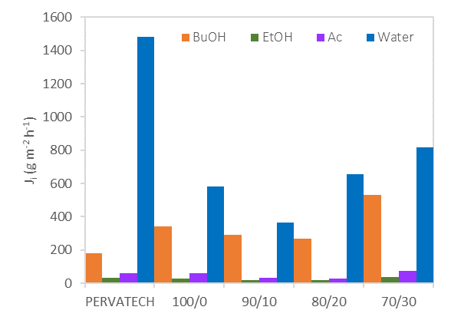
Figure 1. Flux comparison of commercial membrane PERVATECH and PEBAX/ HMImFAP polymeric membrane
4. Conclusions
Polymeric inclusion membranes were made of different amounts of polymer/IL for the recovery of butanol from aqueous solutions by PV process. It was observed that the flux increased as the temperature increased. Adding IL to the membrane showed an improvement by increasing the butanol flux and decreasing the water in the permeate stream. Finally, the influence of the composition of the membranes in the separation of butanol-water mixtures was studied and the performance of the membranes was compared with other commercial membranes showing a significant improvement.
Acknowledgements: This research has been funded by the Spanish Ministry of Economy and Competitiveness (Projects CTQ2015-66078-R and CTQ2016-75158-R). Carla Arregoitia also thanks for a PhD scholarship.
References
[1] D. Cai, H. Chen, C. Chen, S. Hu, Y. Wang, Z. Chang, Q. Miao, P. Qin, Z. Wang, J. Wang, T. Tan, Gas stripping-pervaporation hybrid process for energy-saving product recovery from acetone-butanol-ethanol (ABE) fermentation broth, Chem. Eng. J. 287 (2016) 1–10.
[2] N. Abdehagh, F.H. Tezel, J. Thibault, Separation techniques in butanol production: Challenges and developments, Biomass and Bioenergy. 60 (2014) 222–246.
[3] W. S. Winston Ho, and Kamalesh K. Sirkar, Membrane handbook, New York, Elsevier, 1992.
[4] S. Manshad, M.G. Mohd Nawawi, Membranes with favorable chemical materials for pervaporation process: A review, J. Membr. Sci. Technol. 06 (2016).

