Separation of mixtures containing SO₂, CO₂ a CH₄ using membranes
based on polymers with intrinsic microporosity
Petr Stanovsky^{1*}, Andrea Zitkova¹, Magda Karaszova¹, Pavel Izak¹,
Bibiana Comesaña Gándara², Neil McKeown²
¹ Instit. of Chem. Proc. Fund. CAS, Rozvojova 135, 165 02 Prague 6 – Suchdol, Czech Republic;
² Univ. Edinburgh, Sch. Chem., EaStCHEM, David Brewster Rd., Edinburgh EH9 3FJ, Midlothian, Scotland
*Corresponding author: stanovsky@icpf.cas.cz
Highlights
- Separation of CO₂ from CH₄ is efficient and overcome the Robeson upper bound 2008
- Permeability of SO₂ and CO₂ is very high but SO₂/CO₂ selectivity is low for industrial use.
- Selectivity of aged PIM membrane increased after testing with pure CO₂.
1. Introduction
Membrane separation of gases offer several advantages compared to common industrial methods as such as energy efficiency, safety and no additional waste production. One of the recent progressive direction in the field of polymer membrane science is a new class of ultrapermeable polymers based on inefficient packing of the two-dimensional chains – polymers with intrinsic microporosity (PIM).
2. Methods
Membranes were made of polymer with intrinsic microporosity based on tetramethyltetrahydronaphthalene combined with triptycene PIM-TMN-Trip (P5) casted from chloroform solution and further treated with methanol. The procedure of membrane preparation is described in detail in publication Rose et al [1].
Permeation of selected gases and its mixtures was tested using two apparatuses. First allows to set SO₂ concentration in mixture of air, N₂, CO₂ [3]. Second apparatus allow mixing CH₄, N₂, CO₂ or real biogas. The both allows analyzing either retentate or permeate stream via set of electrochemical and infrared detectors.
Membranes were tested for different values of SO₂ concentration ranging from 500 to 2500 ppm at temperature 25°C in mixture of 20% vol. CO₂ and dry air under 100 kPa of upstream and 90 kPa of downstream pressure. Further separation of mixture with 1800 ppm under increasing upstream pressure varying from 200 up to 500 kPa. Another tests with single gas as CO₂ and CH₄, their mixtures and real biogas from wastewater treatment plant were done at upstream pressure ranges from 100kPa to 500 kPa and 98 kPa of downstream pressure.
3. Results and discussion
Tested PIM-TMN-Trip membrane has shown superior separation properties for CO₂/CH₄ mixture. Combined ideal selectivity and permeability of single gases (gray circles in Fig. 1) lies above Robeson bound [2]. However, the membrane have shown lower values of permeability for CO₂ than similarly prepared membrane by Rose [1]. Permeability of CH₄ slightly increase with increasing trans-membrane pressure; on the other hand, CO₂ permeability remain almost constant over all range of trans-membrane pressure. Mixtures of CO₂ with CH₄ and real biogas with traces of H₂S and siloxanes (red triangles and blue diamonds in Fig. 1) have shown the same permeability for CO₂ with mixed gas selectivity higher than ideal selectivity of particular gases similarly as for polymer PIM based on spirobifluorene unit. Mixed gas selectivity decreased with increasing trans-membrane pressure. Moreover, as the measurement was done for mixtures and afterwards for single gases with CO₂ as the last one; we observed afterwards big increase in selectivity without change of CO₂ permeability. This CO₂ sorption-induced ageing improved selectivity of separation considerably (empty circles in Fig. 1).
Separation of SO₂ from dry stream containing initially 1800ppm SO₂ in mixture of air and 20 % vol. CO₂ is rather low (selectivity is approx. 2) and basically similar to our recent results of water-swollen thin film composite membrane Toray [3] in terms of selectivity but it have much higher permeability for SO₂. Permeability of SO₂ decreased with increasing trans-membrane pressure.
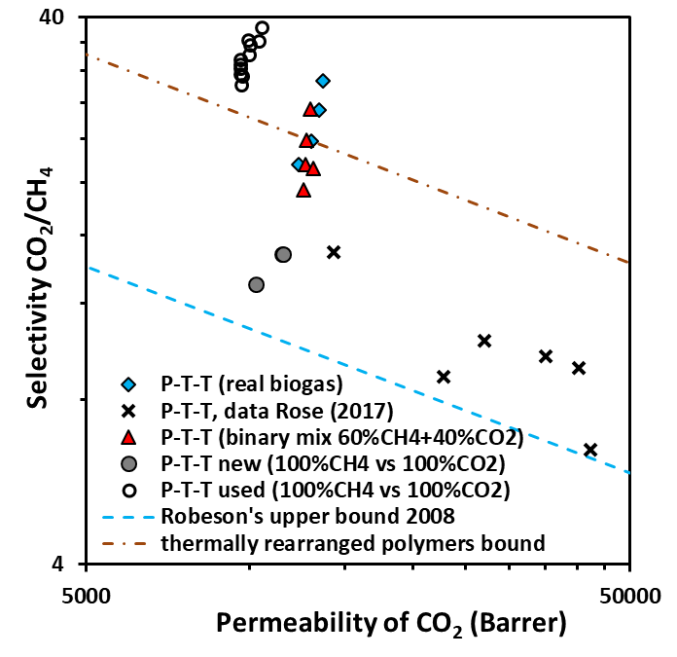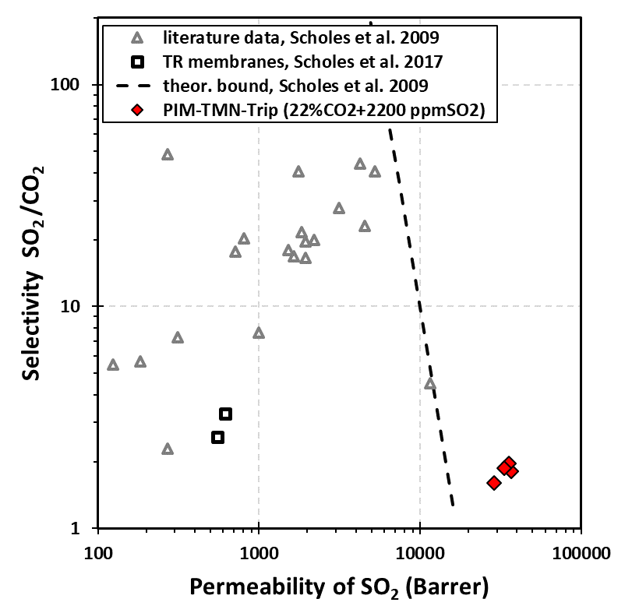
Figure 1. Selectivity CO₂/CH₄ vs permeability of CO₂ Figure 2. Selectivity SO₂/CO₂ vs permeability of SO₂
4. Conclusions
Tested PIM-TMN-Trip membrane have shown superior separation properties for mixture of CO₂/CH₄ mixture (CO₂ permeability 10-12.10³ Barrer, selectivity 13-15, selectivity of used and likely aged membrane 30-38). Permeability of SO₂ from air-CO₂ mixture was very high (29-37.10⁴ Barrer) but selectivity of SO₂ separation from CO₂ was small (1.6-2.0).
5. Acknowledgement
The support of Czech Science Foundation (project No. 18-05484S) is gratefully acknowledged.
References
- I. Rose, C.G. Bezzu, M. Carta, et al., Nature Mat. 16 (2017) 932-937.
- L.M. Robeson, J. Membrane Sci. 320 (2008) 390-400.
- A. Zitkova, M. Karaszova, P. Stanovsky, J. Vejrazka, P. Izak, Chem. Eng. Tech. 42 (2019) 1304-1309.
- C.A. Scholes, S.E. Kentish, W.S. Stevens, Sep. Purif. Rew. 38 (2009) 1–44.

