Reactor concept for continuous milli-reactors
Marlies Moser, Esteban Rosasco, Norbert Merkel, Alain Georg
Fluitec mixing + reaction solutions AG, Seuzachstrasse 40, 8413 Neftenbach, Switzerland
*Corresponding author: mm@fluitec.ch
Highlights
- Scale-up of exothermic reactions up to 2500 – 4300 t y⁻¹.
- Concept for a safe reactor design.
- Countercurrent safety purge system.
- Control system with a standard operating manual.

1. Introduction
Flow Chemistry at production and pilot scale presents new challenges to plant manufacturers. Scale-up of highly exothermic and fast reactions requires reliable safety measures. This work shows a reactor concept with safety elements for hazardous reactions including technical and electronic solutions to prevent an excessive temperature and pressure.
2. Methods
This pilot plant was designed and manufactured by Fluitec. Also, programming was done by Fluitec using Siemens PLC.
3. Results and discussion
The DN50 reference pilot plant for 2500 – 4300 t y⁻¹ consists of two dosing systems, a tubular reactor containing static mixer heat exchangers [1], the safety purge system and a quench tank (Figure 1). Its underlying concept merges directives and standards of four fields: mechanical engineering (PED 2014/68/EU, MD 2006/42/EC, ATEX 2014/34/EU), chemical engineering (thermal safety concepts from F. Stoessel [2]), electrical engineering and safety (functional safety SIL according to EN 61511).
With this plant, three protection goals are met: dosing, inadmissible temperature and pressure. The devices are monitored by multiple mass flow meters, axial temperature sensors along the reactor, SIL approved temperature sensors and pressure sensors. In the case of a failure, the SIL approved safety purge system will empty out the reactor within a few seconds and direct the media to the quench tank, where it will be immediately inertised. This countercurrent safety purge was developed as an event preventing safety device. Besides this also damage limiting devices were installed such as rupture discs and a safety valve.

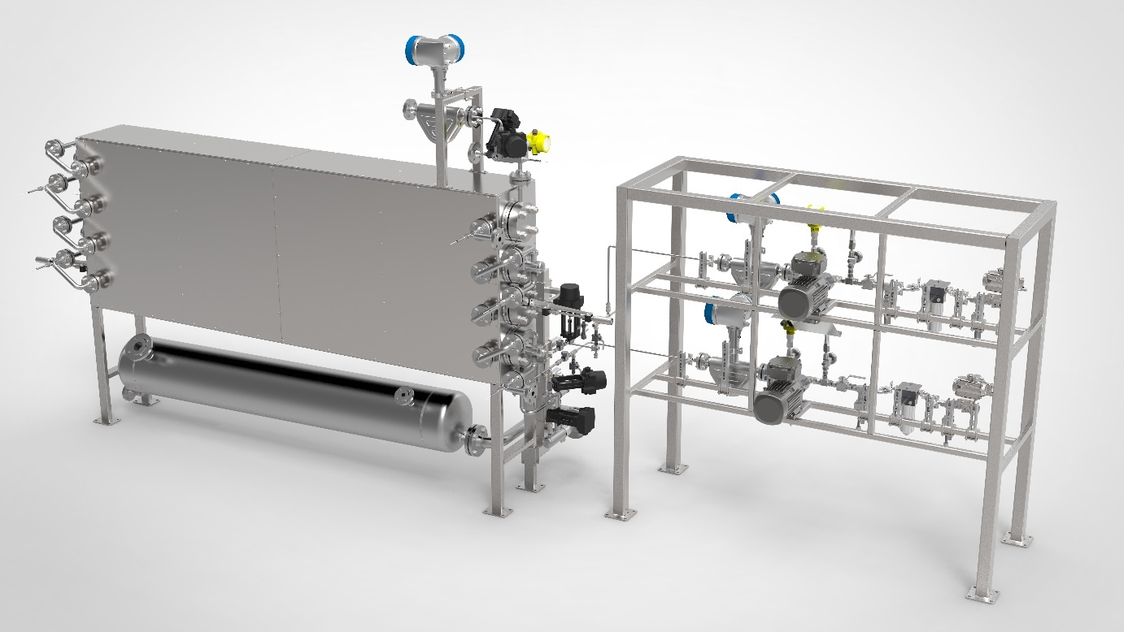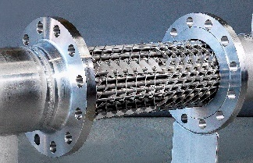
Figure 1. Reference pilot plant (2500 – 4300 t y⁻¹) containing two dosing systems, DN50 mixer heat exchangers and the safety purge system with quench tank.
4. Conclusions
This concept together with the scalable bundle mixer heat exchanger provides a way to tackle the scale-up problem of highly exothermic reactions in tubular reactors. The reactor and programming of the control system needs to be adjusted according to the characteristic temperature levels of the desired and decomposition reaction.
References
- A. Georg, M.B. Daescher, Chem. Ing. Tech. 2005, 77 (6), 681-693.
- F. Stoessel, Thermal Safety of Chemical Processes: Risk Assessment and Process Design, John Wiley & Sons, Weinheim 2008.

