A Bayesian approach for continuous improvement of kinetic parameter estimates
Karsten H. G. Rätze¹, Kevin McBride², Kai Sundmacher^{1,2}
1 Otto von Guericke University, Magdeburg; 2 Max Planck Institute for Dynamics of Complex Technical Systems, Magdeburg
*Corresponding author: raetze@mpi-magdeburg.mpg.de
Highlights
- Optimal experimental design (OED) with Bayesian parameter estimation
- Continuous improvement of estimation quality via repeated OED and experiments
- Optimal control trajectories for parameter estimation of the Hydroformylation of 1-decene

1. Introduction
Estimation of kinetic model parameters requires experimental data which needs to be gathered over multiple experiments with varying reaction conditions. As a consequence, building a mechanistic reaction model is labor intensive and requires significant financial investments. Combining optimal experimental design (OED) with dynamic perturbation experiments [1] improves the data generation while reducing the overall experimental effort. By embedding the OED in a sequential approach of repeated experimental design, execution of experiments and subsequent parameter estimation, the amount of necessary experiments is reduced to a minimum. However, implementing the proposed procedure requires repeated usage and updates of prior information on the kinetic parameters. Bayesian parameter estimation is one possible solution by incorporating prior information of different sources in the parameter estimation process while simultaneously providing a measure of the estimation quality.

2. Methods
The parameter estimation procedure may be exemplified using four steps. Initially, a structurally viable, dynamic kinetic model is required with initial values for the model parameters. To improve the quality of the error bounds of the parameter estimations, measurment errors of the experimental equipment are required. Initially, OED generates dynamic control profiles respective to the chosen optimality criterion (A-, D- or E-optimality). Additionally, optimal measurement times need to be calculated that incorporate physical limitations of the experimental equipment and procedure. After performing the experiment, the prior information is used to perform the parameter estimation using Monte Carlo Marcov Chain simulations.
3. Results and discussion
To exemplify the proposed procedure, the hydroformylation of 1-decene is chosen as example reaction. Based on mechanistic models from literature [2] a selected set of unknown parameters 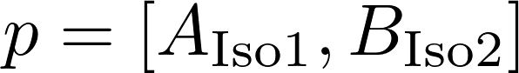 is chosen for parameter estimation. An initial guess is provided which deviates from the true parameter values 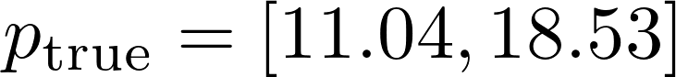 found in [2]. Besides limiting the measurment data to two of the reactants, dodec-1-ene and dodec-2ene, the limitations of the experimental equipment are incorporated by enforcing a two minute time interval between measurments and limiting the rate of change of the reaction temperature 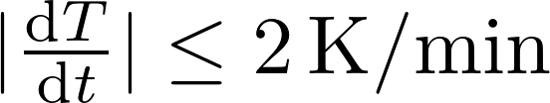. A normal distribution is chosen with 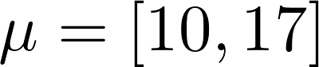 and 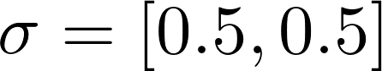 as prior information for the parameters.
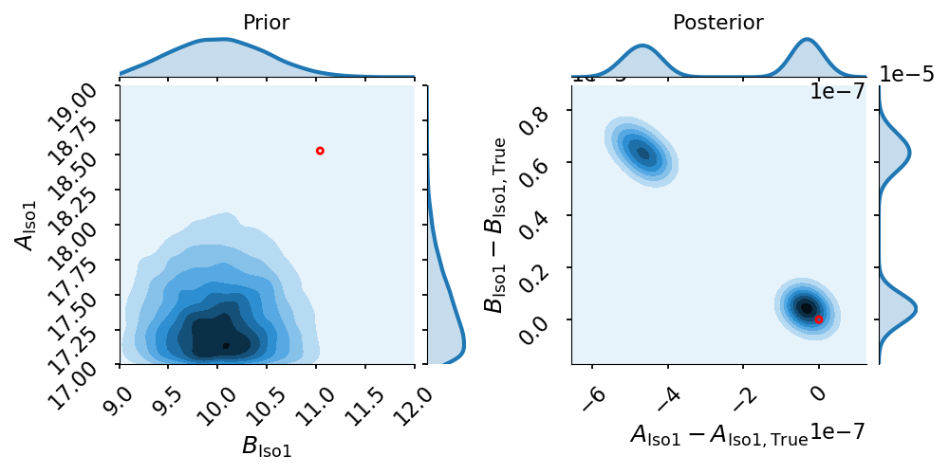
Figure 1. Probability density function improvement of and after one experiment.
Figure 1, depicts the improvement of the parameter probability density functions. In addition to the adequate approximation of the true parameter values via the density mean, the standard deviation of both probability density functions indicate a significant improvement of the estimation quality.
4. Conclusions
The proposed procedure shows a fast convergence to the true parameter values while simultaneously providing an indicator for the estimation quality. The standard deviation may be used as a stopping criterion for determining the necessary amount of experimental data, thereby reducing the development time for reaction kinetic models and improving economics.
Acknowledgements
This work is part of the Collaborative Research Center/Transregio 63 „Integrated Chemical Processes in Liquid Multiphase Systems“ (subproject B1). Financial support by the Deutsche Forschungsgemeinschaft (DFG, German Research Foundation) is gratefully acknowledged. The corresponding author is also affiliated to the „International Max Planck Research School for Advanced Methods in Process and Systems Engineering”.
References

[1] P. Heidebrecht, K. Sundmacher, L.T. Biegler, AIChE Journal 57 (2011) 2888–2901.
[2] A. Jörke, T. Gaide, A. Behr, A. Vorholt, A. Seidel-Morgenstern, C. Hamel, Chemical Engineering Journal 313 (2017) 382–397.

