Thermal stability of the inulinase of Kluyveromyces marxianus in the presence of organic cosolutos.
(*) Augusto Castillo¹, Angel Castro², Roberto Vega³
¹Departamento Académico de Agroindustria, Facultad de Ingeniería Universidad Nacional del Santa, Av. Pacifico 508. Teléfono +5144-312639. Chimbote, Perú; ²Departamento Académico de Microbiología y Biotecnología, Facultad de Ciencias Universidad Nacional del Santa, Av. Pacifico 508. Teléfono +5144-312639. Chimbote, Perú; ³Departamento de Bioquímica, Facultad de Farmacia y Bioquímica. Universidad Nacional Mayor de San Marcos, Jr. Puno 1002, Teléfono +5116197000-4831. Lima, Perú.
*Corresponding author: acascal2002@yahoo.es; acastillo@uns.edu.pe

Highlights
- Exo-inulinase produced by fermentation of Kluyveromyces marxianus in yacon extract.
- Checking glycerol, mannitol and sorbitol as stabilizing substances in biocatalysis.
- Improvement of the thermal and kinetic stability of the semi-concentrated inulinase.
.

1. Introduction
The exo-inulinase of Kluyveromyces marxianus NRRL-Y 7571 is an extracellular enzyme that catalyzes the hydrolysis of inulin into practically pure fructose. Also inulinase has been found transfructosilación activities. The biggest problem facing the use of inulinase is its poor kinetic and thermal stability. One way to stabilize an enzyme is to use substances that increase its thermodynamic stability.
2. Methods
A batch culture of K. marxianus was carried out in an automated 2 L fermenter with optimized liquid medium, containing yacon extract, to generate the enzymatic extract, then the separation by centrifugation and semi-concentration of the inulinase by precipitation with ethanol.
The activity and thermal stability data were obtained, incubating 10 mL of the enzyme semi-concentrate containing 5% and 10% of glycerol, mannitol and sorbitol, as corrected, in 0.05 M citrate phosphate buffer, pH 5.0, at 55ºC for different periods, after which the remaining activity was measured. Enzymatic activities were determined by measurements of initial velocity on a standard 20 g / L sucrose solution. The analyzes of reducing sugars and proteins were made by DNS and Bradford.
3. Results and discussion
The results showed that the presence of each of the cosolutos: glycerol, mannitol and sorbitol in their two concentration levels, increased the catalytic activity of inulinase by an average of 15.81%, which shows that each substance had a power-inducing effect catalytic enzyme. Correspondingly, the three cosolutos improved the biocatalytic and thermodynamic stability under non-reactive conditions of the exo-inulinase, with 5% glycerol contributing the best (Fig. 1), reaching the lowest value of the kinetic constant of equal denaturation at 0.0845 h⁻¹ and 7.5 times the average life time of the inulinase acting without stabilizer. This is because the substances contributed to maintain the native conformation of the enzyme, deduced that it became more rigid, at least in certain areas of its surface, supported by the mechanism of the exclusion of substances from the surface of the protein, which increases the structured water around that area.
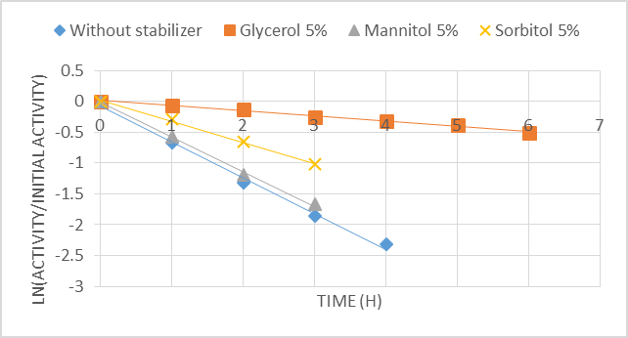
Figure 1. Effect of glycerol, mannitol and 5% sorbitol each on the thermal stability of K. marxianus NRRL-Y 7571 inulinase acting on sucrose.
4. Conclusions
The presence of each of the substances: glycerol, mannitol and sorbitol, improved the biocatalytic and thermodynamic stability under non-reactive conditions of the semi-concentrated exo-inulinase of K. marxianus NRRL-Y 7571, with glycerol contributing more significantly.
References
[1] S. Belluzo, V. Boeris, B. Farruggia, P. Picó. International Journal of Biological Macromolecules 49 (2011) 936– 941.
[2] J. Diestra, L.Margarito, R. Vega, A. Castillo. Scientia Agropecuaria 6(4) (2015): 303-312.
[3] S. Golunski, V. Astolfi, N. Carniel, D. de Oliveira, M. Di Lucio, M. Mazutti, H. Treichel. Separation and purification technology, 78 (2011): 261-265.

