Stabilization of goethite suspensions using Zirconium(IV) salts and its application to an imaging-free bi-dimensional size analysis
M. Distaso^{1,2}, M. Uttinger^{1,2}, J. Walter^{1,2}, C. Lübbert^{1,2}, T. Thajudeen^{1,2}, W. Peukert^{1,2}
1 Institute of Particle Technology, FAU Erlangen-Nuremberg, Cauerstraße 4, 91058 Erlangen, Germany;
2 Center for Functional Particle Systems, FAU Erlangen-Nuremberg, Haberstraße 9a, 91058 Erlangen, Germany
*Corresponding author: monica.distaso@fau.de
Highlights
- Goethite particles are stabilized using Zr(IV) salts.
- The suspensions were further processed and a fine and coarse fractions of particles were separated.
- Size analysis was carried out by combining sedimentation- and gas-phase analysis.
- The results match the size distribution obtained from image analysis.

1. Introduction
Goethite (α-FeOOH) is a technologically relevant material, widely used as adsorbent in waste water treatment, as precursor for magnetic drives and as a yellow pigment.,, Goethite typically comprise particles with acicular shape, often entangled in macroscopic agglomerates with limited dispersibility and only short time stabilization against agglomeration. The colloidal stability of suspensions is an important pre-requisite to ensure that the properties of the individual particles are extended to their ensembles in liquid phase. To achieve colloidal stability of goethite particles we consider for the first time the use of aqueous solution of Zr(IV) salts as stabilizers and we carry out a comparison with the already known AlCl₃⋅6H₂O.
2. Methods
Sedimentation analysis by Analytical Centrifugation (AC) and Ultracentrifugation (AUC) supported by ξ-potential measurements, time resolved UV-Vis spectroscopy and FTIR spectroscopy is used thoroughly to ascertain the stability of the suspensions.

3. Results and discussion
The colloidal stabilization enabled the separation between the fine and coarse fractions that constitute the particles ensemble. The fine fraction showed a ξ-potential > 50 mV and was found to be stable for more than 70 h at 25 °C. In a previous study, some of us demonstrated that the combination of two analytical techniques, namely AUC and scanning mobility particle size analysis (SMPS), enables an accurate characterization of the length and width of gold and ZnO nanorods.⁴ This approach was applied to stabilized goethite particles suspensions, whereby a bi-dimensional size analysis was carried out showing excellent agreement with the results obtained by Scanning Electron Microscopy (SEM) analysis.
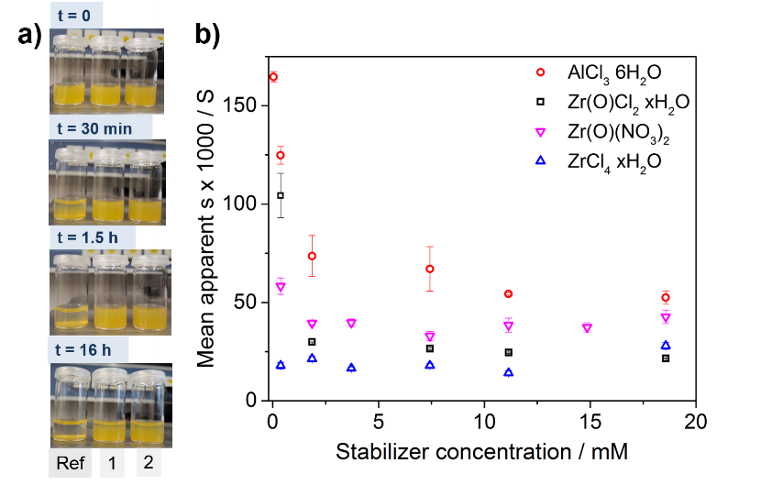 | c)
Figure 1. a) Digital micrographs of goethite suspensions in water and Zr stabilized suspensions with Zr(IV) concentration 3.71 mM (1) and 15 mM (2) at different time intervals; b) comparison between AlCl₃⋅6H₂O and Zr salts with different counter ions. [α-FeOOH] = 3.71 mM in all cases. Rods with mean width and length of (25 ± 8) nm and (135 ± 55) nm, respectively, were analyzed; c) SEM analysis of stabilized goethite particles.
4. Conclusions
Excellent colloidal stability of goethite particles with acicular shape was achieved using Zr(IV) salts as stabilizers. The suspensions could be further processed and a bi-dimensional size analysis was carried out by AUC and SMPS to assess the size distribution of the sample, without counting the particles from SEM images.
References
R.M. Cornell, U. Schwertmann, The iron oxides: Structure, properties, reactions, occurrences, and uses, 2nd, completely rev. and extended ed. ed., Wiley-VCH, Weinheim, 2003.
² E. R. Encina, M. Distaso, R. N. Klupp Taylor, W. Peukert “Synthesis of Goethite alpha-FeOOH Particles by Air Oxidation of Ferrous Hydroxide Fe(OH)2 Suspensions: Insight on the Formation Mechanism“ Cryst. Growth Des. 2015, 15, 194.
³ A. Güldenpfennig, M. Distaso, R. N. Klupp Taylor, W. Peukert “Modelling the two-dimensional growth and oriented attachment of goethite nanorods synthesized via oxidation of aqueous ferrous hydroxide slurries” Chem. Eng. J. 2018, 347, 798.
⁴ T. Thajudeen, J. Walter, R. Srikantharajah, C. Lübbert, W. Peukert “Determination of the length and diameter of nanorods by a combination of analytical ultracentrifugation and scanning mobility particle sizer” Nanoscale Horizons 2017, 2, 253.

R.M. Cornell, U. Schwertmann, The iron oxides: Structure, properties, reactions, occurrences, and uses, 2nd, completely rev. and extended ed. ed., Wiley-VCH, Weinheim, 2003.
E. R. Encina, M. Distaso, R. N. Klupp Taylor, W. Peukert “Synthesis of Goethite alpha-FeOOH Particles by Air Oxidation of Ferrous Hydroxide Fe(OH)2 Suspensions: Insight on the Formation Mechanism“ Cryst. Growth Des. 2015, 15, 194.
A. Güldenpfennig, M. Distaso, R. N. Klupp Taylor, W. Peukert “Modelling the two-dimensional growth and oriented attachment of goethite nanorods synthesized via oxidation of aqueous ferrous hydroxide slurries” Chem. Eng. J. 2018, 347, 798.

