Simultaneous saccharification and fermentation of LX-cellulose for the production of high optical pure L(+)-lactic acid
Linda Schroedter¹, Friedrich Streffer², Peter Unger¹, Joachim Venus^{1*}
1 Leibniz-Institute for Agricultural Engineering and Bioeconomy (ATB),
Department of Bioengineering, Max-Eyth-Allee 100, 14469 Potsdam, Germany;
2 LXP Group GmbH, Rheinstr. 3, 14513 Teltow, Germany
*Corresponding author: jvenus@atb-potsdam.de
Highlights
- L-lactic acid of optical purity >99% is produced from lignocellulosic biomass.
- Time of inoculation has influence on the overall yield of the SSF process.
- Using the SSF-process enables to decrease process durations <24 h.

1. Introduction
Lignocellulosic biomass is an abundant and inexpensive renewable material which does not compete with the production of food. Several lignocellulosic waste streams of agro-industrial processes yet bear the possibility to be valorized. In this study, lignocellulosic biomass was utilized as an alternative sugar source for the fermentative production of high optical pure L(+)-lactic acid (L-LA). The recalcitrant nature of the lignocellulose was overcome by the patented LX-pretreatment [1]. Mild process conditions reduce the formation of furfural or hydroxy-methylfurfural (HMF) which enhances the subsequent fermentation. Simultaneous saccharification and fermentation (SSF) is performed, employing the thermophilic bacterium Bacillus coagulans. Low pH and high temperature regime of the SSF allow the process to be operated under non-sterile conditions.
In classical SSF, enzymes and inoculum are added simultaneously to the vessel [2]. Additionally, fed-batch studies developed effective feeding schemes using various time points for supplement of enzyme or inoculum [3]. Nevertheless, a systematic approach is needed to understand the influence of delayed inoculum supplement to the enzyme reaction. This study aims to contribute to the development of optimized feeding schemes for SSF of lignocellulosic substrates.
2. Methods
The lignocellulosic feedstock that was used in our experiments was the fibrous effluent of an anaerobic digestion plant fed with corn silage. Pretreatment was done by the LXP Group GmbH at a dry matter content of approx. 80% employing the patented LX-method [1]. The lignocellulosic biomass was dissolved in 75 - 80% phosphoric acid at 60 to 75 °C at a ratio of approx. 1:3 (w/w) for 15 - 45 min at ambient pressure. After the dissolution was complete the carbohydrates were precipitated leading to a process stream referred to as LX-cellulose.
With this LX-cellulose, SSFs were carried out at ATB in 1 L-scale using the enzyme CellicCTec2® (Novozymes A/S, Denmark) and the thermophilic bacterium B. coagulans isolate A166 at 50 °C and pH 5 adding 10 g L⁻¹ yeast extract as nutrient and 20% (w/w) NaOH for pH regulation. In contrast to classical SSF in which enzymes and inoculum are added at once, we also performed “delayed SSF” experiments by adding inoculum subsequently to the enzymes at different time points (0, 6 and 12 h).
3. Results and discussion
The “delayed SSF” strategy yielded in L-LA with 99.5% optical purity. Our experimental results showed that by delaying the addition of the inoculum an improvement on the overall yield of the process was achieved. Figure 1.A shows that a delay of 6 h can enhance overall yield to 10% (t = 12 h). The overall yield is given as produced lactic acid divided by the total sugars that could potentially be released from the substrate (in g_{LA} g_{Sug}⁻¹). Furthermore, from Figure 1.B it can be stated that with B. coagulans A166 SSF process durations of <24 h are possible. This is also due to the fact that the mild conditions of the LX-method reduce the formation of growth inhibitors during pretreatment.
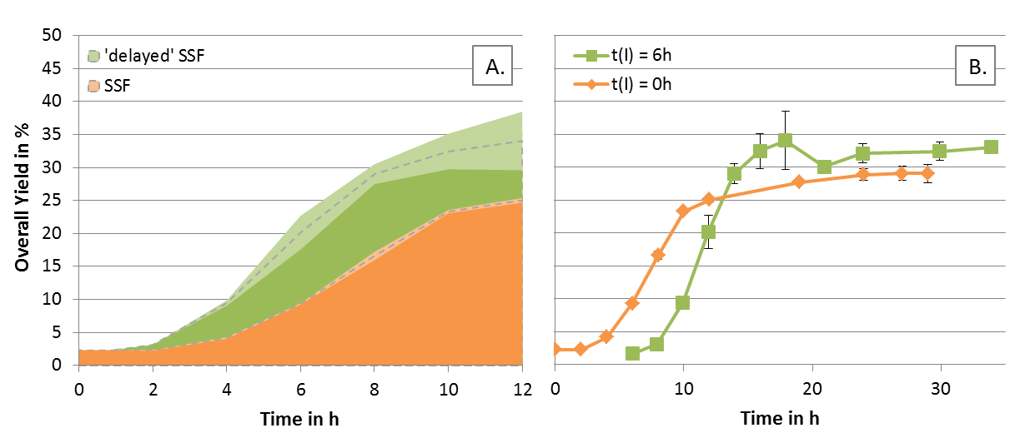
Figure 1. SSF of LX-pretreated corn silage digestate employing B. coagulans A166; comparison of inoculation at t(I) = 0 h and t(I) = 6 h (‘delayed’ SSF): A. yield over time of fermentation; B. yield over time of whole SSF process.
4. Conclusions
Our study aimed at producing high optical pure L-LA from corn silage digestate which was pretreated by the LX-method. The B. coagulans isolate A166 effectively fermented glucose and xylose to L-LA, reaching high productivity. The SSF experiments indicated that time of inoculation is crucial for the development of an optimal process. Final titers of around 20 g L⁻¹ were obtained, with an optical purity of 99.5%.

References
- Streffer, F. (2009). Patent No PCT/EP2009/007583 Munich, Germany: European Patent Office.
- F. Cui et al., Bioresour. Technol. 102 (2011) 1831-1836.
- J. Hu et al., Bioresour. Technol. 182 (2015) 251-257.

